Eight Mile Plains gateway

draft neighbourhood plan

Brisbane City Plan 2014

Amendment package – October 2022
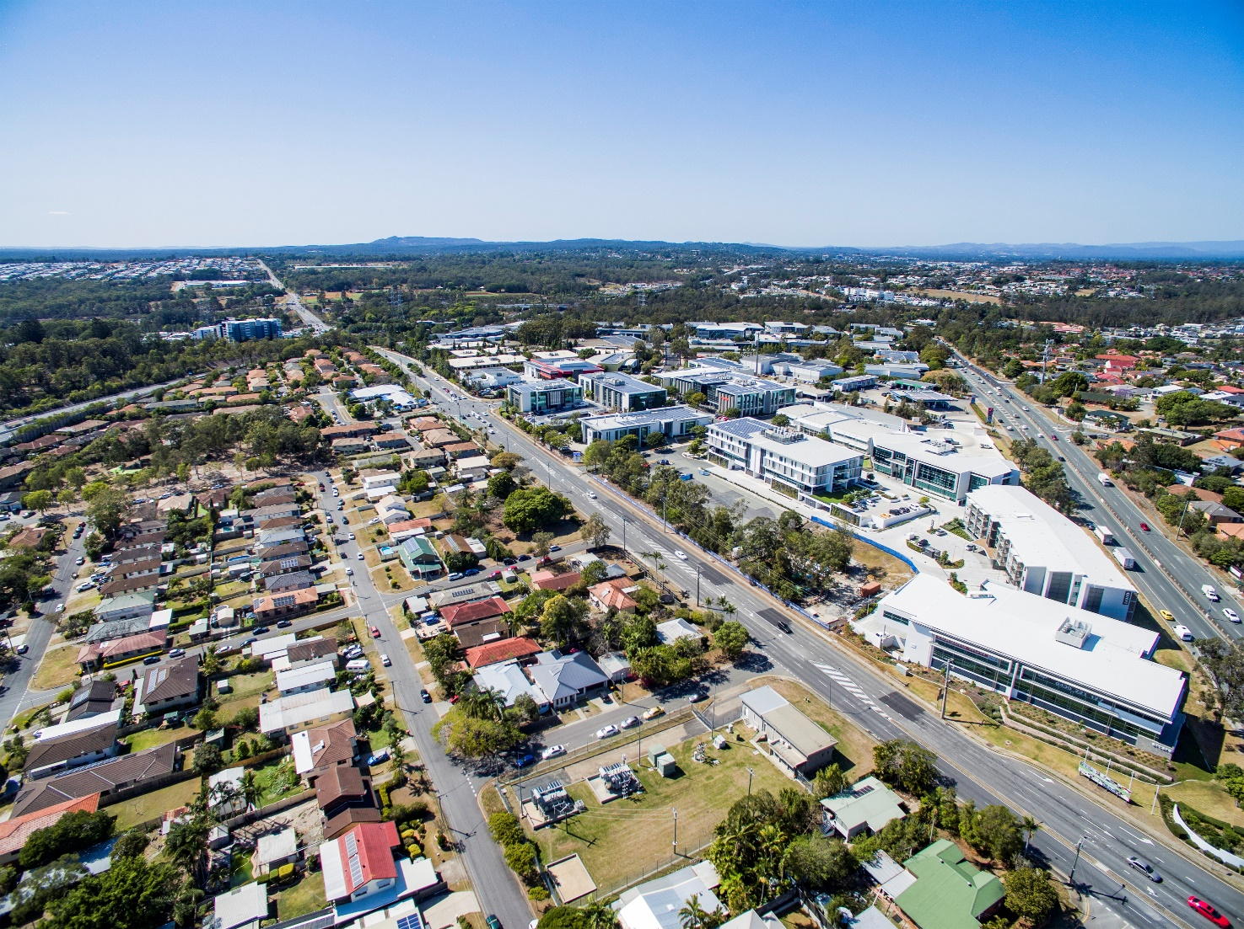

Table of Contents
Part A: Explanatory Notes 4
Purpose 5
Introduction 5
Background 5
Community engagement 6
The neighbourhood plan boundary 7
Precincts 8
Key planning outcomes 10
Economy, industry and jobs 10
Infrastructure, active and public transport 10
Environment and open space 10
Public realm and community facilities 11
Housing choice 11
Amendment summary 13
Conclusion 15
Part B: Major Amendment v25.00/2022 16
Part 1 Amendment of Part 1 (About the planning scheme) 18
1.1 Amendment of section 1.2 (Planning scheme components) 18
Part 2 Amendment of Part 5 (Tables of assessment) 19
2.1 Amendment of section 5.9 (Categories of development and assessment—Neighbourhood plans) 19
Part 3 Amendment of Part 7 (Neighbourhood plans) 26
3.1 Amendment of section 7.1 (Preliminary) 26
3.2 Amendment of section 7.2 (Neighbourhood plan codes) 26
7.2.5.5 Eight Mile Plains gateway neighbourhood plan code 26
7.2.5.5.1 Application 26
7.2.5.5.2 Purpose 27
7.2.5.5.3 Performance outcomes and acceptable outcomes 30
Table 7.2.5.5.3.A—Performance outcomes and acceptable outcomes 30
Table 7.2.5.5.3.B—Maximum building height 38
Table 7.2.5.5.3.C—Minimum building setback 39
3.3 Amendment of section 7.2 (Neighbourhood plans) 47
7.2.11.4 Kuraby neighbourhood plan code 47
7.2.11.4.1 Application 47
7.2.11.4.2 Purpose 47
3.4 Amendment of section 7.2 (Neighbourhood plan codes) 51
7.2.18.4 Rochedale urban community neighbourhood plan code 51
7.2.18.4.1 Application 51
7.2.18.4.2 Purpose 52
7.2.18.4.3 Performance outcomes and acceptable outcomes 58
Table 7.2.18.4.3.A—Performance outcomes and acceptable outcomes 58
7.2.18.4.3.B—Maximum building height and gross floor area 72
7.2.18.4.3.C—Local Parkland – valuable features 73
Part 4 Amendment of Part 8 (Overlays) 82
4.1 Amendment to section 8.2.19 (Significant landscape tree overlay code) 82
Part 5 Amendment of Schedule 2 (Mapping) 83
5.1 Amendment to SC2.2 (Zone maps) 83
5.2 Amendment to Table SC2.2.1 (Zone maps) 83
5.3 Amendment to SC2.3 (Neighbourhood plan maps) 83
5.4 Amendment to Table SC2.3.1 (Neighbourhood plan maps) 84
5.5 Amendment of Schedule 2.4 (Overlay maps) 85
5.6 Amendment of Table SC2.4.1 (Overlay maps) 85
Part 6 Amendment of Schedule 6 (Planning scheme policies) 86
Part 7 Amendment of Appendix 2 (Table of amendments) 86
7.1 Amendment to Appendix 2 (Table of amendments) 86
Supplement 1—A3 Map Tiles 87

Part A: Explanatory Notes

Purpose
The purpose of these explanatory notes is to provide context to the Eight Mile Plains gateway neighbourhood plan amendment package (the amendment package), including the key outcomes sought and the process undertaken to develop the draft neighbourhood plan. The explanatory notes are for information only and do not form part of the amendment package.

Introduction
The amendment package sets out the statutory amendments required to amend Brisbane City Plan 2014 (the planning scheme) to incorporate a new neighbourhood plan and proposed updates to two existing neighbourhood plans. It contains two parts: this explanatory statement (for information only) and the amendment package, which specifies the proposed statutory changes to the planning scheme. The amendment respects and supports religious diversity in the area as part of a multi-cultural community. It also supports the continuing development of one of Brisbane’s global precincts in providing scalable industrial activity, world-class business environments and global research opportunities.

Background
Brisbane City Council (Council) proposes to include a new neighbourhood plan in the planning scheme to guide future development and coordinate land use and infrastructure over a 10-year period and beyond for parts of the suburbs of Eight Mile Plains and Rochedale. These suburbs include key economic and employment hubs and areas with proposed significant infrastructure investment (e.g. Brisbane Metro). Once adopted, the neighbourhood plan will become part of the planning scheme.

The Eight Mile Plains gateway neighbourhood plan area includes parts of the existing Rochedale urban community and Kuraby neighbourhood plans. These neighbourhood plans will be updated as a consequence of the amendment package to remove the areas now covered by the Eight Mile Plains gateway neighbourhood plan. The Eight Mile Plains gateway neighbourhood plan boundary has been consistently used for consultation purposes since project launch in early 2019.

Council has developed the amendment package to amend the planning scheme. The amendment package forms a major amendment to the planning scheme as defined in the Planning Act 2016 and has been prepared in accordance with the Minister’s Guidelines and Rules.

Council commenced the neighbourhood planning process to focus on the Eight Mile Plains gateway area in May 2019. The Eight Mile Plains gateway neighbourhood plan draft strategy (the draft strategy) was released in November 2019 and was open for public consultation from 18 November 2019 to 16 December 2019. Feedback from the community, including the Community Planning Team (CPT) meetings, online survey and strategy responses, was used in the preparation of the draft neighbourhood plan. Internal Council stakeholders have also been involved in preparing the draft neighbourhood plan.

Council endorsed the amendment package on 25 May 2021 and submitted the amendment to the Minister for State interest review. Following review, the amendment package was amended to address conditions received from the then Deputy Premier and Minister for State Development, Infrastructure, Local Government and Planning dated 28 September 2021.

The amendment package was released for public consultation from 8 November 2021 to 6 December 2021. Following a review and analysis of the submissions received, updates were made to the amendment package, and it was submitted to the Queensland Government on 7 June 2022 for consideration. The Minister advised on 2 September 2022 that the proposed amendment package was approved for adoption in the planning scheme.

Community engagement
The neighbourhood planning process involved a series of community engagement stages. A summary of the community engagement process is detailed in the following table.

Table 1: Key community engagement summary.
Engagement type | Date and location | Number
Online issues survey | May 2019 to June 2019 | 283 responses
Interactive mapping | May 2019 to June 2019 | 204 responses
Community Planning Team | Wednesday 17 July 2019 – The Glen Hotel, Gaskell Street, Eight Mile Plains | 8 attendees
Community Planning Team | Thursday 8 August 2019 – The Glen Hotel, Gaskell Street, Eight Mile Plains | 14 attendees
Community Planning Team | Wednesday 4 September 2019 – The Glen Hotel, Gaskell Street, Eight Mile Plains | 12 attendees
Information kiosks | Saturday 30 November 2019 – The Glen Hotel, Gaskell Street, Eight Mile Plains | 8 attendees
Information kiosks | Thursday 5 December 2019 – Brisbane Technology Park Conference Centre, Eight Mile Plains | 7 attendees
Newsletters | Newsletter 1 – 13 May 2019  Newsletter 2 – 18 November 2019 | Sent to 4,384 residents and local businesses.  Two hundred copies were distributed at the Eight Mile Plains busway station.
Draft amendment package consultation | 8 November 2021 to 6 December 2021 | Public consultation and feedback on the draft amendment package
Talk to a planner sessions (during consultation period) | Saturday 20 November 2021 | 5 attendees
Talk to a planner sessions (during consultation period) | Wednesday 24 November 2021 | 20 attendees

The neighbourhood plan boundary
The draft plan comprises parts of the suburbs of Eight Mile Plains and Rochedale. The neighbourhood plan boundary is outlined in Figure 1 below.

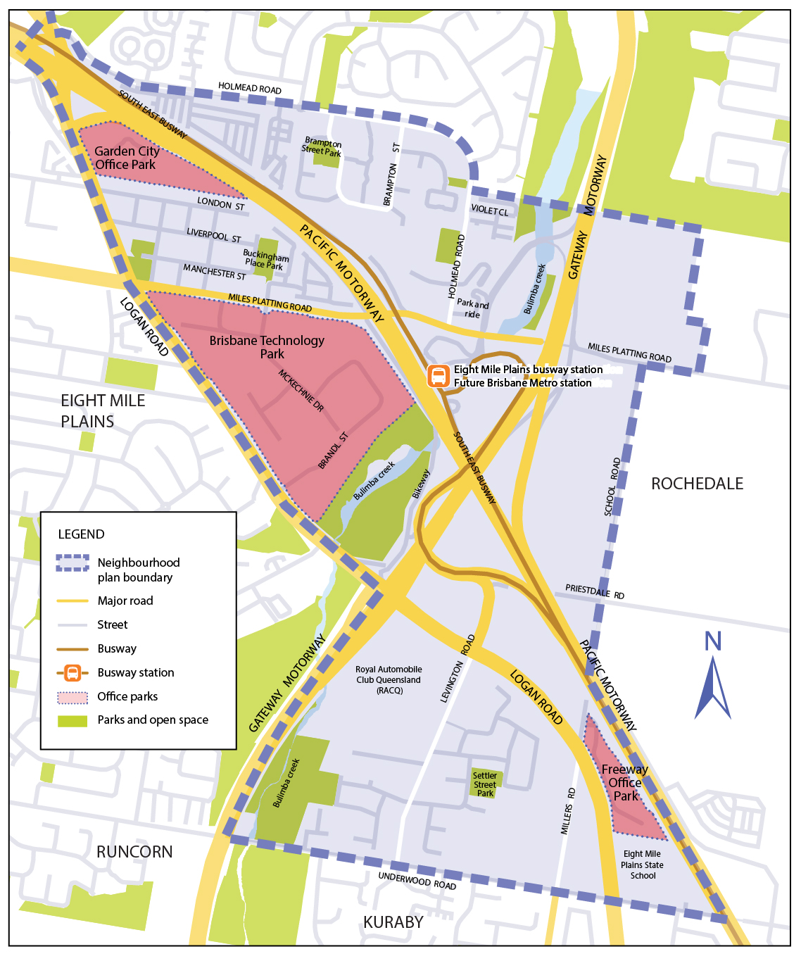
Figure 1—Neighbourhood plan boundary.

Precincts
Neighbourhood plans include precincts and may also include sub-precincts. Precincts have been identified to address or provide for particular land uses, urban design, infrastructure or other site characteristics (e.g. environmental values), and have a specific set of provisions to achieve those outcomes. Located within a precinct, sub-precincts are smaller portions of the overall precinct, and have more detailed provisions to achieve the intended land use outcomes.

The amendment package proposes five precincts within the draft neighbourhood plan area. Three of these precincts have sub-precincts. The proposed precincts are outlined in Figure 2 and also detailed in Part B of the draft amendment package. These precincts provide specific guidance on the types of uses and development outcomes supported in these locations and include:

- NPP-001: Brisbane Technology Park precinct
  - NPP-001a: Mixed industry and business core sub-precinct
- NPP-002: Busway station precinct
- NPP-003: Gateway business precinct
- NPP-004: Logan Road employment precinct
  - NPP-004a: Levington Road employment sub-precinct
- NPP-005: Potential development areas precinct
  - NPP-005a: Holmead Road sub-precinct.

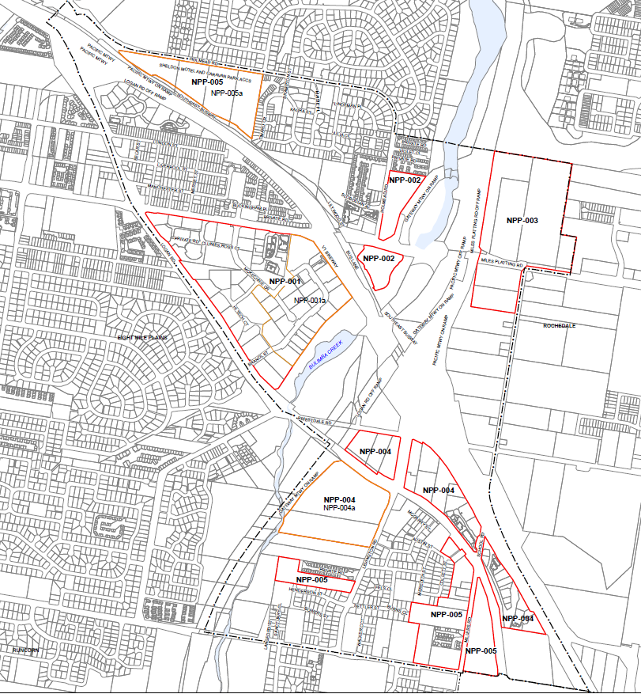
Figure 2—Draft Eight Mile Plains gateway neighbourhood plan boundary and precincts

Key planning outcomes
The amendment package includes requirements to ensure that development responds to key regional and local planning outcomes sought for the draft plan area including:

Economy, industry, and jobs

The Brisbane Technology Park (BTP) is a Specialised centre, providing advanced manufacturing and research technology uses that make a significant economic contribution to the region. Other major employment uses within the area include the RACQ headquarters, Garden City Office Park and Freeway Office Park.

The amendment package seeks to:
- encourage localised employment and retail opportunities by attracting and retaining advanced technology and manufacturing industries at key locations
- support the continued growth of Brisbane Technology Park and employment uses along Logan Road, including small cafes and shops that would support local residents and workers.

The amendment package seeks to achieve this through:
- providing for additional building heights and a mixture of commercial and retail uses within BTP
- introducing precincts (Gateway business precinct and Logan Road employment precinct) with specific requirements regarding building heights, setbacks and landscaping
- encouraging light industry, warehousing, office and commercial uses along Miles Platting Road and School Road in the Gateway business precinct, capitalising on the strategic location close to arterial roads.

Infrastructure, active and public transport

The Eight Mile Plains gateway area is the southern gateway of the Brisbane LGA and is well connected to the region by the Gateway and Pacific motorways and Logan Road. The existing Eight Mile Plains busway station provides public transport connections to the Brisbane CBD. The Eight Mile Plains busway station will also become the final interchange for the future Brisbane Metro, with its depot to be located on School Road.

The amendment package seeks to:
- provide additional services and facilities for residents and workers
- improve links for public and active transport
- support and promote non-car reliant modes of transportation for residents and workers to help reduce traffic congestion and on-street car parking in local streets.

The amendment package seeks to achieve this through:
- encouraging development to support greater active transport connections between BTP and the existing Eight Mile Plains busway station
- encouraging improved connections throughout the area to facilitate walking and cycling between business, residences and public transport, particularly between the future Brisbane Metro station and BTP
- supporting improvements to the pedestrian environment with wider footpaths and shade trees planned for as a part of development outcomes.

Environment and open space

The plan area has important environmental areas, including the Bulimba Creek corridor, that provide environmental value as well as opportunities for outdoor space and recreation.

The amendment package seeks to:
- protect and enhance the environmental and habitat values of the Bulimba Creek corridor
- retain existing open space
- ensure that development responds to environmental constraints and seeks to retain existing significant vegetation.

The amendment package seeks to achieve these goals by:
- requiring development (as it occurs) to include street trees that will create a shade canopy, widen footpaths, and deliver public realm improvements such as public art or communal outdoor space
- changing key sites currently zoned Open space to the Conservation zone to provide for increased protection of these areas
- including provisions to ensure the protection and rehabilitation of areas in the Bulimba Creek catchment
- requiring development to retain existing significant vegetation and to protect key landscape tree sites for their contribution to the streetscape character
- requiring future development in the Potential development areas precinct to prepare a structure plan to ensure that existing environmental values and the character of the area are protected.

Public realm and community facilities

The urban fabric of the neighbourhood plan area includes a number of streetscapes, public spaces, community facilities, places of worship and meeting places, that foster greater community connection.

The amendment package seeks to:
- encourage development to deliver high-quality urban design and architecture contributing to the identity of BTP through onsite amenities such as built form, landscaping, public realm, and public art
- maintain existing public space within BTP to contribute to the amenity for workers
- support the continued operation of established places of worship.

The amendment package seeks to achieve these goals by:
- encouraging development to increase connections within the area, particularly between the Eight Mile Plains busway station and BTP, through streetscape improvements such as planting and footpath upgrades
- including provisions to support the ongoing operations of places of worship
- encouraging the retention of established vegetation through setbacks and landscaping requirements that contribute to the public realm and subtropical environment of the neighbourhood plan area, especially in BTP
- encouraging the development of a public plaza on the existing public space at the end of McKechnie Drive.

Housing choice

Existing residential development is predominantly comprised of detached dwellings. There is also a range of units, townhouses and caravan parks established across the area.

The amendment package seeks to:
- provide diverse housing options for the local community
- provide a variety of housing options close to public and active transport options, employment, and services.

The amendment package seeks to achieve these goals by:
- proposing townhouses up to three storeys in height (Low-medium residential zone) in selected locations, next to public transport, services, and existing multiple dwellings
- providing housing choice close to the future Rochedale busway station and existing employment opportunities through land zoning
- providing for apartments and units up to five storeys in height in a small area along Underwood Road near the school, shops, and the future Rochedale busway station
- ensuring that new houses are well integrated with the community and existing infrastructure
- seeking to maintain existing affordable housing.

Amendment summary
Table 2: Amendment summary.
Part | Planning scheme reference | Proposed amendment | Part B amendment reference
Part 1 (About the planning scheme) | Table 1.2.2—Neighbourhood plans precincts and sub-precincts | Add new row for the Eight Mile Plains gateway neighbourhood plan.  - NPP-001: Brisbane Technology Park  - NPP-001a: Mixed industry and business core  - NPP-002: Busway station  - NPP-003: Gateway business  - NPP-004: Logan Road employment  - NPP-004a: Levington Road employment  - NPP-005: Potential development areas  - NPP-005a: Holmead Road | Part 1.1 (1)
Part 5 (Tables of assessment) | Table 5.9.1—Categories of development and assessment—Neighbourhood Plans | Add new row for the Eight Mile Plains gateway neighbourhood plan for the categories of development and assessment changes. Changes to the level of assessment for Material change of use applications are indicated in the table. | Part 2.1 (2)
Part 5 (Tables of assessment) | Section 5.9 Categories of development and assessment—Neighbourhood plans, Tables 5.9.83.A to D—Eight Mile Plains gateway neighbourhood plan | Add new tables for the Eight Mile Plains gateway neighbourhood plan including Table 5.9.83.A: material change of use; Table 5.9.83.B: reconfiguring a lot; Table 5.9.83.C: building work; Table 5.9.83.D: operational work; and  Table 5.9.83.A: material change of use to include table of assessment changes for the Brisbane Technology Park precinct (NPP-001), the Gateway business precinct (NPP-003) the Levington Road employment sub-precinct (NPP-004a), and the Holmead Road sub-precinct (NPP-005a). | Part 2.1 (3)
Part 7 (Neighbourhood plans) | Table 7.1.1 Neighbourhood plan codes, 7.2.5.5 – Eight Mile Plains gateway neighbourhood plan | Add new row for the Eight Mile Plains gateway neighbourhood plan code. | Part 3.1 (4)
Part 7 (Neighbourhood plans) | 7.2.5.5 – Eight Mile Plains gateway neighbourhood plan code | Add Eight Mile Plains gateway neighbourhood plan code. | Part 3.2 (5)
Part 7 (Neighbourhood plans) | 7.2.11.4 Kuraby neighbourhood plan code | Amend the Kuraby neighbourhood plan code. | Part 3.3 (6)
Part 7 (Neighbourhood plans) | 7.2.18.4 Rochedale urban community neighbourhood plan code | Amend the Rochedale urban community neighbourhood plan code. | Part 3.4 (7)
Part 8 (Overlays) | Table 8.2.19.3.C – Significant landscape trees in specific locations | Amend the Significant landscape tree overlay code to include significant landscape trees in the suburbs of Eight Mile Plains and Rochedale. | Part 4.1  (8 and 9)
Schedule 2 (Mapping) | SC2.2 Zone Maps – ZM-001 (Tile 44) | Amend ZM-001 (Tile 44) to include changes in the Eight Mile Plains gateway neighbourhood plan area. | Part 5.1 (10)
Schedule 2 (Mapping) | SC2.2 Zone maps, Table SC2.2.1—Zone maps | Amend Table SC2.2.1 to include new gazettal date for ZM-001 (Tile 44). | Part 5.2 (11)
Schedule 2 (Mapping) | NPM-005.5 Eight Mile Plains gateway neighbourhood plan map | Add NPM-005.5 Eight Mile Plains gateway neighbourhood plan map. | Part 5.3 (12)
Schedule 2 (Mapping) | NPM-011.4 Kuraby neighbourhood plan map | Add new NPM-011.4 Kuraby neighbourhood plan map. | Part 5.3 (13)
Schedule 2 (Mapping) | NPM-018.4 Rochedale urban community neighbourhood plan map | Add new NPM-018.4 Rochedale urban community neighbourhood plan map. | Part 5.3 (14)
Schedule 2 (Mapping) | Table SC2.3.1—Neighbourhood plan maps | Amend Table SC2.3.1 Neighbourhood plan maps to include change gazettal dates for Kuraby and Rochedale urban community neighbourhood plans and add gazettal date for NPM-005.5. | Part 5.4  (15 to 17)
Schedule 2 (Mapping) | SC2.4 Overlay maps, OM-004.1 Dwelling house character overlay map | Amend OM-004.1 Dwelling house character overlay map (Tile 44) to include changes in the Eight Mile Plains gateway neighbourhood plan. | Part 5.5 (18)
Schedule 2 (Mapping) | SC2.4 Overlay maps, OM-019.1 Significant landscape tree overlay map | Amend OM-019.1 Significant landscape tree overlay map (Tile 44) to include changes in the Eight Mile Plains gateway neighbourhood plan. | Part 5.5 (19)
Schedule 2 (Mapping) | SC2.4 Overlay maps, OM-019.2 Streetscape hierarchy overlay map | Amend OM-019.2 Streetscape hierarchy overlay map (Tile 44) to include changes in the Eight Mile Plains gateway neighbourhood plan. | Part 5.5 (20)
Schedule 2 (Mapping) | SC2.4 Overlay maps, Table SC2.4.1 | Amend Table SC2.4.1 to include new gazettal date for OM-004.1 Dwelling house character overlay map (Tile 44). | Part 5.6 (21)
Schedule 2 (Mapping) | SC2.4 Overlay maps, Table SC2.4.1 | Amend Table SC2.4.1 to include new gazettal date for OM-019.1 Significant landscape tree overlay map (Tile 44). | Part 5.6 (22)
Schedule 2 (Mapping) | SC2.4 Overlay maps, Table SC2.4.1 | Amend Table SC2.4.1 to include new gazettal date for OM-019.2 Streetscape hierarchy overlay map (Tile 44). | Part 5.6 (23)
Schedule 6 (Planning scheme policies) | SC6.16 Infrastructure design planning scheme policy, Chapter 1, 1.1 Introduction, 1.1.1 Relationship to planning scheme | Amend table in 1.1.1 Relationship planning scheme to include Eight Mile Plains gateway neighbourhood plan. | Part 6 (24)
Schedule 6 (Planning scheme policies) | SC6.29 Structure planning planning scheme policy, 1 Introduction, 1.1 Relationship to the planning scheme | Amend table in 1.1 Relationship planning scheme to include Eight Mile Plains gateway neighbourhood plan. | Part 6 (25)
Appendix 2 (Table of Amendments) | Table AP2.1—Table of amendments | Insert date of adoption and effective date, planning scheme version number, amendment type and summary of amendments as a result of the neighbourhood plan. | Part 7.1 (26)

Conclusion
The neighbourhood planning process commenced in March 2019. The amendment package is a product of a range of technical studies and feedback received from the community and stakeholders. The amendment package proposes a range of changes to the planning scheme including a new Eight Mile Plains gateway neighbourhood plan code, changes to zones, overlays and planning scheme policies.

Part B: Major Amendment v25.00/2022

It is hereby certified that this is a true and correct copy of Brisbane City Plan 2014 Major Amendment v25.00/2022 made, in accordance with the Planning Act 2016, by Brisbane City Council.

John Cowie
Manager
City Planning and Economic Development
City Planning and Sustainability
Brisbane City Council

Part 1 Amendment of Part 1 (About the planning scheme)

1.1 Amendment of section 1.2 (Planning scheme components)
- Section 1.2 Planning scheme components, Table 1.2.2—Neighbourhood plans precincts and sub-precincts–
insert before Enoggera district neighbourhood plan:
‘
Eight Mile Plains gateway neighbourhood plan | NPP-001: Brisbane Technology Park  NPP-001a: Mixed industry and business core  NPP-002: Busway station  NPP-003: Gateway business  NPP-004: Logan Road employment  NPP-004a: Levington Road employment  NPP-005: Potential development areas  NPP-005a: Holmead Road
’.

Part 2 Amendment of Part 5 (Tables of assessment)

2.1 Amendment of section 5.9 (Categories of development and assessment—Neighbourhood plans)
- Section 5.9 Categories of development and assessment—Neighbourhood plans, Table 5.9.1—Neighbourhood plan categories of development and assessment changes–
insert before Enoggera district neighbourhood plan:
‘
Neighbourhood Plan | MCU | ROL | Building work | Operational work
Eight Mile Plains gateway neighbourhood plan | Change | No change | No change | No change
’.
- Section 5.9 Categories of development and assessment—Neighbourhood plans–
insert before Table 5.9.23.A—Enoggera district neighbourhood plan: material change of use:
‘
Table 5.9.83.A—Eight Mile Plains gateway neighbourhood plan: material change of use
Use | Categories of development and assessment | Assessment benchmarks
If in the neighbourhood plan area
MCU, if assessable development where not listed in this table | No change | Eight Mile Plains gateway neighbourhood plan code
If in the Brisbane Technology Park precinct (NPP-001)
Bar | Assessable development—Code assessment
Bar | If involving an existing premises with no increase in gross floor area | Eight Mile Plains gateway neighbourhood plan code  Centre or mixed use code  Specialised centre code  Specialised centre zone code  Prescribed secondary code
Bar | Assessable development—Code assessment
Bar | If involving a new premises or an existing premises with an increase in gross floor area | Eight Mile Plains gateway neighbourhood plan code  Centre or mixed use code  Specialised centre code  Specialised centre zone code  Prescribed secondary code
Community use where a maximum 1,200m² gross floor area | Accepted development, subject to compliance with identified requirements
Community use where a maximum 1,200m² gross floor area | If involving an existing premises with no increase in gross floor area, where complying with all acceptable outcomes in section A of the Specialised centre code | Not applicable
Community use where a maximum 1,200m² gross floor area | Assessable development—Code assessment
Community use where a maximum 1,200m² gross floor area | If involving an existing premises with no increase in gross floor area, where not complying with all acceptable outcomes in section A of the Specialised centre code | Eight Mile Plains gateway neighbourhood plan code  Specialised centre code—purpose, overall outcomes and section A outcomes only
Community use where a maximum 1,200m² gross floor area | If involving a new premises or an existing premises with an increase in gross floor area | Eight Mile Plains gateway neighbourhood plan code  Community facilities code  Specialised centre code  Specialised centre zone code  Prescribed secondary code
Educational establishment where technical institute or university, and where not including accommodation | Accepted development, subject to compliance with identified requirements
 | If involving an existing premises with no increase in gross floor area, where complying with all acceptable outcomes in section A of the Specialised centre code | Not applicable
 | Assessable development—Code assessment
 | If involving an existing premises with no increase in gross floor area, where not complying with all acceptable outcomes in section A of the Specialised centre code | Eight Mile Plains gateway neighbourhood plan code  Specialised centre code—purpose, overall outcomes and section A outcomes only
 | If involving a new premises or an existing premises with an increase in gross floor area | Eight Mile Plains gateway neighbourhood plan code  Community facilities code  Specialised centre code  Specialised centre zone code  Prescribed secondary code
Function facility | Accepted development, subject to compliance with identified requirements
Function facility | If involving an existing premises with no increase in gross floor area, where complying with all acceptable outcomes in section A of the Specialised centre code | Not applicable
Function facility | Assessable development—Code assessment
Function facility | If involving an existing premises with no increase in gross floor area, where not complying with all acceptable outcomes in section A of the Specialised centre code | Eight Mile Plains gateway neighbourhood plan code  Specialised centre code—purpose, overall outcomes and section A outcomes only
Function facility | If involving a new premises or an existing premises with an increase in gross floor area | Eight Mile Plains gateway neighbourhood plan code  Specialised centre code  Specialised centre zone code  Prescribed secondary code
Health care service | Accepted development, subject to compliance with identified requirements
Health care service | If involving an existing premises with no increase in gross floor area, where complying with all acceptable outcomes in section A of the Specialised centre code | Not applicable
Health care service | Assessable development—Code assessment
Health care service | If involving an existing premises with no increase in gross floor area, where not complying with all acceptable outcomes in section A of the Specialised centre code | Eight Mile Plains gateway neighbourhood plan code  Specialised centre code—purpose, overall outcomes and section A outcomes only
Health care service | If involving a new premises or an existing premises with an increase in gross floor area | Eight Mile Plains gateway neighbourhood plan code  Community facilities code  Specialised centre code  Specialised centre zone code  Prescribed secondary code
Theatre | Accepted development, subject to compliance with identified requirements
Theatre | If involving an existing premises with no increase in gross floor area, where complying with all acceptable outcomes in section A of the Specialised centre code | Not applicable
Theatre | Assessable development—Code assessment
Theatre | If involving an existing premises with no increase in gross floor area, where not complying with all acceptable outcomes in section A of the Specialised centre code | Eight Mile Plains gateway neighbourhood plan code  Specialised centre code—purpose, overall outcomes and section A outcomes only
Theatre | If involving a new premises or an existing premises with an increase in gross floor area | Eight Mile Plains gateway neighbourhood plan code  Specialised centre code  Specialised centre zone code  Prescribed secondary code
If in the Gateway business precinct (NPP-003)
Educational establishment where technical institute or university, and where not including accommodation | Accepted development, subject to compliance with identified requirements
 | If involving an existing premises with no increase in gross floor area, where complying with all acceptable outcomes in section A of the Specialised centre code | Not applicable
 | Assessable development—Code assessment
 | If involving an existing premises with no increase in gross floor area, where not complying with all acceptable outcomes in section A of the Specialised centre code | Eight Mile Plains gateway neighbourhood plan code  Specialised centre code—purpose, overall outcomes and Section A outcomes only
 | If involving a new premises or an existing premises with an increase gross floor area | Eight Mile Plains gateway neighbourhood plan code  Community facilities code  Specialised centre code  Specialised centre zone code  Prescribed secondary code
If in the Levington Road employment sub-precinct (NPP-004a) of the Logan Road employment precinct (NPP-004)
Transport depot | Assessable development—Code assessment
Transport depot | If involving an existing premises with no increase in gross floor area | Eight Mile Plains gateway neighbourhood plan code  Specialised centre zone code  Specialised centre code  Prescribed secondary code
If in the Holmead Road sub-precinct (NPP-005a) of the Potential development areas precinct (NPP-005)
Relocatable home park | Assessable development—Code assessment
Relocatable home park | If on the site of an existing relocatable home park or tourist park | Eight Mile Plains gateway neighbourhood plan code  Tourist park and relocatable home park code  Emerging community zone code  Prescribed secondary code

Table 5.9.83.B—Eight Mile Plains gateway neighbourhood plan: reconfiguring a lot
Development | Categories of development and assessment | Assessment benchmarks
ROL, if assessable development | No change | Eight Mile Plains gateway neighbourhood plan code

Table 5.9.83.C—Eight Mile Plains gateway neighbourhood plan: building work
Development | Categories of development and assessment | Assessment benchmarks
Building work, if assessable development | No change | Eight Mile Plains gateway neighbourhood plan code

Table 5.9.83.D—Eight Mile Plains gateway neighbourhood plan: operational work
Development | Categories of development and assessment | Assessment benchmarks
Operational work, if assessable development | No change | Eight Mile Plains gateway neighbourhood plan code
’.

Part 3 Amendment of Part 7 (Neighbourhood plans)

3.1 Amendment of section 7.1 (Preliminary)
- Section 7.1 Preliminary, Table 7.1.1 Neighbourhood plan codes–
insert before Ferny Grove—Upper Kedron neighbourhood plan:
‘
7.2.5.5 | Eight Mile Plains gateway neighbourhood plan | NPM-005.5
’.

3.2 Amendment of section 7.2 (Neighbourhood plan codes)
- Section 7.2 Neighbourhood plan codes–
insert before Ferny Grove—Upper Kedron neighbourhood plan code:
‘

7.2.5.5 Eight Mile Plains gateway neighbourhood plan code

7.2.5.5.1 Application
- This code applies to assessing a material change of use, reconfiguring a lot, operational work or building work in the Eight Mile Plains gateway neighbourhood plan area if:
- assessable development where this code is an applicable code identified in the assessment benchmarks column of a table of assessment for a neighbourhood plan (section 5.9); or
- impact assessable development.
- Land in the Eight Mile Plains gateway neighbourhood plan area is identified on the NPM-005.5 Eight Mile Plains gateway neighbourhood plan map and includes the following precincts:
- Brisbane Technology Park precinct (Eight Mile Plains gateway neighbourhood plan/NPP-001):
- Mixed industry and business core sub-precinct (Eight Mile Plains gateway neighbourhood plan/NPP-001a).
- Busway station precinct (Eight Mile Plains gateway neighbourhood plan/NPP-002).
- Gateway business precinct (Eight Mile Plains gateway neighbourhood plan/NPP-003).
- Logan Road employment precinct (Eight Mile Plains gateway neighbourhood plan/NPP-004):
- Levington Road employment sub-precinct (Eight Mile Plains gateway neighbourhood plan/NPP-004a).
- Potential development areas precinct (Eight Mile Plains gateway neighbourhood plan/NPP-005):
- Holmead Road sub-precinct (Eight Mile Plains gateway neighbourhood plan/NPP-005a).
- When using this code, reference should be made to section 1.5, section 5.3.2 and section 5.3.3.
Note—The following purpose, overall outcomes, performance outcomes and acceptable outcomes comprise the assessment benchmarks of this code.
Note—This neighbourhood plan includes a table of assessment with variations to categories of development and assessment. Refer to Table 5.9.83.A, Table 5.9.83.B, Table 5.9.83.C and Table 5.9.83.D.
Note—The term ‘advanced manufacturing’ is defined as a manufacturing process that takes advantage of high-technology or knowledge-intensive inputs that include uses such as chemical and medicinal manufacturing, vehicle and transport manufacturing, professional and scientific equipment manufacturing, computer and electronic manufacturing, specialised machinery and equipment manufacturing.
Note—The term ‘creative industry’ is defined as a business in the digital, entrepreneurial, and cultural sectors that produce music and performing arts; film, television and radio; advertising and marketing; software development and interactive content; writing, publishing and print media; and architecture, design and visual arts.

7.2.5.5.2 Purpose
- The purpose of the Eight Mile Plains gateway neighbourhood plan code is to provide finer grained planning at a local level for the Eight Mile Plains gateway neighbourhood plan area.
- The purpose of the Eight Mile Plains gateway neighbourhood plan code will be achieved through overall outcomes including overall outcomes for each precinct of the neighbourhood plan area.
- The overall outcomes for the neighbourhood plan area are:
- Eight Mile Plains gateway has a mix of residential, commercial, industrial, community, creative industry, health care and educational uses that supports economic development and community needs.
- Development is concentrated within and around the Brisbane Technology Park precinct, Gateway business precinct and Logan Road employment precinct to support investment and employment.
- Development provides a safe and shaded pedestrian environment that facilitates access to and from residential land, employment precincts, existing and future public transport services and along major road corridors.
- Development responds to the city’s subtropical climate through landscaping and vegetation that contributes to the local amenity and environment.
- A mix of housing densities and types provide the local community and workers opportunities to live close to employment nodes, major public transport nodes and corridors.
- Ecological and environmental values are protected, enhanced and rehabilitated.
- Creative industries are facilitated where they are complementary to surrounding uses and do not result in adverse noise, air, odour and light impacts on sensitive uses.
- Sites with established places of worship identified in Figure a are supported and the associated traffic and noise impacts on adjoining premises are expected.
- Development is of a height, scale and form which is consistent with the amenity and character, community expectations and infrastructure assumptions intended for the relevant precinct, sub-precinct or site and is only developed at a greater height, scale and form where there is both a community need and an economic need for the development.
- Brisbane Technology Park precinct (Eight Mile Plains gateway neighbourhood plan/NPP-001) overall outcomes are:
- Development reinforces the existing cluster of specialist advanced manufacturing, medical research and other knowledge based industries in this precinct.
- Development provides for low impact industry, office, research and technology industry uses and other non-sensitive uses that support the night-time economy including bar, function facility and theatre.
- Development provides for community uses, educational establishment (including technical institute and university and not accommodation), function facility, health care service, indoor sport and recreation, and food and drink outlet uses that meet the needs of workers and businesses.
- Development delivers high quality urban design and architecture contributing to the identity of the precinct through onsite amenities such as built form, landscaping, public realm and public art.
- Development promotes enhanced pedestrian and active transport connections to surrounding precincts and the Eight Mile Plains busway station.
- Building heights within the Brisbane Technology Park precinct transition down from the core to the balance of the precinct, to minimise amenity impacts.
Note—Core refers to the Mixed industry and business core sub-precinct (Eight Mile Plains gateway neighbourhood plan code/NPP-001a).
- Development provides a sensitive transition between residential and employment uses along Miles Platting Road and Logan Road through building articulation, building variation, landscaping and open space.
- Development in the Mixed industry and business core sub-precinct (Eight Mile Plains gateway neighbourhood plan/NPP-001a):
- Provides for a plaza that supports pedestrian movement and preserves the existing open space for employees and local residents.
- Busway station precinct (Eight Mile Plains gateway neighbourhood plan/NPP-002) overall outcomes are:
- Development integrates with the Eight Mile Plains busway station and car park facility to support their continued access and operation.
- A mix of accommodation activities and small-scale non-residential uses are provided to meet commuter needs whilst not challenging the retail primacy of Rochedale town centre.
- Gateway business precinct (Eight Mile Plains gateway neighbourhood plan/NPP-003) overall outcomes are:
- Development provides a high quality and distinctive gateway to the precinct along Miles Platting Road and supports road and pedestrian connections to the Rochedale town centre and surrounding areas.
- Development capitalises on the strategic location of the precinct close to arterial roads and provides for low impact industry, office and warehouse uses.
- Development provides for educational establishment (where a technical institute or university and not accommodation), to support local knowledge industries.
- Development for food and drink outlet, service industry and shop uses are small in scale, serving local residents and workers and do not challenge the retail primacy of the existing Rochedale town centre.
- Development improves the visual amenity of the precinct through high quality built form and landscaping along road corridors that transitions down in building height and scale to adjoining residential areas.
- Development, including any development footprint plan, is not located within habitat areas and ecological corridors (private and public) identified in Figure e.
- Logan Road employment precinct (Eight Mile Plains gateway neighbourhood plan/NPP-004) overall outcomes are:
- Development provides a high quality and distinctive gateway to Brisbane along Logan Road and provides for ancillary uses that support local businesses and workers.
- Development for non-residential purposes enhances the public realm by orientating the building towards the street and facilitating safe pedestrian access.
- Development in the Levington Road employment sub-precinct (Eight Mile Plains gateway neighbourhood plan/NPP-004a):
- Provides for the continuation of office, research and technology industry, and food and drink outlet and transport depot uses.
- Potential development areas precinct (Eight Mile Plains gateway neighbourhood plan/NPP-005) overall outcomes are:
- Development provides a high quality and distinctive gateway to Brisbane that improves the legibility of the area;
- Development of sites in a residential zone category are well integrated with the existing infrastructure;
- Development provides housing choice close to the future Rochedale busway station and existing employment opportunities in the neighbourhood plan area.
- Development in the Holmead Road sub-precinct (Eight Mile Plains gateway neighbourhood plan/NPP-005a) overall outcomes are:
- Relocatable home parks that provide housing diversity and affordable housing options remain in this sub-precinct;
- Redevelopment for other than relocatable home park uses in this sub-precinct comprises a mix of affordable dwelling houses, dual occupancies and multiple dwellings up to 2 storeys in height, with a yield of 25 dwellings per hectare.

7.2.5.5.3 Performance outcomes and acceptable outcomes
Table 7.2.5.5.3.A—Performance outcomes and acceptable outcomes
Performance outcomes | Acceptable outcomes
General
Development is of a height that achieves the intended outcome for the neighbourhood plan, improves the amenity of the neighbourhood plan area, contributes to a cohesive streetscape and built form character and is:  - consistent with anticipated density and assumed infrastructure demand;  - aligned to community expectations about the number of storeys to be built;  - proportionate to and commensurate with the utility of the site area and frontage width;  - designed to avoid adverse amenity impacts on adjoining development.  Note—Development that exceeds the intended number of storeys or building height can place disproportionate pressure on the transport network, public space or community facilities in particular. | AO1  Development complies with the building height in Table 7.2.5.5.3.B.  Note—Neighbourhood plans will mostly specify a maximum numbers of storeys where zone outcomes have been varied in relation to building height.
Development is of a scale and form that:  - creates a cohesive streetscape and built form character;  - enables existing and future buildings to be well separated from each other;  - does not prejudice the development of adjoining sites;  - results in sensitive massing and articulation to ensure the building does not dominate the street or other pedestrian spaces.  Note—Development that is over-scaled for its site can result in an undesirable built form that significantly reduce streetscape character and amenity. | AO2  Development complies with the setbacks in Table 7.2.5.5.3.C.  Note—This can be demonstrated by a building location envelope, elevations and section.  Note—The building envelope must include all requirements from any applicable overlay codes.
Development supports the retention of significant vegetation and large subtropical shade trees.  Note—Refer to the Vegetation planning scheme policy for guidance on the identification and protection of significant vegetation. | AO3  No acceptable outcomes prescribed.
Development, except for a dwelling house, provides on-site landscaping that:  - improves the subtropical character, amenity and microclimate of the site;  - enables overlooking of the street and public spaces;  - provides natural shade to mitigate urban heat island impacts, reduce glare and improve pedestrian comfort;  - reduces the area of impervious surfaces and supports stormwater quality.  Note—This is demonstrated by a site landscape concept plan.  Note—Refer to the Vegetation planning scheme policy for guidance on the identification and protection of significant vegetation. | AO4.1  Development, except for a dwelling house, provides on-site landscaping along the side and rear boundaries that:  - provides a minimum of 2m wide landscaped areas excluding areas required for vehicle and pedestrian access;  - incorporates layered landscaping capable of accommodating large subtropical trees for building and pedestrians;  - is accessible for watering and maintenance;  - screens driveways, services and loading areas, plant rooms or other utilities.  Note—This can be demonstrated by a landscape concept plan in accordance with the Planting species planning scheme policy.  Note—Refer to the Vegetation planning scheme policy for guidance on the identification and protection of significant vegetation.
AO4.2
Development, except for a dwelling house, provides on-site landscaping along the front boundary of the site that:
  - supports passive surveillance of the street and adjoining public spaces;
  - enhances the existing landscape and streetscape character.
If in the Brisbane Technology Park precinct (Eight Mile Plains gateway neighbourhood plan/NPP-001)
Development has site cover which:  - is of an appropriate form and intensity for the location;  - balances built form with open space, parking and landscaping at ground level;  - limits areas of external surface car parking;  - provides for landscaping and retains existing significant vegetation.  Note—Significant vegetation is defined in the Vegetation planning scheme policy. | AO5  Development has a maximum site cover of 75%.  Note—The site cover must address landscaping, significant vegetation and setback requirements as specified in Table 7.2.5.5.3.C.
Development defines the street edge and reinforces the desired character of the precinct through:  - orientation to the street;  - providing overlooking and casual surveillance from upper level balconies and windows;  - clearly defined building entrances;  - high quality finishes at the ground storey pedestrian level. | AO6  No acceptable outcome is prescribed.
Development provides site entrances which:  - define the threshold between public and private space;  - provide safe, secure and convenient access to the site for building occupants and visitors;  - provide a sufficiently scaled and sheltered entry and meeting space;  - provide lighting. | AO7.1  Development entrances are well lit and clearly visible from the street, and are not obscured by fencing, walls, advertising or car parking.
AO7.2
Development provides for:
  - a clear path of travel from the public footpath to building entry;
  - seating or other facilities such as short-term bicycle parking near the entry.
Development provides car parking which:  - minimises the impact on the quality of adjoining streetscapes or public spaces in terms of location, bulk, form and amenity impacts including noise, light or odours;  - takes account of the following:  - setback distances to mitigate impacts;  - the scale and detail of any parking structure walls when viewed from the street and adjoining properties;  - the visual impact of open car parking and vehicle movement areas on the street and adjoining properties;  - convenient, safe and legible vehicle access and car parking for users. | AO8.1  Development provides car parking which is:  - located underground; or  - not visible from the street, other public spaces or adjoining properties; or  - set back from front, rear and side boundaries in compliance with the requirements in Table 7.2.5.5.3.C.  Note—Car parking which extends 1m above ground level will be counted in the maximum building height and will be subject to the relevant boundary setback requirements.
AO8.2
Development does not provide a basement parking structure which:
  - extends above ground level forward of the main building line;
  - impacts on connections between the public footpath or space and the development.
AO8.3
Development only provides car parking located above ground if:
  - it is fully integrated within the building design and is sleeved by development to required active frontages; or
  - it offers short-term car parking for customers, visitors or service providers, that is a portion of the total required car parking, and does not impact on active frontage requirements; or
  - it is located to the side or rear of the site away from the primary street or active frontage.
AO8.4
Development for a multistorey or podium car park:
  - is not located on the street frontage and is behind smaller uses and avoids long blank walls particularly adjacent to a primary entrance from a key pedestrian connection;
  - includes building facade details that extend to screen the car parking floors;
  - is screened to become a visually interesting structure.
Development fronting Miles Platting Road:  - provides appropriate building height transition from existing residential uses on the northern side of Miles Platting Road to employment uses on Clunies Ross Court;  - does not result in built form impacts on residential amenity for existing residential dwellings on the northern side of Miles Platting Road;  - ensures that a canyoning effect is not created. | AO9  Development provides building height transitions from existing residential uses on the northern side of Miles Platting Road to Clunies Ross Court as outlined in Figure b.
Development provides an engaging pedestrian friendly streetscape with uses that activate Clunies Ross Court and McKechnie Drive. | AO10  Development fronting Clunies Ross Court and McKechnie Drive provides:  - a continuous built form to the street at the nominated setback;  - a ground storey fully occupied by active non-residential uses;  - awning for the building frontage;  - lighting of publicly accessible areas including the underside of awnings;  - at least 1 pedestrian entry and exit for every 20m of building frontage;  - a minimum of 50% transparent external wall materials up to a height of 2.5m above pavement level.
Development fronting Miles Platting Road addresses the street and facilitates passive surveillance of the streetscape. | AO11  Development fronting Miles Platting Road provides:  - a continuous built form to the street at the nominated setback;  - a minimum of 50% transparent external wall materials up to a height of 2.5m above pavement level;  - windows that are oriented to the street and allow for passive surveillance of the streetscape;  - at least 1 pedestrian entry and exit every 20m of building that are clearly defined.
Development of a podium along Miles Platting Road provides:  - communal open space that meets the needs of building occupants and supports public usage;  - subtropical design elements such as shading, weather protection and cross ventilation;  - landscaping, including shade trees to support microclimate management and mitigate urban heat island effect. | AO12.1  Development of the podium along Miles Platting Road provides landscaped outdoor spaces equivalent to a minimum 30% of the podium area.  Note—Outdoor space does not include spaces where more than 70% of the perimeter is enclosed.
AO12.2
Development of a podium along Miles Platting Road incorporates:
  - sun shading devices, adjustable screens, awnings or pergolas and innovative landscaping or planting on the north facing building facades;
  - elements that improve ventilation in and around the outdoor space through strong sectional and facade articulation, open courtyards and landscaped areas.
If in the Mixed industry and business core sub-precinct (Eight Mile Plains gateway neighbourhood plan/NPP-001a)
Development provides public realm that is designed and sited to:  - promote pedestrian movement;  - improve the pedestrian connectivity through the precinct to the future public transport infrastructure;  - provide options for the flexible use of the space by the community;  - encourage a high level of accessibility and activation. | AO13  Development provides a plaza that preserves the existing open space that:  - is at a location shown in Figure c;  - is of a minimum size of 150m²;  - is accessible to occupants, visitors and local residents during business hours;  - provides pathways that improve pedestrian connection between Brandl Street and McKechnie Drive.  Note—The plaza is to be completed in compliance with the specifications of the Infrastructure design code and Infrastructure design planning scheme policy.
If in the Gateway business precinct (Eight Mile Plains gateway neighbourhood plan/NPP-003)
Development has site cover which:  - is of an appropriate form and intensity for the location;  - balances built form with open space, parking and landscaping at ground level;  - limits areas of external surface car parking;  - provides for landscaping and retains existing significant vegetation that contributes to local landscape character values and amenity.  Note—Refer to the Vegetation planning scheme policy for guidance on the identification and protection of significant vegetation. | AO14  Development has a maximum site cover of 75%.  Note—The site cover must address landscaping, significant vegetation and setback requirements as specified in Table 7.2.5.5.3.C.
Development siting, road network, access, car parking, servicing, public spaces and uses create a sense of place, identity and vibrancy for the precinct. | AO15  Development is in accordance with the design principles identified in Figure d with:  - active frontage-primary and active frontage-secondary provided along key roads;  - new roads that create connections through to the Rochedale town centre and surrounding uses; and  - vegetation buffers provided to the north.
Development protects, restores and secures habitat areas and ecological corridors as shown in Figure e. | AO16.1  Development, if including fencing:  - enables the unobstructed movement of fauna to outside the corridor; and  - enables the unobstructed movement of fauna within the corridor.
AO16.2
Development rehabilitates and stabilises land within the Habitat areas and ecological corridors shown in Figure e in accordance with an approved rehabilitation plan.
Note—Council will require the submission of a rehabilitation plan to demonstrate achievement of this outcome. Rehabilitation is to be:
- completed within 1 year of the operational works approval being granted;
- maintained for a minimum of 3 years, removing rubbish and weeds, and managing erosion.
If in the Logan Road employment precinct (Eight Mile Plains gateway neighbourhood plan/NPP-004)
Development enhances connectivity to local businesses and services by providing direct pedestrian access to the building from the Logan Road frontage. | AO17  Development provides a minimum of one pedestrian entrance per building along the Logan Road frontage.
Development ensures that car parking and access does not dominate the Logan Road frontage by ensuring that:  - car parking is not located between Logan Road and the building frontage;  - access points are located to minimise impact on the pedestrian environment. | AO18.1  Development along Logan Road ensures that car parking is located in areas behind the building and is not discernible from street frontages.
AO18.2
Development along Logan Road has only one vehicular access point from the road which is sleeved along the side boundary of the site.

If in the Potential development areas precinct (Eight Mile Plains gateway neighbourhood plan/NPP-005)
Development is in accordance with a structure plan to ensure it is:  - designed so that it is well integrated with:  - adjoining residential development;  - existing road network;  - surrounding open space areas;  - active travel connections.  - designed to ensure that environmental values and constraints are addressed;  - designed to incorporate subtropical design principles with significant landscaping;  - designed to achieve a mix of universal housing types, providing housing diversity and enabling people to find suitable accommodation throughout their life cycle. | AO19  Development is consistent with a structure plan prepared in accordance with the Structure planning planning scheme policy.  Note—A structure plan prepared in accordance with the Structure planning planning scheme policy can assist in demonstrating achievement of this outcome and is a useful tool to integrate development layout with all relevant spatial attributes as addressed in overlays and neighbourhood plans.
Development on the significant corner site indicated in Figure f, provides a prominent visual reference that:  - reinforces a southern gateway creating a sense of arrival to the neighbourhood plan area and Brisbane;  - delivers architectural excellence through design, treatment and articulation;  - incorporates subtropical design principles through planting and landscaping;  - defines the site and its setting through building form, expression, silhouette, scale, materials and landscaping;  - accommodates high levels of pedestrian movement to the significant corner site. | AO20  No acceptable outcome prescribed.

Table 7.2.5.5.3.B—Maximum building height
Development | Maximum building height (storeys)
If in the Brisbane Technology Park precinct (Eight Mile Plains gateway neighbourhood plan/NPP-001)
Any development in this precinct except for development in the Mixed industry and business core sub-precinct (Eight Mile Plains gateway neighbourhood plan/NPP-001a) | 6 storeys
If in the Mixed industry and business core sub-precinct (Eight Mile Plains gateway neighbourhood plan/NPP-001a)
Any development in this sub-precinct | 8 storeys
If in the Gateway business precinct (Eight Mile Plains gateway neighbourhood plan/NPP-003)
Any development | 6 storeys
If in the Logan Road employment precinct (Eight Mile Plains gateway neighbourhood plan/NPP-004)
Any development | 4 storeys
If in the Mixed use (Corridor zone precinct) and not in a precinct of the Eight Mile Plains gateway neighbourhood plan
Development of a site in the Mixed use (Corridor zone precinct) | 10 storeys
Note—Sites in the Mixed use (Corridor zone precinct) include 201 Holmead Road and 42, 54 and 66 Slobodian Avenue where an existing preliminary approval (A002822502) applies allowing for a maximum building height of 10 storeys.
Note—If in the Potential development areas precinct (Eight Mile Plains gateway neighbourhood plan/NPP-005) the maximum building height is determined by the relevant residential zone code.

Table 7.2.5.5.3.C—Minimum building setback
Note—All measurements are minimums unless specified as a maximum.
Development | Level | Front setback (m) | Side setback (m) | Rear setback (m)
If in the Brisbane Technology Park precinct (Eight Mile Plains gateway neighbourhood plan/NPP-001)
Any development | For the part of the building up to 2 storeys | Maximum 6 | 3 | 3
Any development | For the part of the building above 2 storeys | 9 | 6 | 6
Where front boundary adjoins Miles Platting Road | For the part of the building up to 2 storeys | 4 | 3 | 3
Where front boundary adjoins Miles Platting Road | For the part of the building above 2 storeys | 8 | 6 | 3
Where front boundary adjoins Clunies Ross Court | For the part of the building up to 4 storeys | 0 | 3 | 3
Where front boundary adjoins Clunies Ross Court | For the part of the building above 4 storeys | 6 | 6 | 3
Where a boundary adjoins Logan Road | For the part of the building up to 2 storeys | Maximum 6 | 3 | 6
Where a boundary adjoins Logan Road | For the part of the building above 2 storeys | 9 | 3 | 9
If in the Gateway business precinct (Eight Mile Plains gateway neighbourhood plan/NPP-003)
Any development | For the part of the building up to 2 storeys | Maximum 6 | 3 | 6
Any development | For the part of the building above 2 storeys | 9 | 3 | 9
If in the Logan Road employment precinct (Eight Mile Plains gateway neighbourhood plan/NPP-004)
Any development | For the part of the building up to 2 storeys | Maximum 6 | 3 | 3
Any development | For the part of the building above 2 storeys | 9 | 6 | 6

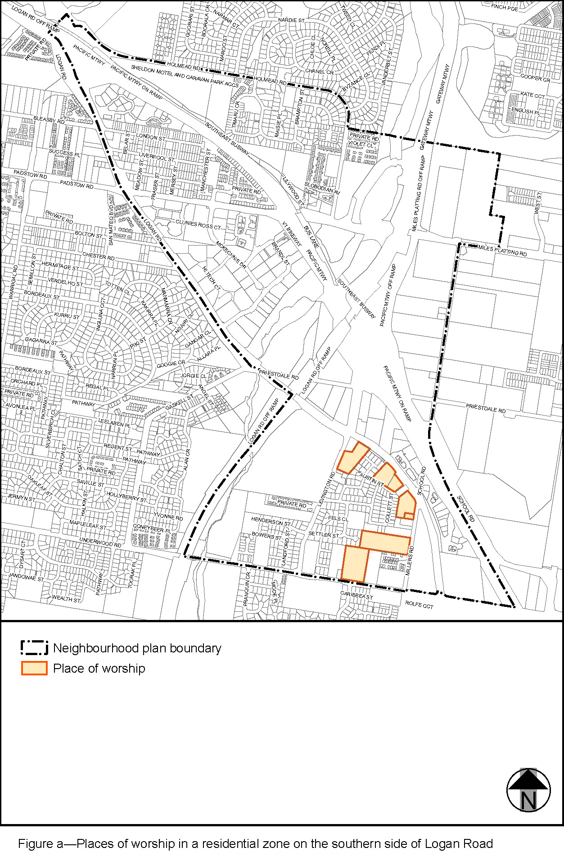

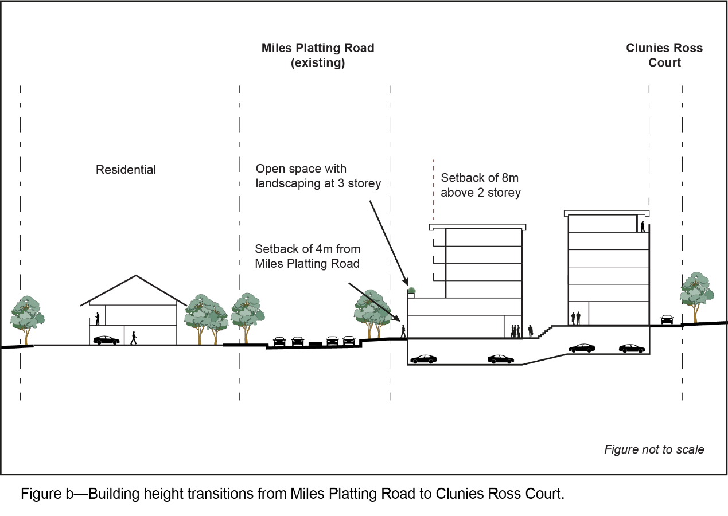
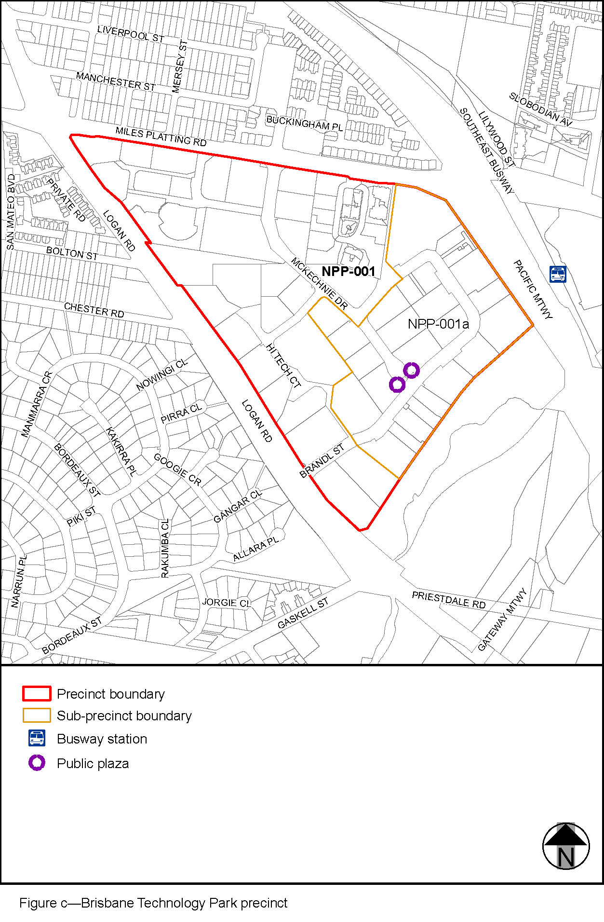

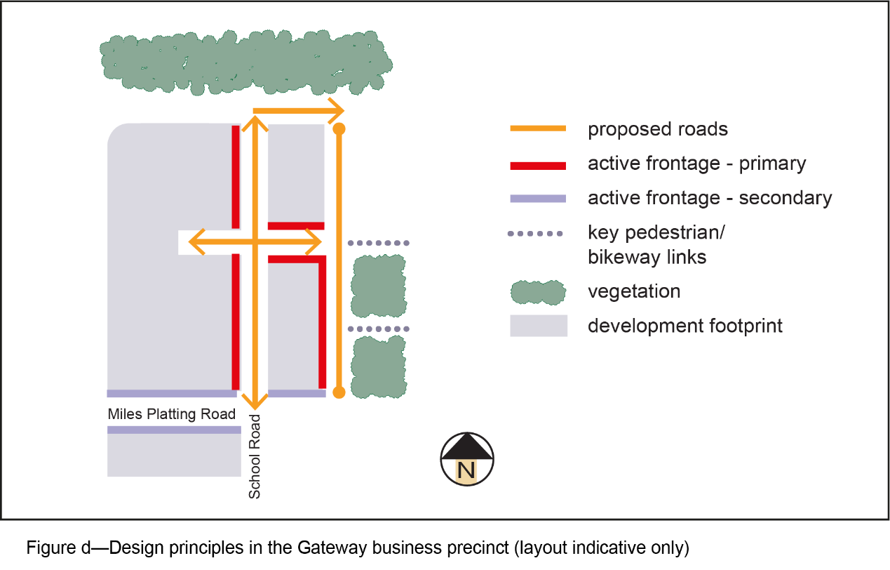

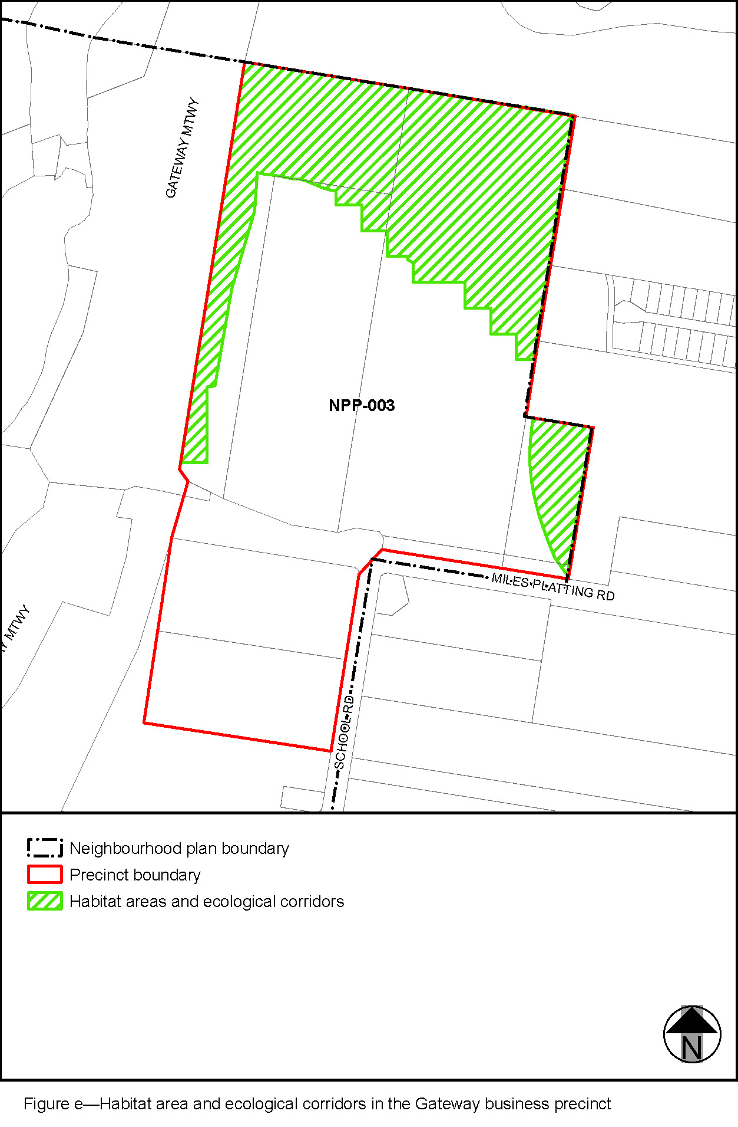
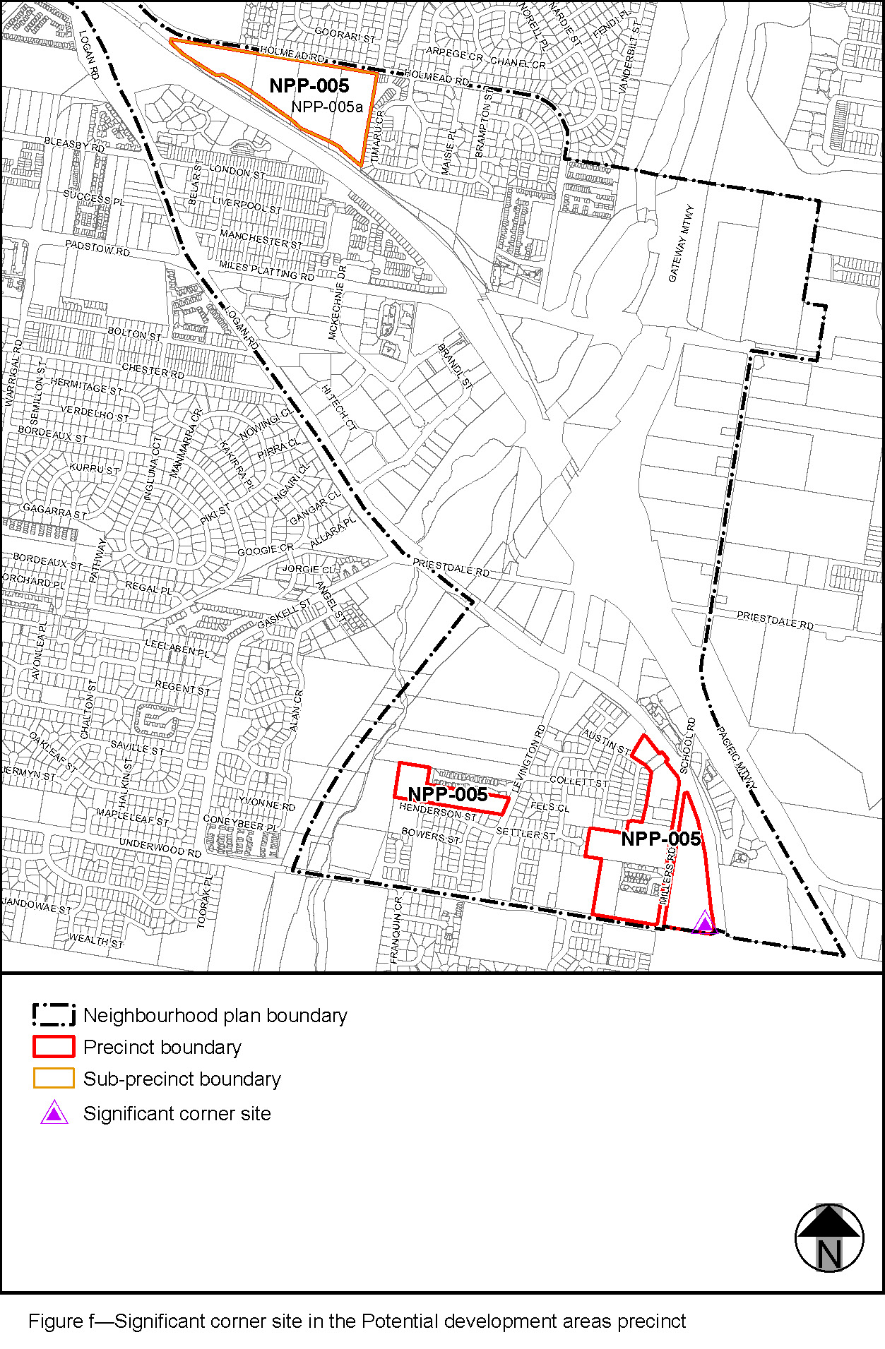

3.3 Amendment of section 7.2 (Neighbourhood plans)
- Section 7.2 Neighbourhood plan codes, 7.2.11.4 Kuraby neighbourhood plan code–
omit, insert:
‘

7.2.11.4 Kuraby neighbourhood plan code

7.2.11.4.1 Application
- This code applies to assessing a material change of use, reconfiguring a lot, operational work or building work in the Kuraby neighbourhood plan area if:
- assessable development where this code is an applicable code identified in the assessment benchmarks column of a table of assessment for a neighbourhood plan (section 5.9); or
- impact assessable development.
- Land in the Kuraby neighbourhood plan area is identified on the NPM-011.4 Kuraby neighbourhood plan map.
- When using this code, reference should be made to section 1.5, section 5.3.2 and section 5.3.3.
Note—The following purpose, overall outcomes, performance outcomes and acceptable outcomes comprise the assessment benchmarks of this code.
Note—This neighbourhood plan includes a table of assessment. Refer to Table 5.9.35.A, Table 5.9.35.B, Table 5.9.35.C and Table 5.9.35.D.

7.2.11.4.2 Purpose
- The purpose of the Kuraby neighbourhood plan code is to provide finer grained planning at a local level for the Kuraby neighbourhood plan area.
- The purpose of the Kuraby neighbourhood plan code will be achieved through overall outcomes.
- The overall outcomes for the neighbourhood plan area are:
- Development creates functional and integrated communities;
- Land subject to development constraints, character or environmental values indicated in Figure a or Figure b in this code or shown on an overlay map is protected from inappropriate development in order to maintain its character, natural and ecological significance;
- Open space, parks and recreational facilities meet the needs of the community and are located in accessible locations that are well connected within the neighbourhood plan area;
- Development in a potential development area addresses the location of the land, availability of services, environmental constraints, amenity, and existing patterns of development to ensure an integrated development outcome;
- Residential development identified in Figure a or Figure b provides for a mix of housing types, styles and densities, in particular:
- low density residential – dwelling houses: contains dwelling densities of between 10 and 15 dwellings per hectare;
- low density residential – dwelling houses and multiple dwellings: contains dwelling densities of up to 20 dwellings per hectare where between 400m and 800m of the Kuraby Railway Station or Fruitgrove Railway Station and is designed to ensure compatibility with the form and scale of detached housing;
- low–medium density residential – multiple dwellings: contains dwelling densities of up to 25 dwellings per hectare where within 400m of the Kuraby railway station or Fruitgrove railway station.
Note—Residential densities and yields are to be calculated excluding parts of the site that are not within a potential development area. These include areas with development constraints or character or environmental values identified in overlay maps. Yields and maximum gross floor area for multiple dwellings and dual occupancy are to be calculated across the potential development area including all access ways and roads respectively.
- Multiple dwellings are not accommodate in the Low density residential zone, including where in a potential development area.
- Development contiguous to the major electrical easement that passes through the Kuraby district is screened by appropriate planting.

7.2.11.4.3 Performance outcomes and acceptable outcomes

Table 7.2.11.4.3—Performance outcomes and acceptable outcomes
Performance outcomes | Acceptable outcomes
PO1  Development must protect biodiversity and landscape values and provide access along the public corridor. | AO1  Development that includes land within the Habitat areas and ecological corridors (public) as defined on Figure a and Figure b ensure that:  - the land is rehabilitated and stabilised in accordance with an approved rehabilitation plan;  - land is transferred to the Council for public ownership and included in the conservation zone;  - a road with a shared use (pedestrian and cyclist path) in an adjoining 6m wide verge is constructed within the Potential development area.

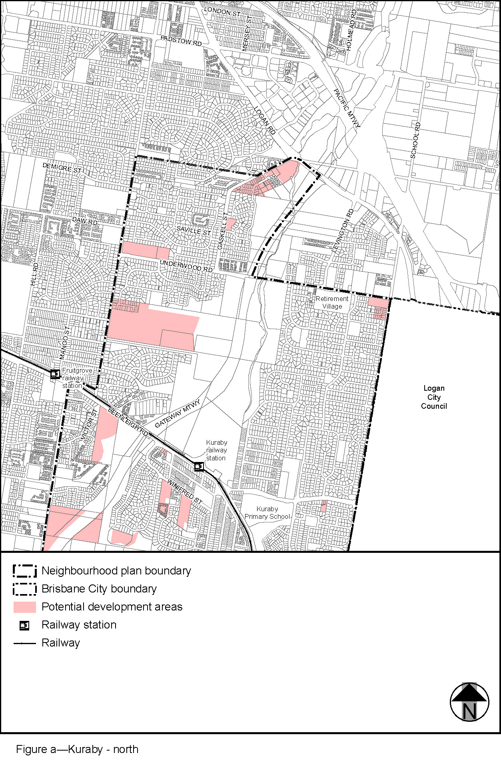
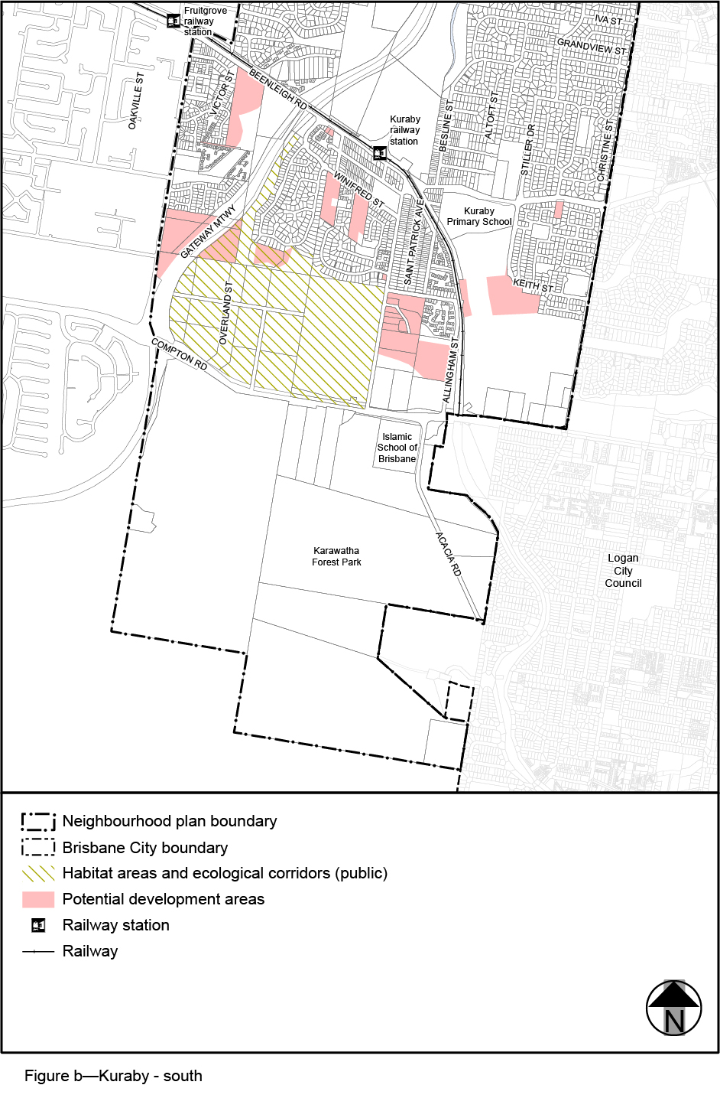
’.

3.4 Amendment of section 7.2 (Neighbourhood plan codes)
- Section 7.2 Neighbourhood plans, 7.2.18.4 Rochedale urban community neighbourhood plan code–
omit, insert:
‘

7.2.18.4 Rochedale urban community neighbourhood plan code

7.2.18.4.1 Application
      - This code applies to assessing a material change of use, reconfiguring a lot, operational work or building work in the Rochedale urban community neighbourhood plan area if:
- assessable development where this code is an applicable code identified in the assessment benchmarks column of a table of assessment for a neighbourhood plan (section 5.9); or
- impact assessable development.
      - Land within the Rochedale urban community neighbourhood plan area is identified on the NPM-018.4 Rochedale urban community neighbourhood plan map and includes the following precincts:
- Town centre precinct (Rochedale urban community neighbourhood plan/NPP-001);
- Neighbourhood centre and business service centre precinct (Rochedale urban community neighbourhood plan/NPP-002);
- Business park and gateway civic precinct (Rochedale urban community neighbourhood plan/NPP-003):
          - Business park sub-precinct (Rochedale urban community neighbourhood plan/NPP-003a);
          - Gateway civic sub-precinct (Rochedale urban community neighbourhood plan/NPP-003b).
- Future industry precinct (Rochedale urban community neighbourhood plan/NPP-004);
- Potential development area precinct (Rochedale urban community neighbourhood plan/NPP-005):
          - Very low density residential sub-precinct (Rochedale urban community neighbourhood plan/NPP-005a);
          - Low density residential sub-precinct (Rochedale urban community neighbourhood plan/NPP-005b);
          - Low–medium density residential sub-precinct (Rochedale urban community neighbourhood plan/NPP-005c);
          - Mixed use sub-precinct (Rochedale urban community neighbourhood plan/NPP-005d);
          - Proposed busway station sub-precinct (Rochedale urban community neighbourhood plan/NPP-005e);
          - Community uses sub-precinct (Rochedale urban community neighbourhood plan/NPP-005f).
      - When using this code, reference should be made to section 1.5, section 5.3.2 and section 5.3.3.
Note—The following purpose, overall outcomes, performance outcomes and acceptable outcomes comprise the assessment benchmarks of this code.
Note—This neighbourhood plan includes a table of assessment with variations to categories of development and assessment. Refer to Table 5.9.59.A, Table 5.9.59.B, Table 5.9.59.C and Table 5.9.59.D.

7.2.18.4.2 Purpose
      - The purpose of the Rochedale urban community neighbourhood plan code is to provide finer grained planning at a local level for the Rochedale urban community neighbourhood plan area.
      - The purpose of the Rochedale urban community neighbourhood plan code will be achieved through overall outcomes including overall outcomes for each precinct of the neighbourhood plan area.
      - The overall outcomes for the neighbourhood plan area are:
- The Rochedale urban community (‘Rochedale’) is developed as an integrated and master-planned urban community with a mix of uses. These include a range of residential, commercial, industrial and educational uses.
- Rochedale will mainly comprise residential areas in a series of neighbourhoods, each with a neighbourhood centre that acts as a focal point. There will be a mix of residential types, sizes, tenure and densities providing housing choice and affordability for all stages of the life cycle to meet diverse community needs. Affordable housing is encouraged through development bonuses. The interface between higher densities and lower densities is managed through building heights decreasing with increasing distance from centres and major roads.
- Multiple dwellings are not accommodated in the Low density residential zone, including where in a precinct.
- The range of commercial areas maximises the opportunities for local employment, to provide superior business settings and cluster compatible businesses and services.
- Koalas and their habitats are protected.
- Existing vegetation in parks is retained to provide amenity as well as retain elements of the Rochedale cultural landscape. Opportunity exists for the re-alignment of the local park to the south-east of the Rochedale Road and Ford Road intersection to include an existing mature orchard.
- Development incorporates innovative integrated water management strategies which contribute to making Rochedale water efficient.
- Core and fringe waterway corridors are located along the existing creek networks of Rochedale and provide for multifunctional uses. Through rehabilitation:
          - the core waterway corridor provides for water conveyance, protection of waterway health, wildlife movement, vegetation protection, urban amenity and low-impact recreation;
          - the fringe waterway corridor, located either side of the core waterway corridor and protecting the core waterway corridor from adverse impacts;
          - provides for pedestrian/cycle movement, essential infrastructure and where shown, local parks.
- Where safe traffic operation allows, direct lot access will be encouraged to create active frontages and social interaction, streetscape amenity and safety. Direct lot access is not appropriate on the major roads.
- The focus of the public transport system in Rochedale will be the Town centre precinct (Rochedale urban community neighbourhood plan/NPP-001). However, the further development of the South East Busway is likely to create a new busway station on Underwood Road. This will provide an opportunity for the surrounding community to receive a much higher level of service.
- Land to the east of Rochedale around Ford Road, Alperton Road and Kloske Road supports valued wildlife. The road network must be designed to direct through-traffic away from this area.
- The enhancement of movement system connectivity between Rochedale and communities to the west is to be considered in future movement system planning for the area. In particular, improved public and active transport connections are strongly encouraged. Enhancements to the general road system will focus on improving network efficiency and capacity along existing road corridors such as Mt Gravatt-Capalaba Road and Miles Platting Road.
- New infrastructure will be provided to the neighbourhood plan area in accordance with Council's Local government infrastructure plan.
- The long-term intention for the landfill site is for it to continue operation. Options for the site following the end of landfill activities include a metropolitan park.
- Development is of a height, scale and form which is consistent with the amenity and character, community expectations and infrastructure assumptions intended for the relevant precinct, sub-precinct or site and is only developed at a greater height, scale and form where there is both a community need and an economic need for the development.
      - Town centre precinct (Rochedale urban community neighbourhood plan/NPP-001) overall outcomes are:
- The Town centre precinct is the main commercial centre for the Rochedale community and is to have the role and function consistent with the District centre zone. It is the central location for retail, community, business and commercial uses in Rochedale. The town centre will contain at least 1 supermarket and supporting shops, as well as business or office uses. Additional facilities, such as for health care service and gymnasium, are encouraged to locate within the precinct, providing residents with local services as well as adding to the centre’s vitality.
- The precinct provides centrally located bus stops and will be the focus of active and public transport in Rochedale. Residential development is supported and affordable housing is encouraged.
- The town centre itself has a sense of place featuring a town square, flanked by buildings with community facilities, and, food and drink outlets, with a strong link to a town park and nearby waterway corridor. The town centre may be developed in stages until the ultimate development is realised.
- The town centre is a compact centre with active streetscapes and pedestrian environments and is not dominated by parking. It provides clear access including a town centre main street, vistas and focus to the nearby town park and waterway corridor to the west of the town centre. Refer to Figure c, Figure d and Figure e which reflect the design principles for how the town centre should ultimately develop. These include the relationship between the town park, community facilities and surrounding uses, the location of active frontages and the function and format of the main street.
- Through traffic is discouraged from using the main streets by appropriate measures that limit vehicle speed and restrict the road to 2 lanes of moving traffic. The provision of landscaping and kerbside parking assists in achieving a pedestrian-friendly main street. All car parking is accessed via internal town centre roads, not from Miles Platting Road or Gardner Road.
- The town square is the pre-eminent civic space within Rochedale and will perform a vital role in facilitating community interaction. The town square is a versatile space which allows for a variety of uses such as community markets and gatherings.
- Unrestricted community access is required to promote a sense of community ownership. To achieve this outcome, the town square should be dedicated to the Council for public ownership.
      - Neighbourhood centre and business service centre precinct (Rochedale urban community neighbourhood plan/NPP-002) overall outcomes are:
- These centres are located to best service the convenience needs of the surrounding community. Figure a indicates the location for these centres and allows flexibility in siting where 2 corner locations are shown. One of the corner sites is developed as a single, consolidated centre. The remaining corner site is developed in character with the adjoining land uses. The maximum gross floor area of each neighbourhood and business service centre is 1,500m². Full-line supermarkets (greater than 1,000m² or more than one supermarket activity), discount department stores and retail/bulky goods warehousing are not consistent with the outcomes sought for this precinct.
- These centres provide strong links with the pedestrian and cycle networks and parks (where applicable) and surrounding residential precincts. Parks that adjoin a centre provide a focus and orientation for the centre.
- Neighbourhood centres, as identified in Figure a, are small convenience centres that provide local services to the surrounding residential neighbourhoods. These services include shops, restaurants and supporting community uses and childcare facilities. The neighbourhood centres have the role and function consistent with a Neighbourhood centre zone.
- Business service centres, as identified in Figure a, are small convenience centres that provide local services to the surrounding business community. These services include small food outlets, support office uses for businesses and limited retail. Childcare facilities are not considered compatible with these centres because of their close proximity to the landfill site.
- Impact assessable uses that are consistent with the outcomes sought for the precinct include:
          - centre activities (excluding childcare centre in a business service centre);
          - multiple dwellings.
- Impact assessable uses that are not consistent with the outcomes sought for the precinct include a childcare centre in a business service centre.
      - Business park and gateway civic precinct (Rochedale urban community neighbourhood plan/NPP-003) overall outcomes are:
- This precinct accommodates specialised employment opportunities within Rochedale.
- Business park sub-precinct (Rochedale urban community neighbourhood plan/NPP-003a):
          - This sub-precinct forms a buffer area between the Rochedale landfill, the future industry area and residential areas. It accommodates high amenity and low impact industry. Ancillary uses such as cafes are consistent with the outcomes sought. Stand-alone office or retail uses are not consistent with the outcomes sought.
          - A function facility is encouraged, adjoining the business service centre and waterway.
          - Stand-alone childcare centre facilities are not considered compatible due to the sub-precinct’s proximity to the landfill site. However, small-scale childcare facilities that can provide adequate space and equipment to allow active play may be supported where they are ancillary to and integrated with an industry use on the same site.
- Gateway civic sub-precinct (Rochedale urban community neighbourhood plan/NPP-003b):
          - This sub-precinct is in a visible location near the motorways and has signature buildings that act as a gateway into Rochedale. It accommodates offices and related educational facilities. This is the only sub-precinct where a service station is appropriate.
- Impact assessable uses that are consistent with the outcomes sought for this precinct include:
          - if in the Business park sub-precinct (Rochedale urban community neighbourhood plan/NPP-003a):
      - function facility;
      - educational establishment where a technical institute;
      - childcare centre where integrated with an industry on the same site and catering for workers on the site;
      - service industry;
      - warehouse;
      - telecommunications facility where any tower is located 30m from the site boundary of a dwelling house or land included in Low density residential.
          - a service station if in the Gateway civic sub-precinct (Rochedale urban community neighbourhood plan/NPP-003b).
- Impact assessable uses that are not consistent with the outcomes sought for this precinct include an office if in the Business park sub-precinct.
      - Future industry precinct (Rochedale urban community neighbourhood plan/NPP-004) overall outcomes are:
- Waterway corridors are rehabilitated upon development of a site.
- It is anticipated that low impact industry to medium impact industry will locate on this site.
- Development provides a recreation space appropriate for use by the site’s worker population.
- Development takes into consideration the site’s proximity to Bulimba Creek and its strategic role in forming part of the north–south fauna corridor.
Note—A structure plan is to be prepared in accordance with the Structure planning planning scheme policy for industrial development.
      - Potential development area precinct (Rochedale urban community neighbourhood plan/NPP-005) overall outcomes are:
- Very low density residential sub-precinct (Rochedale urban community neighbourhood plan/NPP-005a):
          - This sub-precinct comprises predominantly dwelling houses located to protect and strengthen the ecological values of the precinct.
          - Land in this sub-precinct will have a yield of 5 dwellings per hectare and a minimum lot size of 2,000m².
          - Reconfiguration to create smaller lots may be supported where it can be demonstrated that a better ecological outcome will be achieved and provided that the semi-rural, open space character of the area will not be compromised.
          - Impact assessable uses that are not consistent with the outcomes sought for this sub-precinct include:
          - multiple dwelling;
          - reconfiguring of lots less than 2,000m².
- Low density residential sub-precinct (Rochedale urban community neighbourhood plan/NPP-005b):
          - This sub-precinct predominantly comprises a mix of lot sizes for detached dwelling houses with a yield of 14 dwellings per hectare.
          - Land located adjoining the low–medium density residential potential development area, within a 400m walkable catchment of local neighbourhood centres lot boundaries or facing onto local parks, will support multiple dwellings with a yield of 16 dwellings per hectare.
          - Affordable housing is encouraged.
          - Impact assessable uses that are consistent with the outcomes sought include multiple dwellings (where complying with AO21), except where in the Low density residential zone.
- Low-medium density residential sub-precinct (Rochedale urban community neighbourhood plan/NPP-005c):
          - This sub-precinct comprises a mix of dwelling houses and multiple dwellings at a yield of 16-25 dwellings per hectare. Multiple dwellings are not accommodated in the Low density residential zone.
          - Aged-care accommodation and affordable housing will be supported near neighbourhood centres and the town centre.
- Mixed use sub-precinct (Rochedale urban community neighbourhood plan/NPP-sub-005d):
          - This sub-precinct comprises predominantly higher density multiple dwellings located around the Town centre precinct, neighbourhood centres and busway stations. Multiple dwellings are not accommodated in the Low density residential zone.
          - Some small-scale commercial activities will be acceptable, where they are compatible with the residential nature of the area. These commercial uses will be on the ground and lower levels of a multiple dwelling, or may be accommodated within the same site in a separate building.
          - Affordable housing is encouraged.
          - The Mixed use sub-precinct at Underwood Road and at the intersection of Miles Platting Road and Rochedale Road has a yield of 40 dwellings per hectare.
          - The Mixed use sub-precinct around the Town centre precinct (Rochedale urban community local plan/NPP-001) has a yield of 50 dwellings per hectare.
- Proposed busway station sub-precinct (Rochedale urban community neighbourhood plan/NPP-005e):
- This sub-precinct is intended to accommodate a future busway station. Some commercial development, primarily serving the convenience needs of busway patrons, is considered compatible as part of the initial development of the land for a busway station. The preferred longer term development option is for an integrated mixed use precinct incorporating a component of retail, higher density residential, including elements of affordable housing, and high-quality office uses. Full-line supermarkets (greater than 1,000m² or more than one supermarket activity), discount department stores and retail/bulky goods warehousing are not consistent with the outcomes sought for this precinct.
- Development in the community uses sub-precinct (Rochedale urban community neighbourhood plan/NPP-005f):
- Supports the existing community uses located on Rochedale Road to create the opportunity to provide a strong community and educational precinct. The additional land adjoining Redeemer Lutheran College allows uses such as schools, training, community facilities and childcare centre facilities.
- Integrates community uses with the town centre to provide uses such as public meeting places, public halls and a youth activity centre and a childcare centre.
- Encourages the retention and use of the existing community facilities for a range of uses.

7.2.18.4.3 Performance outcomes and acceptable outcomes
Table 7.2.18.4.3.A—Performance outcomes and acceptable outcomes
Performance outcomes | Acceptable outcomes
General
Development is of a height, scale and form that achieves the intended outcome for the precinct, improves the amenity of the neighbourhood plan area, contributes to a cohesive streetscape and built form character and is:  - consistent with the anticipated density and assumed infrastructure demand;  - aligned to community expectations about the number of storeys to be built;  - proportionate to and commensurate with the utility of the site area and frontage width;  - designed to avoid a significant and undue adverse amenity impact to adjoining development;  - sited to enable existing and future buildings to be well separated from each other and to avoid affecting the potential development of an adjoining site.  Note—Development that exceeds the intended number of storeys or building heights can place disproportionate pressure on the transport network, public space or community facilities in particular.  Note—Development that is over-scaled for its site can result in an undesirable dominance of vehicle access, parking and manoeuvring areas that significantly reduce streetscape character and amenity. | AO1  Development complies with the number of storeys and building height in Table 7.2.18.4.3.B.  Note—Neighbourhood plans will mostly specify the maximum number of storeys where zone outcomes have been varied in relation to building heights. Some neighbourhood plans may also specify the height in metres. Development must comply with both parameters where maximum number of storeys and height in metres are specified.
Development protects significant existing vegetation. | AO2  No acceptable outcome is prescribed.
Development avoids interim conflicts with nearby agricultural uses. | AO3  Development does not occur within 500m of poultry sheds until the operation ceases.
Development protects koala habitat within the neighbourhood plan area. | AO4.1  Development including the development footprint and roads does not adversely impact on koalas or their habitat.  Note—A tree survey plan can assist in demonstrating compliance. Guidance on koala habitat, completing a tree survey and designing development to protect koalas, is included in the Biodiversity areas planning scheme policy.
AO4.2
Development including the development footprint, design and layout:
  - protects non-juvenile koala habitat trees;
  - maximises the size and consolidates areas to be conserved as koala habitat on-site and in combination with adjoining sites;
  - maximises connectivity between non-juvenile koala habitat trees which will be conserved on site and with adjoining sites;
  - excludes filling or excavation from the tree protection zone of non-juvenile koala habitat trees.
AO4.3
Development incorporates koala habitat trees in landscaping and open space areas.
Note—Guidance on koala habitat trees in Brisbane is provided in the Biodiversity areas planning scheme policy.
Development design and layout facilitates the safe movement of koalas through the landscape. | AO5  Development, if including fencing or other barriers (including during construction phase), is designed:  - to allow safe koala movement where there is direct threat of injury or death to koalas from incompatible land use activities;  - to exclude koalas from areas containing domestic or security dogs.  Note—Refer to the Queensland Government Koala Safety Fencing and Measures Guideline for further guidance.
Development protects, restores and secures habitat areas and ecological corridors as shown in Figure a. | AO6.1  Development, if including fencing:  - enables the unobstructed movement of fauna to outside the corridor;  - enables the unobstructed movement of fauna within the corridor.
AO6.2
Development, if the site includes land within the Habitat areas and ecological corridors (public) shown in Figure a:
  - the habitat area and ecological corridor is rehabilitated and stabilised in accordance with an approved rehabilitation plan;
  - at the completion of rehabilitation, the land is transferred to Council for public ownership and included in the Conservation zone.
Note—Council will require the submission of a rehabilitation plan to demonstrate achievement of this outcome. Rehabilitation is to be:
- completed within 1 year of the operational works approval being granted;
- maintained for a minimum of 3 years, removing rubbish and weeds, replacing damaged and dead vegetation and managing erosion.
AO6.3
Development, if the site includes land within the habitat areas and ecological corridors (private) shown in Figure a:
  - the habitat area and ecological corridor is rehabilitated and stabilised in accordance with an approved rehabilitation plan;
  - land is secured with covenants or other long-term management agreements as a condition of development approval to ensure the protection of vegetation within the corridor.
Note—Council will require the submission of a rehabilitation plan to demonstrate achievement of this outcome. Rehabilitation is to be:
- completed within 1 year of the operational works approval being granted;
- maintained for a minimum period of 3 years, removing rubbish and weeds, replacing damaged and dead vegetation and managing erosion.
If in the Potential development area precinct (Rochedale urban community neighbourhood plan/NPP-005)
Development of new lots demonstrates that they are suitable to accommodate a range of housing. | AO7.1  Development where house lots are smaller than 400m² demonstrates that:  - a 9m x 15m building envelope can be contained within the lot;  - not more than 10 lots smaller than 400m² adjoin each other where fronting the same street;  - no lot is less than 300m².
AO7.2
Development in the Low density residential sub-precinct (Rochedale urban community neighbourhood plan/NPP-005b) and the Low–medium density residential sub-precincts (Rochedale urban community neighbourhood plan/NPP-005c) achieves a mix of residential lot sizes to encourage different forms of housing choice.
Development provides infrastructure to encourage the rollout of high-speed broadband networks. | AO8  Development provides all lots with high-speed telecommunications infrastructure in accordance with the Infrastructure design planning scheme policy.
Development for a sensitive use or in a sensitive zone or zone precinct is protected from noise from major roads in a manner that does not compromise streetscape amenity and vitality. | AO9  Development of residential uses along suburban routes incorporates suitable facade treatment to mitigate adverse noise impacts.  Note—Council will not support acoustic fencing along suburban routes.
Development provides public parkland on a site or a number of sites that:  - is of a sufficient cumulative area to adequately cater for the recreation needs of the development and the Rochedale community;  - is of a sufficient area and dimensions to cater for a broad range of passive and active recreation activities;  - is distributed to be within a comfortable walking distance of the majority of dwellings;  - is located to protect and optimise valuable landscape features, including the features identified in Table 7.2.18.4.3.C and view corridors;  - has a minimum road frontage of approximately 50%. | AO10.1  Development that includes a district sports park:  - is provided in accordance with the Local government infrastructure plan;  - incorporates sporting facilities such as playing fields as well as ancillary buildings, including club houses, changing facilities and meeting rooms;  - protects the valuable features identified in Table 7.2.18.4.3.C.
AO10.2
Development that includes a district recreation park:
- is provided in accordance with the Local government infrastructure plan;
- provides opportunities for recreation activities;
- protects the valuable features identified in Table 7.2.18.4.3.C.
AO10.3
Development that includes a local recreation park:
- is provided in accordance with the Local government infrastructure plan;
- provides opportunities for recreation activities;
- protects the valuable features identified in Table 7.2.18.4.3.C.
Development provides stormwater management infrastructure that is:  - integrated with other urban infrastructure or located on privately owned open space; or  - located in a suitable public park or fringe waterway corridor and does not reduce the utility, amenity or function of public parkland. | AO11  Development includes stormwater management infrastructure that is:  - provided in privately owned land; or  - located in fringe waterway corridor; or  - located in public parkland only where:  - the park comprises an area of at least 1 hectare;  - it does not result in the removal or interference with the valuable features identified in Table 7.2.18.4.3.C;  - it does not occupy more than 5% of the total land surface;  - it does not reduce the range of quality of recreational opportunities available in the park;  - it incorporates landscaping consistent with the character of the public park.
Development of the public road network:  - is of sufficient capacity to cater for anticipated travel demand;  - is highly interconnected;  - maintains the integrity of the traditional main road grid formed by Rochedale Road, Gardner Road, Miles Platting Road, Underwood Road and Priestdale Road;  - respects local landscape features such as topography and waterways;  - is of a sufficient width to incorporate water sensitive urban design, pedestrian and cyclist paths, on-road car parking and street tree planting;  - caters for and integrates pedestrian and cyclist facilities;  - is designed and constructed so as not to adversely affect permeability of efficient transport services including both active and passenger transport considerations;  - promotes the efficient provision of bus and other public transport infrastructure;  - directs through traffic away from ecologically sensitive areas to the east of Rochedale;  - facilitates active streetscapes and casual surveillance of public parks. | AO12.1  Development ensures that roads border at least 75% of the perimeter of local recreation parks.
AO12.2
Development along suburban routes ensures that:
- direct lot access is not provided;
- rear access lanes are provided behind allotments.
AO12.3
Development allows for road construction within the fringe waterway corridor only where the waterway corridor adjoins a potential development area.
AO12.4
Development of roads does not occupy more than 80% of the fringe waterway corridor.
Development protects and enhances the function, water conveyance and water quality of the fringe waterway corridors. | AO13.1  Development provides fringe corridors 10m wide as shown in Figure b (the fringe corridor is located on one or both sides of the waterway corridor as indicated on the Waterway corridors overlay).
AO13.2
Development on a site containing a private waterway corridor, as shown in Figure b, retains the waterway corridor in private ownership and uses easements and covenants to accommodate stormwater flows.
Development must integrate water supply, waterway corridor, wastewater and stormwater management to ensure protection of the water cycle by:  - minimising water demand;  - minimising discharge and infiltration to public sewerage infrastructure;  - slowing the movement of water through the landscape;  - maximising surface water infiltration;  - minimising wastewater production;  - minimising impacts on the water cycle;  - minimising flooding impacts including no adverse impact on the flood immunity of the Gateway and Pacific motorways;  - protecting waterway health by improving stormwater quality and reducing site run-off;  - incorporating water re-use infrastructure to maximise recycling opportunities;  - minimising the extent of continuous impervious surfaces;  - using alternative water sources via the construction of a reticulated non drinking water network.  Note—Refer to Figure i, Figure j and Figure k which are examples of how water sensitive design principles can be incorporated into road reserves, commercial and residential developments and waterways.  Note—The designated rainwater tank area is the area shown within the neighbourhood plan boundary in Figure a. | AO14.1  Development demonstrates effective management of the water cycle by submitting for approval, at the development application stage, a site-based integrated water management plan that includes provisions for the following water sensitive urban design measures:  - NuSewer welded PE sewers;  - reticulated non-drinking water system with a connection to the western corridor recycled water pipeline is supplied to each lot;  - biofiltration pods;  - bioretention systems;  - on-site infiltration/porous pavements;  - conveyance and non-conveyance bioretention systems;  - filter/buffer strips;  - water-efficient landscaping.  Note—The integrated water management plan is to include details of the proposed measures, when they are to be in place, how they are to be implemented (such as conditions on development, covenants) and who will implement and maintain them.
AO14.2
Development occurring in a potential development area provides and connects to a reticulated non-drinking water network supplied by purified recycled water from the western corridor recycled water pipeline that is then connected to:
  - fire hydrants and fire service;
  - outdoor hose connections via below-ground quick-coupling valves for use on:
    - landscaped areas;
    - public and private parks, gardens, landscaped areas and recreation areas;
    - wash-down areas;
    - other uses where appropriate in preference to potable water.
AO14.3
Development provides a site-based stormwater management plan demonstrating compliance with the Stormwater code and the provisions in the Infrastructure design planning scheme policy.
AO14.4
Development demonstrates compliance with regards to stormwater impacts and measures on the Gateway Motorway and Pacific Motorway in accordance with the Infrastructure design planning scheme policy and the Main Roads Road Drainage Manual.
Development incorporates consistent, formalised street planting along roads by:  - defining and enclosing public space;  - enhancing landscape amenity;  - promoting a sense of place for Rochedale;  - providing shade for pedestrian and parked vehicles. | AO15  Development incorporates consistent, regularly spaced street tree plantings of species, along all roads and are selected from the Planting species planning scheme policy list.  Note—For an application for reconfiguring a lot, the Council will require the submission of a street tree planting plan and schedule that demonstrates compliance.
If reconfiguring a lot in the Potential development area precinct (Rochedale urban community neighbourhood plan/NPP-005), where in the Very low density residential sub-precinct (Rochedale urban community neighbourhood plan/NPP-005a)
Development protects and strengthens the ecological values of the precinct while maintaining a semi-rural character. | AO16.1  Development includes a minimum lot size of 2,000m².  Note—Smaller lot sizes may be supported for ecologically sensitive development that retains a semi-rural character and protects and strengthens the ecological values of the precinct.
AO16.2
Development and subdivision layouts are designed to protect and strengthen significant vegetation and koala habitat linkages.
If for a multiple dwelling, where not in the Low density residential zone
Development incorporates landscaping that facilitates sustainable subtropical design by providing:  - sufficient space for the retention and/ or establishment of significant substantial vegetation;  - locally appropriate plant species in accordance with the Planting species planning scheme policy;  - hard-scape/paving design and materials that minimise heat reflection and site run-off;  - appropriate seasonal shade and passive cooling/heating of outdoor spaces throughout the year;  - private open space located to maximise indoor/outdoor connections;  - design and plant selection to minimise water use and contribute to stormwater management. | AO17.1  Development provides a minimum 40% of the site area as open space with a minimum dimension of 3m, with half of the open space dedicated to deep planting with a minimum dimension of 6m.
AO17.2
Development includes plant species in accordance with the Planting species planning scheme policy.
Development involving dual occupancy buildings has the appearance of a single detached house. | AO18.1  Development is located on a lot with a minimum total site area of 800m².
AO18.2
Development is located on a lot with a minimum average lot width of 20m.
AO18.3
Development has a maximum site cover of:
  - 60% for a site with a site area of less than 1,000m²;
  - 50% for a site with a site area of 1,000m² or greater.
AO18.4
Development of dual occupancy dwellings, where provided side by side, share a wall for at least 50% of the total building length.
Development distributes dual occupancies to be subordinate to single, detached houses within the landscape. | AO19.1  Development does not include more than 10% of sites for dual occupancy development.
AO19.2
Development does not include dual occupancies that border another site occupied or subject to a current approval for a dual occupancy except where 2 corner sites share a boundary, provided that the number of dual occupancies fronting a single intersection does not exceed 2.
If for a multiple dwelling in the Potential development area precinct (Rochedale urban community neighbourhood plan/NPP-005), where in the Low density residential sub-precinct (Rochedale urban community neighbourhood plan/NPP-005b) and where not in the Low density residential zone
Development of multiple dwellings is:  - co-located with land designated for increased residential densities; or  - located within a comfortable walking distance of a centre; or  - integrated with a local park. | AO20  Development of multiple dwellings is located:  - adjoining land in the Low-medium density residential sub-precinct (Rochedale urban community neighbourhood plan/NPP-005c); or  - within 400m of a neighbourhood centre lot boundary; or  - directly overlooking a district recreation or local recreation park.
If in the Potential development area precinct (Rochedale urban community neighbourhood plan/NPP-005), where in the Mixed use sub-precinct (Rochedale urban community neighbourhood plan/NPP-005d)
Development is primarily for residential uses. | AO21  Development of residential uses comprises a minimum of 70% of the gross floor area of the overall development for all buildings on a site.
Development limits conflict between residential and non-residential activity. | AO22.1  Development includes minimum lot sizes of:  - 1,600m² for mixed use buildings; or  - 800m² and a minimum frontage of 20m for multiple dwellings.
AO22.2
Development of non-residential uses must be designed and constructed to attenuate and minimise noise impacts to on-site or adjoining residential uses.
AO22.3
Development provides separate pedestrian entries for the residential and non-residential components of the development.
Development of mixed use buildings orientates commercial uses to the street to encourage active street frontages, including an adaptable ground storey to allow maximum flexibility in accommodating different uses such as centre activities in the future. | AO23.1  Development includes commercial uses located on the ground storey and lower floors on or near the street.
AO23.2
Development provides a minimum floor-to-ceiling height of 4.2m for ground-storey uses.
If in the Potential development area precinct (Rochedale urban community neighbourhood plan/NPP-005), where in the Mixed use sub-precinct (Rochedale urban community neighbourhood plan/NPP-005d) around the town centre and near the intersection of Gardner Road and Miles Platting Road
Development is in keeping with the higher density character of the sub- precinct and buildings emphasise corners, vistas and create interest in the streetscape.  Affordable housing is also encouraged through development bonuses.  Note—Refer to design principles contained in Figure c, Figure d and Figure e. | AO24  Development complies with gross floor area as set out in Table 7.2.18.4.3.B.
If in the Potential development area precinct (Rochedale urban community neighbourhood plan/NPP-005), where in the Mixed use sub-precinct (Rochedale urban community neighbourhood plan/NPP005d) at Underwood Road, School Road and the intersection of Miles Platting Road and Rochedale Road
Development:  - is in keeping with the medium density character of the sub-precinct;  - buildings emphasise corners, vistas and create interest in the streetscape;  - affordable housing is also encouraged through development bonuses. | AO25  Development complies with the gross floor area as set out in Table 7.2.18.4.3.B.
If in the Town centre precinct (Rochedale urban community neighbourhood plan/NPP-001)
Development including building siting, road network, access, parking, servicing, public spaces and mix of uses creates a sense of place, identity and vibrancy for the Rochedale town centre. | AO26  Development contributes towards the ultimate development of the Town centre precinct generally in accordance with the design principles contained in Figure c, Figure d and Figure e.
Development incorporates adequate land to ensure the structure and design outcomes of the Town centre precinct are secured. | AO27  Development is a minimum area of 5 hectares.  Note—This provision does not apply to the subdivision of existing or approved buildings.
Development supports the town centre's role and function by:  - reflecting its role in the Rochedale area as a Corridor zone precinct of the District Centre zone;  - recognising the primacy of Upper Mt Gravatt and Springwood;  - not challenging the primacy of Upper Mt Gravatt as the major centre for the southern part of Brisbane City. | AO28  Development does not exceed the total amount of retail gross floor area within the town centre of 14,500m².  Note—Council will request the submission of an economic analysis for any application that proposes a retail gross floor area in excess of this amount.
Development of non-residential uses is the primary form of development. | AO29  Development of non-residential centre activities comprises a minimum 70% of the gross floor area of the overall development for all buildings on a site.
Development including building siting and design:  - is consistent with the higher density, urban character of the town centre;  - promotes a vibrant active streetscape and public realm;  - emphasises corners and vistas and creates visual interest in the streetscape. | AO30  Development complies with the gross floor area as set out in Table 7.2.18.4.3.B.
Development in the town centre contains clear and direct view lines and pedestrian connections to adjoining buildings, squares and neighbourhoods. | AO31.1  Development provides pedestrian links between all road frontages, major activities and features of the town centre.
AO31.2
Development provides direct lines of sight between the town square, main street and surrounding residential neighbourhoods where possible.
Development is designed with an adaptable ground storey to allow maximum flexibility in accommodating different uses in the future including non-residential uses. | AO32  Development provides a minimum floor-to-ceiling height of 4.8m for the ground storey.
Development of the town square and main street provides an urban environment that supports active uses on its fringes, meeting places, places of interest and comfortable and accessible pedestrian movement and activity. | AO33.1  Development and design of buildings, pathways, landscaping, public spaces and parking integrates the centre and park and facilitates causal surveillance of the town centre by:  - maximising pedestrian entrances of buildings and windows orientated towards the town square and main street;  - ensuring pedestrian walkways are sheltered with awnings that protrude from buildings into these public open spaces;  - ensuring at least 80% of ground-storey frontages are occupied by ‘active’ uses, such as community facilities, retail, sales and restaurants, and that outdoor dining facilities are located immediately adjacent to the town square.
AO33.2
Development discourages through traffic from using the main street by limiting vehicle speed by:
  - restricting the street to 2 lanes of moving traffic;
  - providing kerbside parking interspersed with shade trees;
  - providing pedestrian crossings at regular intervals which may include other road textures.
Note—The Council considers the above measures preferable to traditional traffic calming measures.
If in the Neighbourhood centre and business service centres precinct (Rochedale urban community neighbourhood plan/NPP-002)
Development within a neighbourhood centre:  - reflects the scale and type of development intended for these precincts;  - supports residential development and commercial and retail development;  - does not comprise mixed use development. | AO34.1  Development of non-residential gross floor area within a neighbourhood centre does not exceed 1,500m².  Note—The total amount of non-residential gross floor area excludes community uses and childcare centre.
AO34.2
Development complies with the gross floor area as set out in Table 7.2.18.4.3.B.
Development within a business service centre:  - reflects the scale and type of development intended for the business service centre and business park areas;  - supports commercial, retail and light industrial development;  - does not compromise residential development. | AO35.1  Development within a business service centre does not exceed the total cumulative amount of 1,500m² of gross floor area.
AO35.2
Development complies with the gross floor area as set out in Table 7.2.18.4.3.B.
If in the Town centre precinct (Rochedale urban community neighbourhood plan/NPP-001) or the Business park and gateway civic precinct (Rochedale urban community neighbourhood plan/NPP-003)
Development orientation integrates with the district park. | AO36  Development locates windows, outlook, staff amenities (such as decks or balconies) to directly overlook the district park.
Development design:  - reflects the scale of development intended for the precinct;  - reduces the appearance of scale and bulk of the development through massing and articulation. | AO37  Development complies with gross floor area as set out in Table 7.2.18.4.3.B
If in the Business park and gateway civic precinct (Rochedale urban community neighbourhood plan/NPP-003), where in the Gateway civic sub–precinct (Rochedale urban community neighbourhood plan/NPP-003b)
Development siting, road network, access, car parking, servicing, public spaces and mix of uses create a sense of place, identity and vibrancy for the Gateway civic sub-precinct. | AO38  Development in the Gateway civic sub-precinct is in accordance with the design principles contained in Figure c.
Development size and scale reflects the role of the Gateway civic sub-precinct as an entry precinct to Rochedale. | AO39  Development complies with gross floor area as set out in Table 7.2.18.4.3.B.
Development is designed to mitigate impacts on the values of adjoining habitat areas and ecological corridors. | AO40  Development incorporates sensitive design measures to mitigate adverse impacts on habitat areas and ecological corridors such as buffer planting, appropriate setbacks and fencing.
If in the Future industry precinct (Rochedale urban community neighbourhood plan/NPP-004)
Development ensures building design, landscaping and car parking reflect the site’s visible location adjacent to the Gateway Motorway and as an entry point to Rochedale. | AO41.1  Development provides a landscaped strip with a minimum width of 6m along all road frontages.
AO41.2
Development site cover does not exceed 75% of the site area.
AO41.3
Development consolidates car parking areas into parking courts internal to the site.

7.2.18.4.3.B—Maximum building height and gross floor area
Development | Building height (number of storeys) | Building height (m) | Maximum gross floor area
If in the Town centre precinct (Rochedale urban community neighbourhood plan/NPP-001)
Development other than a supermarket | 2 minimum – 4 maximum | 9.5m minimum – 15m maximum | 150% of the site area
Development other than a supermarket | Note—Development may be increased to a maximum of 6 storeys, 20m building height and 180% gross floor area if:  - the building has 2 street frontages and is located in 1 corner of a lot forming the apex of a road intersection or street corner; or  - it incorporates community facilities; or  - at least 10% of the total number of proposed dwellings is affordable housing.  Note—The cumulative total retail gross floor area within the town centre does not exceed 14,500m².
Supermarket | 2 minimum – 4 maximum | 9.5m minimum – 15m maximum | Not specified
Supermarket | Note—No minimum building height or number of storeys applies to development for a supermarket if:  - it is designed and sited in a manner that demonstrates that the building contributes to the ultimate development of the town centre and design principles contained in Figure c, Figure d and Figure e;  - it is wholly located behind other buildings so that no part other than a pedestrian entry is visible from a street, square or park where any part of a supermarket building has a height less than 2 storeys and 9.5m building height.  Note—The cumulative total retail gross floor area within the town centre does not exceed 14,500m².
If in the Neighbourhood centre and business service centre precinct (Rochedale urban community neighbourhood plan/NPP-002)
Any development in the precinct | 3 | 12m | 80% of the site area
Any development in the precinct | Note—The cumulative total non-residential gross floor area within a neighbourhood centre does not exceed 1,500m².  Note—The cumulative total gross floor area within a business service centre does not exceed 1,500m².
If in the Business Park and Gateway civic precinct (Rochedale urban community neighbourhood plan/NPP-003)
Any development in the sub-precinct | 4 | 15m | Not specified
Function facility | 4 | 15m | 1,800m²
If in the Business Park and gateway civic precinct (Rochedale urban community neighbourhood plan/NPP-003), where in the Gateway civic sub-precinct (Rochedale urban community neighbourhood plan/NPP-003b)
Any development in the sub-precinct | 4 | 15m | 120%
Any development in the sub-precinct | Note—Development may be increased to a maximum of 6 storeys, 20m building height and 150% gross floor area if the building has 2 street frontages and is located in 1 corner of a lot forming the apex of a road intersection or street corner.
If in the Future industry precinct (Rochedale urban community neighbourhood plan/NPP-004)
Any development in the precinct | Not specified | 15m | Not specified
If in the Potential development area precinct (Rochedale community neighbourhood plan/NPP-005), where in the Mixed-use sub-precinct (Rochedale urban community neighbourhood plan/NPP-005d)
Development around the Town centre and near the intersection of Gardner Road and Miles Platting Road | 2 minimum – 4 maximum | 9.5 minimum – 15m maximum | 150% of the site area
Note—Development may be increased to a maximum of 6 storeys, 20m building height and 180% gross floor area if:
- the building has 2 street frontages and is located in 1 corner of a lot forming the apex of a road intersection or street corner; or
- it incorporates community facilities; or
- at least 10% of the total number of proposed dwellings is affordable housing.
Note—Development is a maximum of 3 storeys and 12m building height where within 10m of a boundary to a 3 storey area.
Development adjoining Underwood Road, School Road and the intersection of Miles Platting Road and Rochedale Road | 3 | 12m | 80% of the site area
 | Note—Development may be increased to a maximum of 90% gross floor area if at least 10% of the total number of proposed dwellings are affordable housing.

7.2.18.4.3.C—Local Parkland – valuable features
Location | Valuable natural feature
South-west of Gardner Road and Ford Road extension intersection (rear portion of 297 and 301 Gardner Road) | Native vegetation providing a physical and ecological connection to the waterway corridor
North-east of Gardner Road and new mid-block road intersection (front portion of 310 and 340 Gardner Road) | Scattered mature vegetation and open space
South-west of Prebble Street and Gardner Road intersection (common boundary of 231 and 237 Gardner Road, and 26 Prebble Street) | Ridge-top location with expansive local views. Key component of east–west fauna corridor from Leslie Harrison Dam catchment and Bulimba Creek
South-east of Gardner Road and Ford Road extension intersection (corner of 284, 286 and 290 Gardner Road) | Mature vegetation adjacent to flat expansive open space
North/North-east of Rochedale Road and Ford Road extension intersection (middle portion of 300 and 326 Rochedale Road) | Scattered mature vegetation with views to the Leslie Harrison Dam catchment to the east
North-east of Rochedale Road and Ford Road intersection (common boundary of 380 and 434 Rochedale Road and 20 Ford Road) | Scattered mature vegetation, double row of orchard trees and flat open space
South-east of Rochedale Road and Ford Road intersection (520 Rochedale Road) | Mature row of Cadagi (Eucalyptus torelliana) windbreak and adjacent flat open space
South-west of the Gardner Road and Miles Platting Road intersection (447 Miles Platting Road) | Significant collection of cultivated rare and endangered plants
North-east of the Miles Platting Road and Gardner Road intersection (480 and 490 Miles Platting Road) | Two outstanding examples of weeping figs (Ficus benjamina) and scattered established vegetation
South-east of the Miles Platting Road and Gardner Road intersection (central portion of 519 Miles Platting Road) | Productive mango orchard adjacent to mature figs suitable for integration in a community garden
585 Miles Platting Road (front portion) | Two outstanding examples of Hill’s figs (Ficus hillii)
North-west of the Rochedale Road and Miles Platting Road intersection (602 and 604 Miles Platting Road and 645 Rochedale Road) | Cluster of native vegetation with central clearing and open space to the east
Immediately west of Redeemer Lutheran College (617 Miles Platting Road and 416 Priestdale Road) | Key pedestrian link between the waterway corridor and Redeemer Lutheran College. Also functions as a wildlife corridor between the waterway corridor and Leslie Harrison Dam catchment
North of Rochedale State High School (244 Priestdale Road and 34 School Road) | Scattered mature vegetation contributing to a north–south ecological link
South of Glenmore Crescent extension (South-eastern corner of 309 Priestdale Road) | Native vegetation providing a physical and ecological connection to the waterway corridor

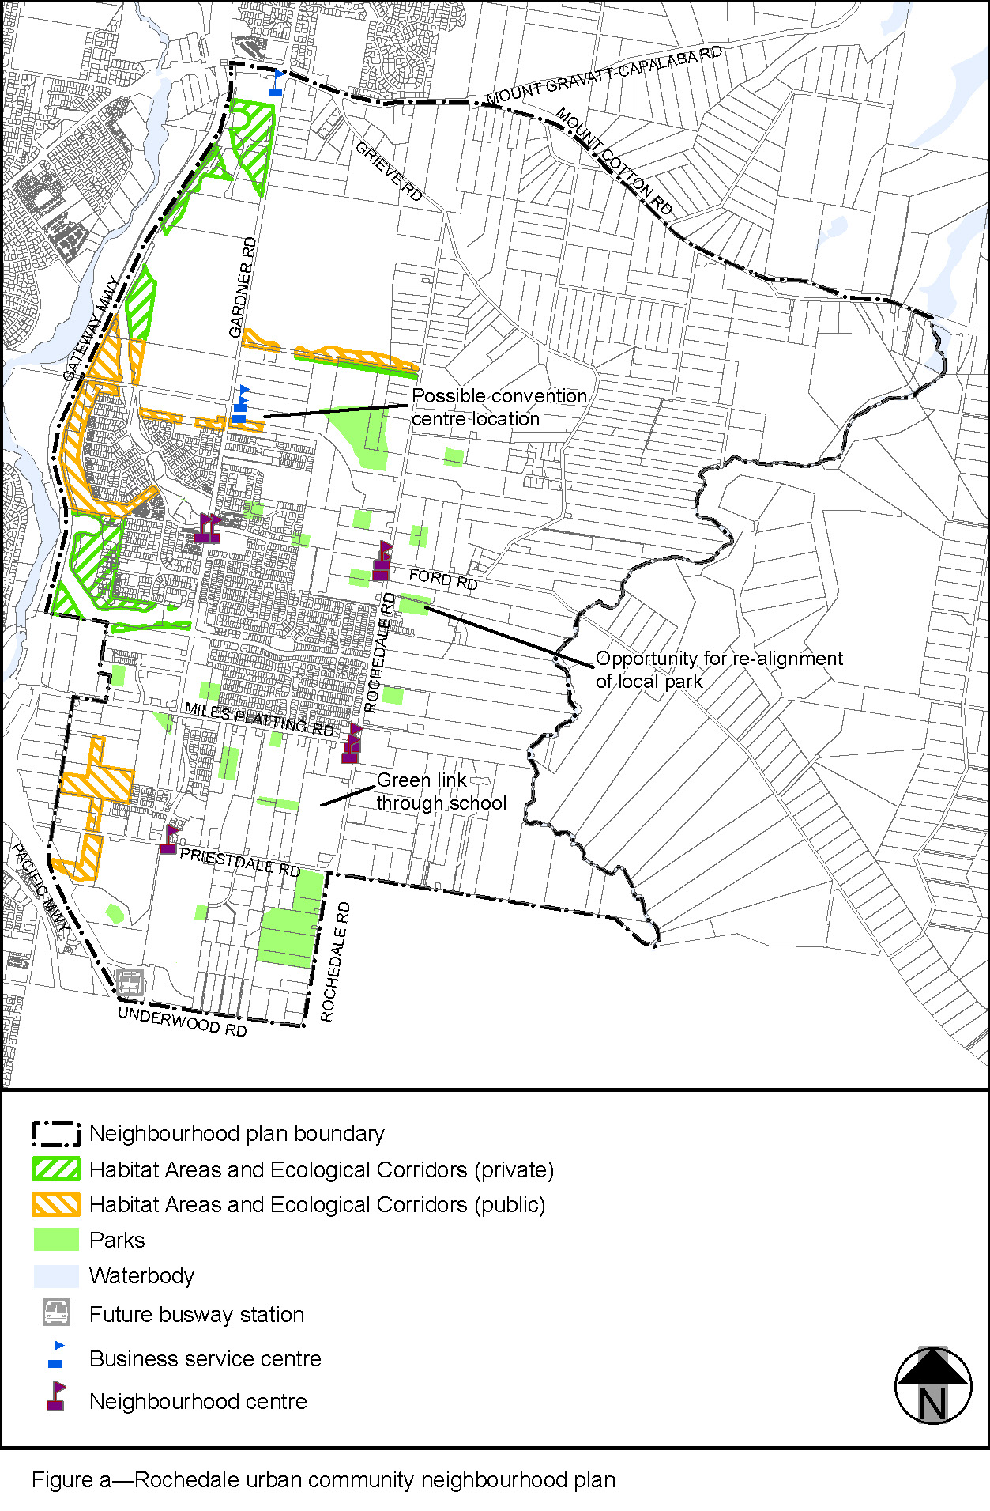

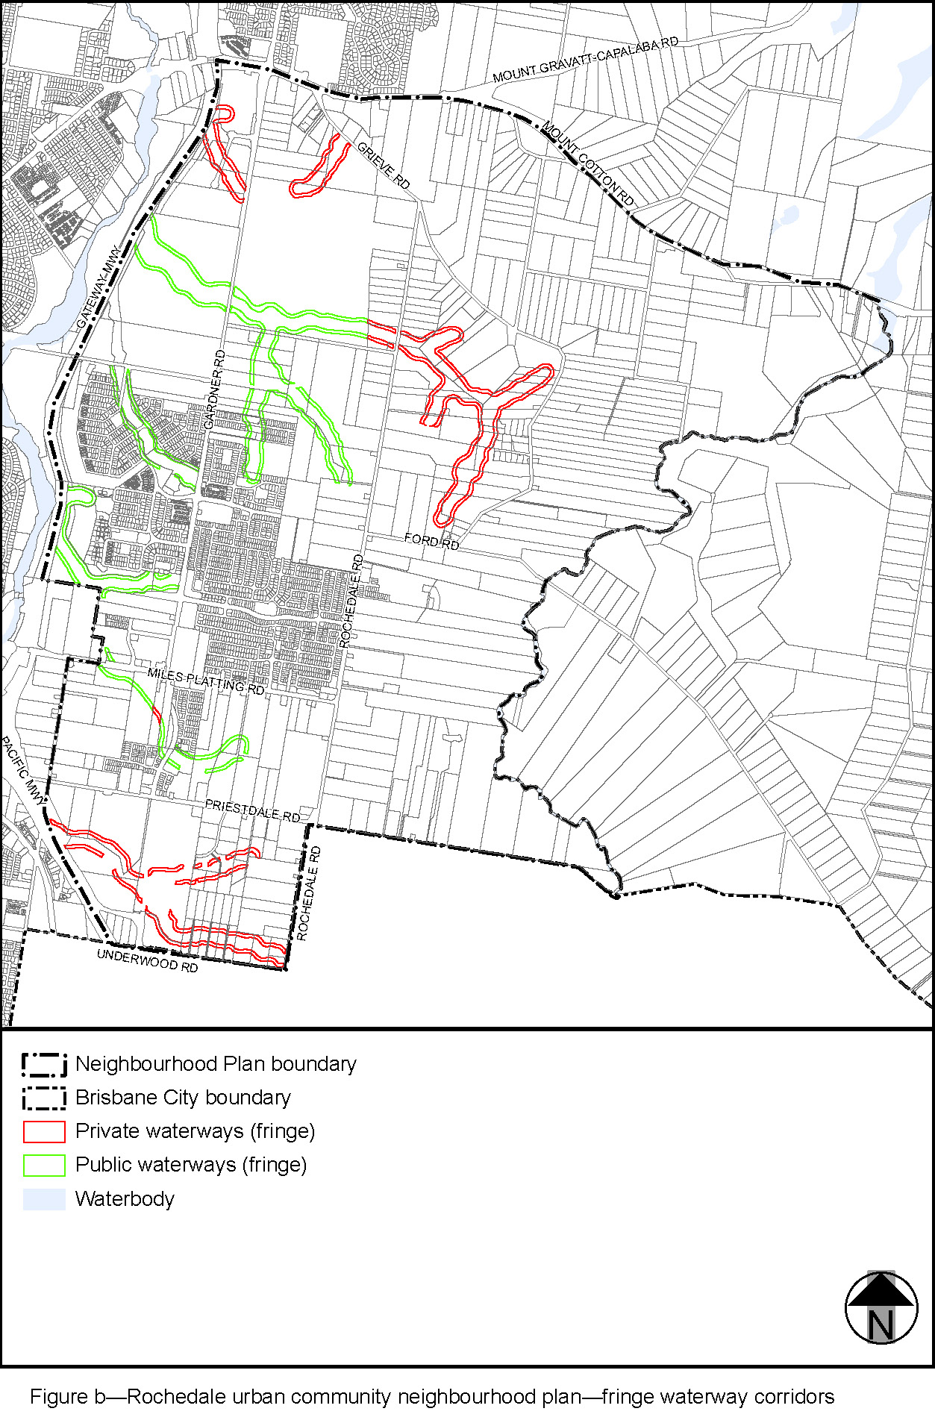
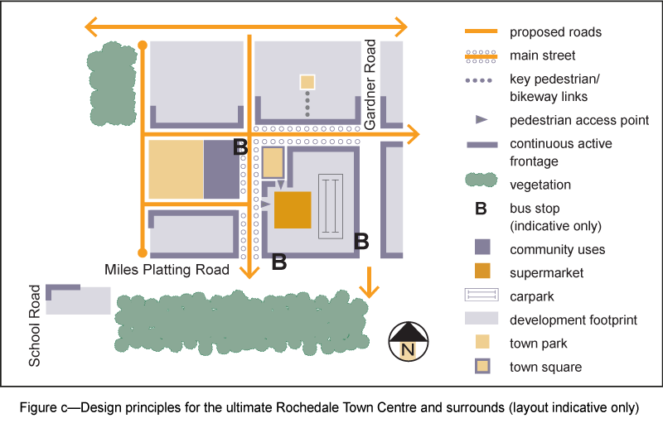
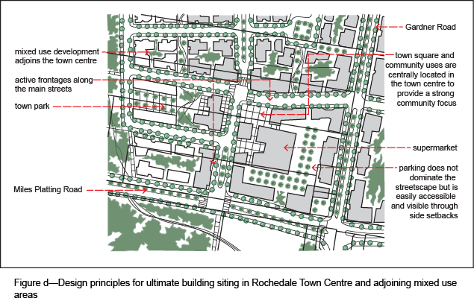

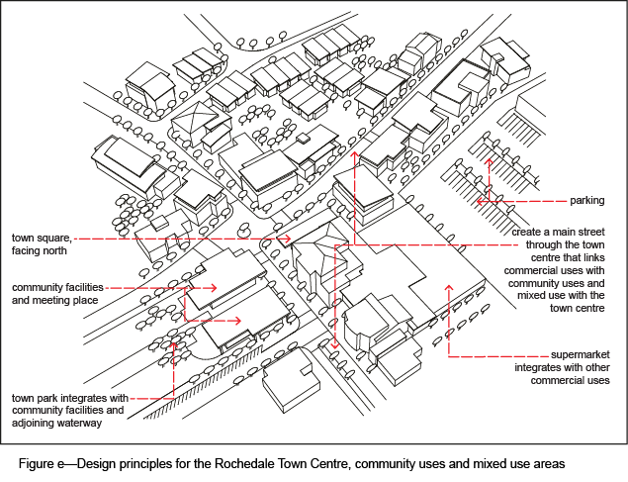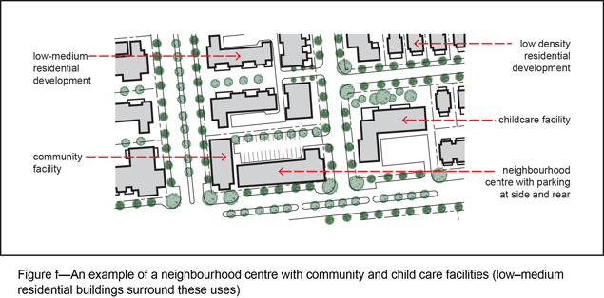
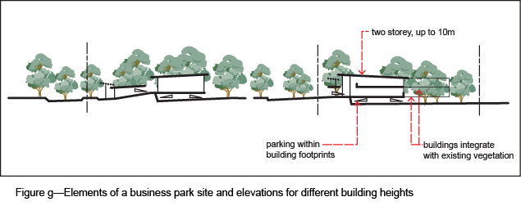
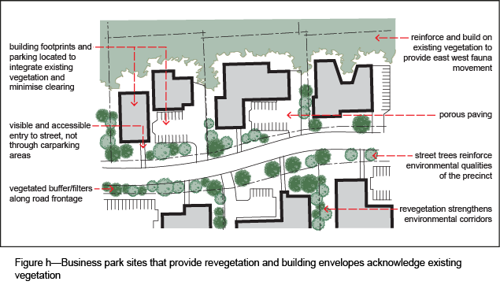
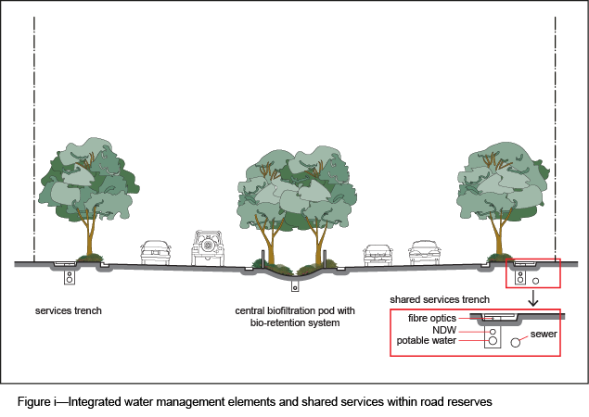
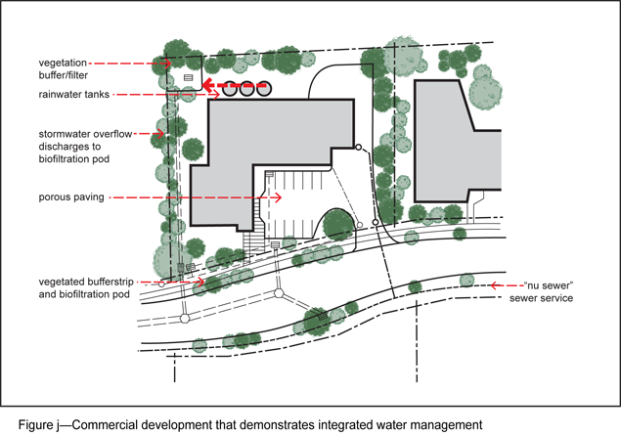 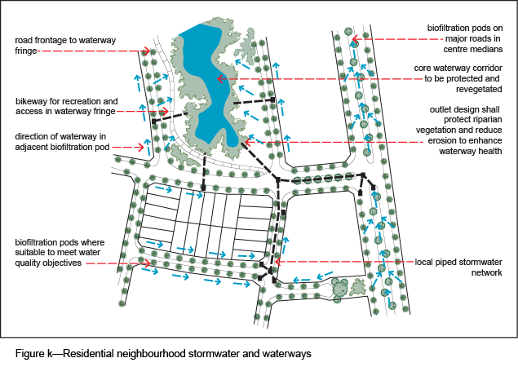 ’.

Part 4 Amendment of Part 8 (Overlays)

4.1 Amendment to section 8.2.19 (Significant landscape tree overlay code)
- Section 8.2.19 Significant landscape tree overlay code, Table 8.2.19.3.C—Significant landscape trees in specific locations–
Insert after Eight Mile Plains:
‘
Group of Eucalyptus spp. gum | 65 Holmead Road (various across site) | L81 SP115498
Group of Eucalyptus spp. and Corymbia spp. gum | 24 Levington Road (throughout site) | L1 RP169907
Group of Eucalyptus tereticornis forest red gum | 75 Levington Road (Levington Road frontage) | L0 SP232001
Groups of Araucaria cunninghamii hoop pine | 17 Lilywood Street (central area of site) | L2 SP114772
Araucaria cunninghamii hoop pine | 21 Liverpool Street (rear of garden) | L1 RP85018
Araucaria cunninghamii hoop pine | 44 Liverpool Street (front corner) | L136 RP13407
Eucalyptus microcorys tallowwood and 7 x Eucalyptus tereticornis forest red gum | 2759 Logan Road (throughout site) | L1 SP323756
2 x Araucaria cunninghamii hoop pine | 78 London Street (front garden) | L218-219 RP13407
Group of Eucalyptus spp. and Corymbia spp. gum | 39 Maisie Place (front garden) | L371 RP893660
2 x Mangifera indica mango | 48 Miles Platting Road | L36-37 RP13407
Angophora leiocarpa smooth barked apple | 160 Miles Platting Road (near entry of Lilywood Street) | L31 SP327882
Grevillea robusta silky oak, 2 x Eucalyptus spp. gum | 370 Underwood Road (back middle of site) | L4 RP90217
3 x Eucalyptus acmenoides white mahogany and 4 x Eucalyptus microcorys tallowwood | 390 Underwood Road (middle and side of site) | L5 RP90217
’.

- Section 8.2.19 Significant landscape tree overlay code, Table 8.2.19.3.C—Significant landscape trees in specific locations–
Insert before Salisbury:
‘
Rochedale
Delonix regia poinciana | 23 School Road (front corner) | L1 RP78857
’.

Part 5 Amendment of Schedule 2 (Mapping)

5.1 Amendment to SC2.2 (Zone maps)
- SC2.2 Zone maps, ZM-001 (Tile 44)

omit, insert:
SC2.2 Zone maps, ZM-001 (Tile 44)–refer to Supplement 1a.

5.2 Amendment to Table SC2.2.1 (Zone maps)
- SC2.2 Zone maps, Table SC2.2.1—Zone maps–
insert after Gazettal date, 27 May 2022
‘
Not applicable | ZM-001 | Zoning map  Map tile 44 | 2 December 2022
’.

5.3 Amendment to SC2.3 (Neighbourhood plan maps)
- SC2.3 Neighbourhood plan maps, NPM-005.5 Eight Mile Plains gateway neighbourhood plan map–
Insert before Ferny Grove—Upper Kedron neighbourhood plan map:
NPM-005.5 Eight Mile Plains gateway neighbourhood plan map – refer to Supplement 1b.

- SC2.3 Neighbourhood plan maps, NPM-011.4 Kuraby neighbourhood plan map–
omit, insert:
NPM-011.4 Kuraby neighbourhood plan map – refer to Supplement 1c.

- SC2.3 Neighbourhood plan maps, NPM-018.4 Rochedale urban community neighbourhood plan map–
omit, insert:
NPM-018.4 Rochedale urban community neighbourhood plan map – refer to Supplement 1d.

5.4 Amendment to Table SC2.3.1 (Neighbourhood plan maps)
- Table SC2.3.1—Neighbourhood plan maps–
insert before Ferny Grove—Upper Kedron neighbourhood plan:
‘
NPM-005.5 | Eight Mile Plains gateway neighbourhood plan map | 2 December 2022
’.

- Table SC2.3.1—Neighbourhood plan maps,
omit, insert:
‘
NPM-011.4 | Kuraby neighbourhood plan map | 2 December 2022
’.
- Table SC2.3.1—Neighbourhood plan maps,
omit, insert:
‘
NPM-018.4 | Rochedale urban community neighbourhood plan map | 2 December 2022
’.

5.5 Amendment of Schedule 2.4 (Overlay maps)
- Schedule 2 Mapping, SC2.4 Overlay maps, OM-004.1 Dwelling house character overlay map (Tile 44)–
omit, insert:
OM-004.1 Dwelling house character overlay map (Tile 44) – refer to Supplement 1e.

- Schedule 2 Mapping, SC2.4 Overlay maps, OM-019.1 Significant landscape tree overlay map (Tile 44)–
omit, insert:
OM-019.1 Significant landscape tree overlay map (Tile 44) – refer to Supplement 1f.

- Schedule 2 Mapping, SC2.4 Overlay maps, OM-019.2 Streetscape hierarchy overlay map (Tile 44)–
omit, insert:
OM-019.2 Streetscape hierarchy overlay map (Tile 44) – refer to Supplement 1g.

5.6 Amendment of Table SC2.4.1 (Overlay maps)
- Schedule 2 Mapping, SC2.4 Overlay maps, Table SC2.4.1—Overlay maps–
insert before OM-005.1 Extractive resources overlay map (all titles, other than where specified below), 30 June 2014:
‘
OM-004.1 | Dwelling house character overlay map  Map tile 44 | 2 December 2022
’.
- Schedule 2 Mapping, SC2.4 Overlay maps, Table SC2.4.1—Overlay maps–
insert before OM-019.2 Streetscape hierarchy overlay map (all titles, other than where specified below), 30 June 2014:
‘
OM-019.1 | Significant landscape tree overlay map  Map tile 44 | 2 December 2022
’.
- Schedule 2 Mapping, SC2.4 Overlay maps, Table SC2.4.1—Overlay maps–
insert before OM-020.1 Traditional building character overlay map (all titles, other than where specified below), 30 June 2014:
‘
OM-019.2 | Streetscape hierarchy overlay map  Map tile 44 | 02 December 2022
’.

Part 6 Amendment of Schedule 6 (Planning scheme policies)
- SC6.16 Infrastructure design planning scheme policy, Chapter 1 Introduction, 1.1 Introduction, 1.1.1 Relationship to planning scheme–
insert before Fortitude Valley neighbourhood plan code:
‘
Eight Mile Plains gateway neighbourhood plan code
Table 7.2.5.5.3.A | AO13 | Chapter 10
’.
- SC6.29 Structure planning planning scheme policy, 1 Introduction, 1.1 Relationship to planning scheme–
insert before Ferny Grove—Upper Kedron neighbourhood plan code:
‘
Eight Mile Plains gateway neighbourhood plan code
Table 7.2.5.5.3.A | AO19 | All
’.

Part 7 Amendment of Appendix 2 (Table of amendments)

7.1 Amendment to Appendix 2 (Table of amendments)
- Appendix 2 Table of Amendments, Table AP2.1—Table of amendments–
insert after v24.00/2022
‘
1 November 2022 (adoption) and 2 December 2022 (effective) | v25.00/2022 | Major | Major amendment to planning scheme (Chapter 2, Part 4 of MGR).  Amendment to planning scheme policy (Chapter 3, Part 1 of MGR).  Refer to Amendment v25.00/2022 for further detail.
’.

Supplement 1—A3 Map Tiles

Supplement 1a: Zone maps ZM-001 (Tile 44)
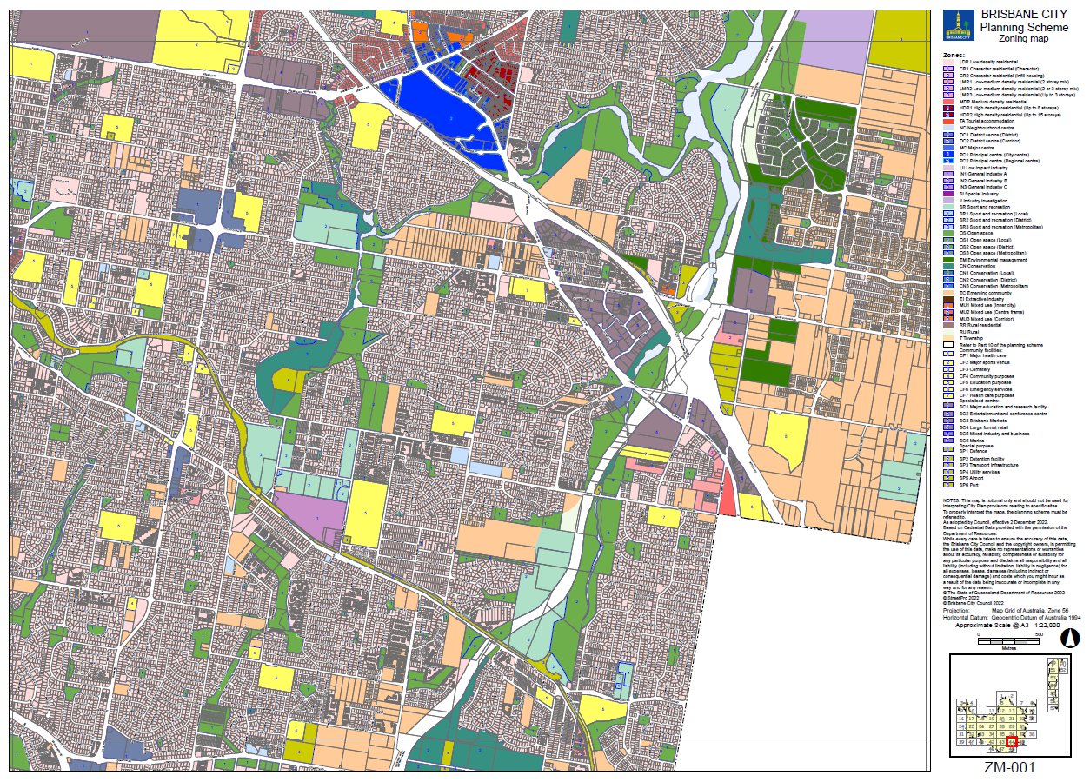

Supplement 1b: NPM-005.5 Eight Mile Plains gateway neighbourhood plan map
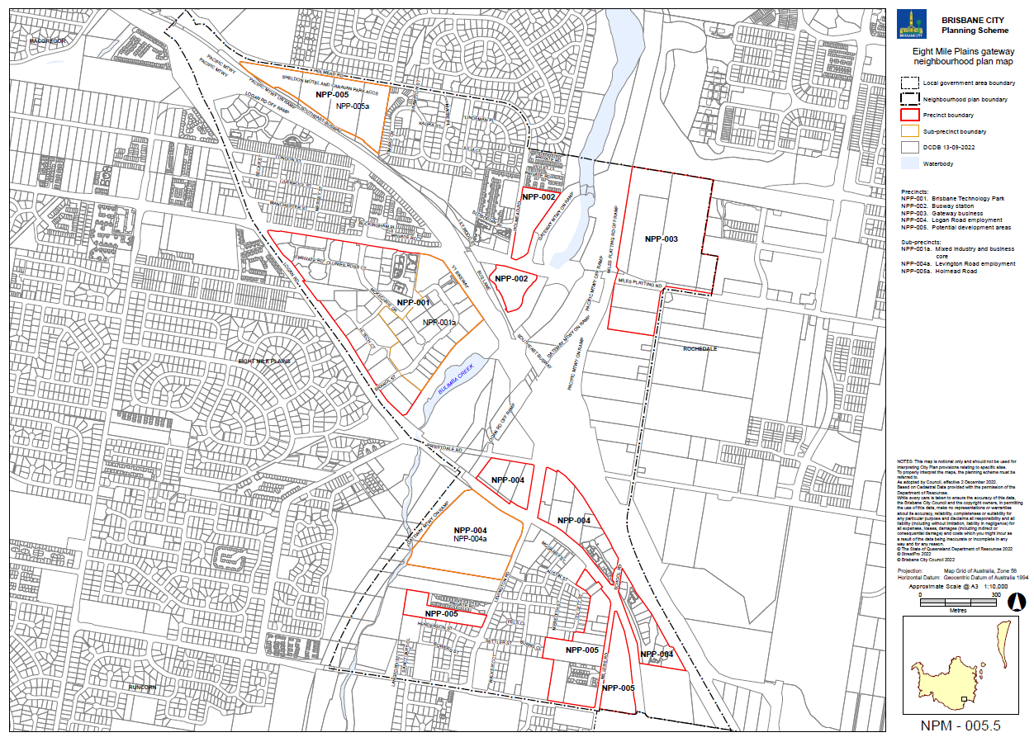

Supplement 1c: NPM-011.4 Kuraby neighbourhood plan map
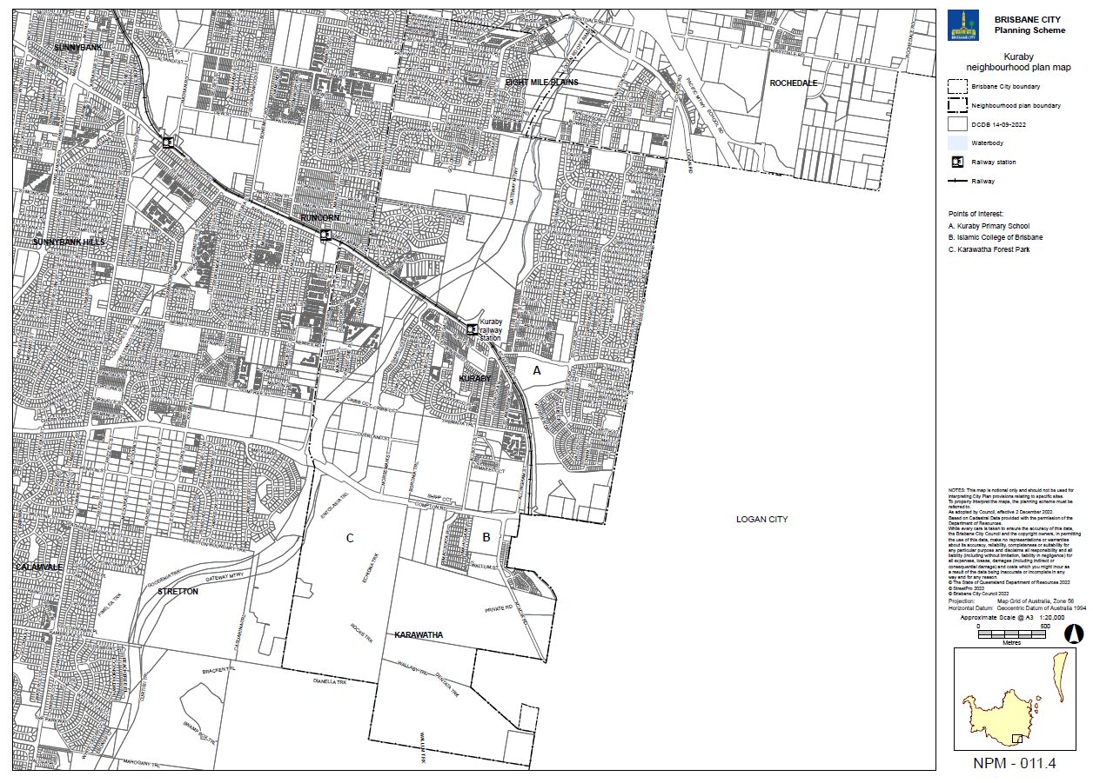

Supplement 1d: NPM-018.4 Rochedale urban community neighbourhood plan map
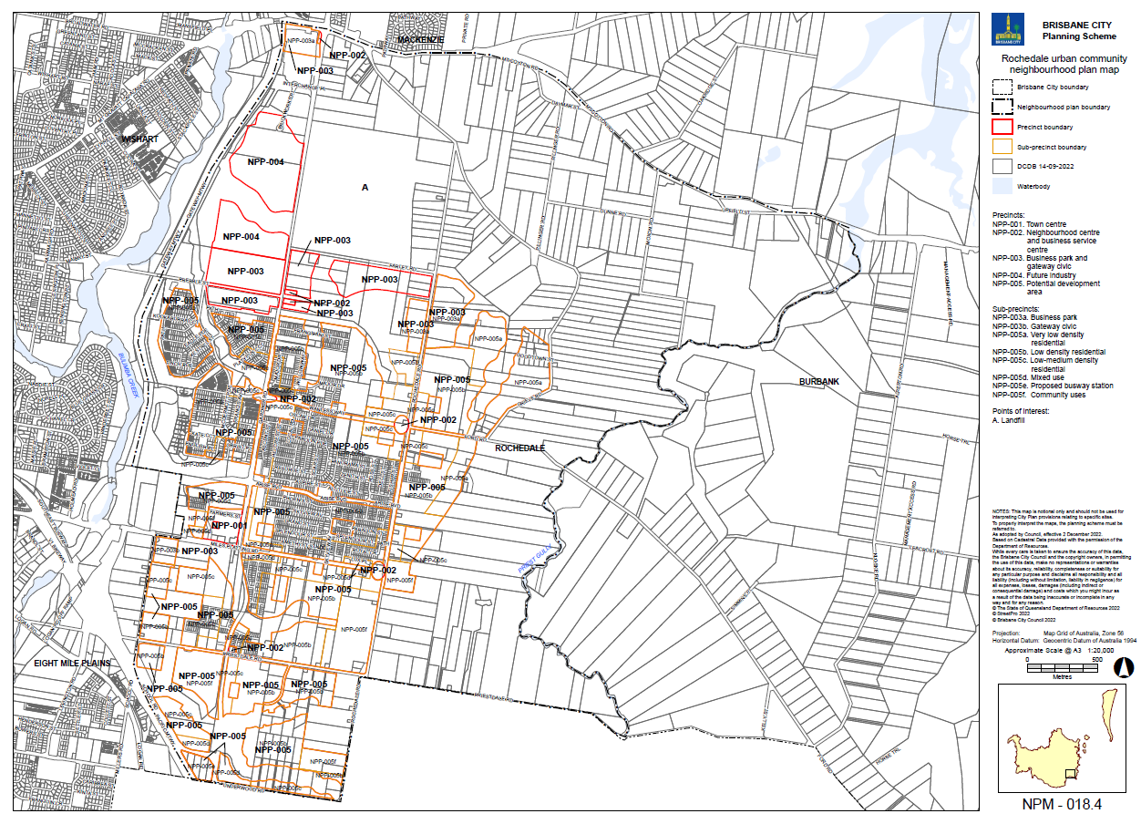

Supplement 1e: OM-004.1 Dwelling house character overlay map (Tile 44)
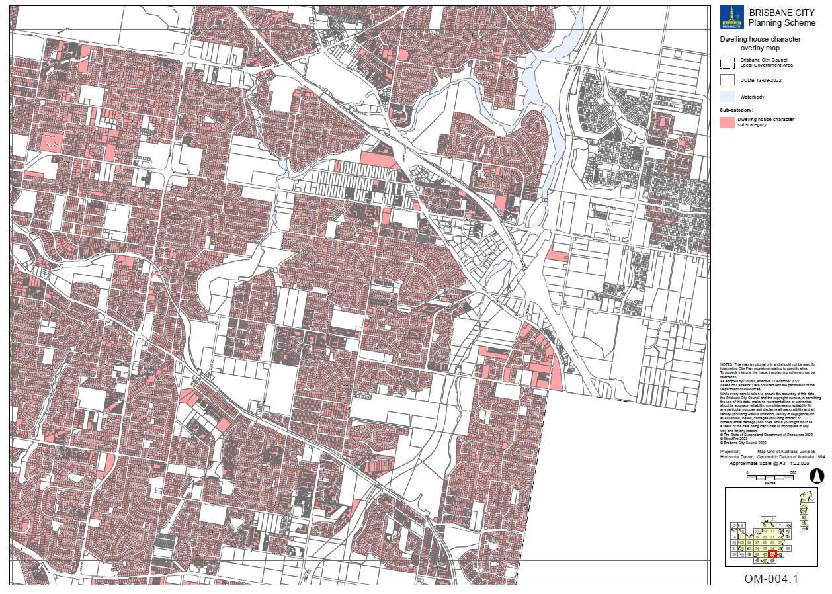

Supplement 1f: OM-019.1 Significant landscape tree overlay map (Tile 44)
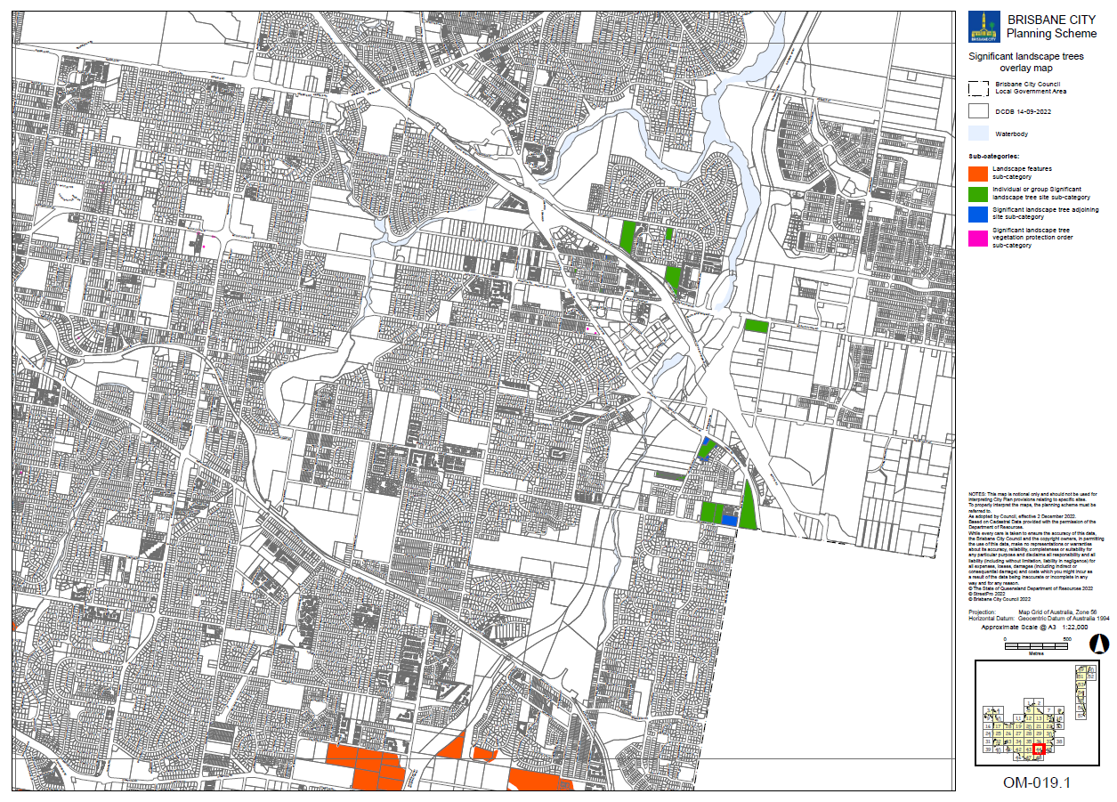

Supplement 1g: OM-019.2 Streetscape hierarchy overlay map (Tile 44)

