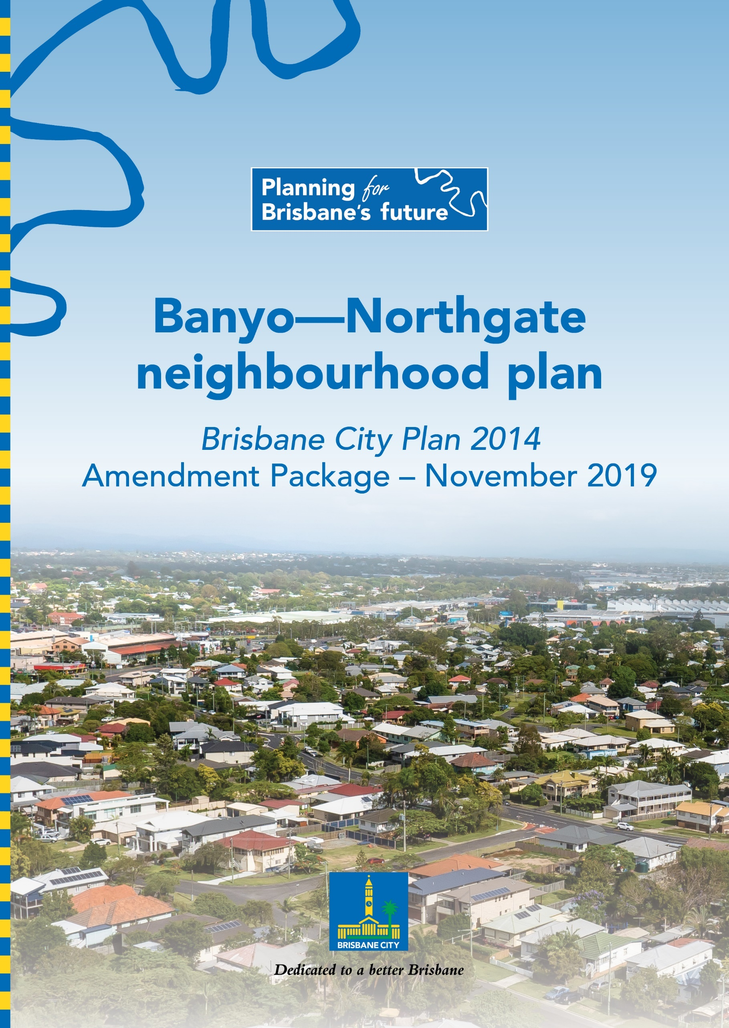

Table of Contents
Part A: Explanatory Notes 1
Glossary 2
Purpose 3
Background 3
What are neighbourhood plans? 3
Community engagement 4
Neighbourhood plan outcomes 5
Part B: Major Amendment v18.00/2020 21
Part 1 Amendment of Part 1 (About the planning scheme) 22
1.1 Amendment of section 1.2 (Planning scheme components) 22
Part 2 Amendment of Part 5 (Tables of assessment) 24
2.1 Amendment of section 5.9 (Categories of development and assessment—Neighbourhood plans) 24
Part 3 Amendment of Part 7 (Neighbourhood plans) 27
3.1 Amendment of section 7.1 (Preliminary) 27
3.2 Amendment of section 7.2 (Neighbourhood plan codes) 28
Part 4 Amendment of Part 8 (Overlays) 51
4.1 Amendment to section 8.2.19 (Significant landscape tree overlay code) 51
Part 5 Amendment of Schedule 2 (Mapping) 53
5.1 Amendment to Schedule 2.1 (Strategic framework maps) 53
5.2 Amendment to Table SC2.1.1 (Strategic framework maps) 53
5.3 Amendment to Schedule 2.2 (Zone maps) 53
5.4 Amendment to Table SC2.2.1 (Zone maps) 53
5.5 Amendment to Schedule 2.3 (Neighbourhood plan maps) 53
5.6 Amendment to Table SC2.3.1 (Neighbourhood plan maps) 53
5.7 Amendment of Schedule 2.4 (Overlay maps) 54
5.8 Amendment of Table SC2.4.1 (Overlay maps) 55
Part 6 Amendment of Schedule 6 (Planning scheme policies) 57
6.1 Amendment to Schedule 6.29 (Structure planning planning scheme policy) 57
Part 7 Amendment of Appendix 2 (Table of amendments) 58
7.1 Amendment to Appendix 2 (Table of Amendments) 58
Supplement 1—A3 Map Tiles 59

Part A: Explanatory Notes

Glossary
Abbreviation | Term
City Plan | Brisbane City Plan 2014
Council | Brisbane City Council
CPT | Community Planning Team
LGIP | Local Government Infrastructure Plan
MCU | Material change of use as defined in the Planning Act 2016
NPP | Neighbourhood plan precinct
PSP | Planning scheme policy
ROL | Reconfiguring a lot as defined in the Planning Act 2016
the Act | Planning Act 2016
the amendment package | Banyo—Northgate neighbourhood plan amendment package
the neighbourhood plan strategy | Banyo—Northgate neighbourhood plan draft strategy
the neighbourhood plan | Banyo—Northgate neighbourhood plan
the neighbourhood plan area | Banyo—Northgate draft neighbourhood plan area

Purpose

The purpose of these explanatory notes is to provide context for the amendment package, including the key outcomes of the neighbourhood plan and the process undertaken to develop the neighbourhood plan. The explanatory notes do not form part of the amendment package.

Background

Council proposes to adopt the amendment package to guide development and coordinate land use in the neighbourhood plan area, which includes Banyo, Northgate, and parts of Nudgee, Nundah, Virginia and Hendra. The amendment package forms a major amendment to City Plan and has been prepared in accordance with Queensland Government requirements. The amendment package consists of a new neighbourhood plan code for the neighbourhood plan area, revised precinct, zone and overlay mapping, and consequential amendments to City Plan. Once adopted, the amendment package will replace the existing Banyo—Nudgee neighbourhood plan and parts of the existing Nundah district neighbourhood plan.

Council commenced the neighbourhood planning process for Banyo—Northgate in November 2016. The first stage of the process involved the preparation of and community consultation on the draft neighbourhood plan strategy. Feedback on the draft neighbourhood plan strategy, along with feedback received through the CPT and the broader community, was then used to inform the second stage of the process, which involved the preparation of and community consultation on the amendment package. More information about the community engagement undertaken to inform this amendment package is outlined in the Community Engagement section below.

Council revised the amendment package following consideration of these submissions and referred the amendment package to the Queensland Government for approval to adopt. On 7 August 2019, the Queensland Government advised Council that the amendment could be adopted into the planning scheme without conditions.

The amendment package has been prepared in line with the following objectives for the neighbourhood plan area:
- provide finer grained planning at a local level for the neighbourhood plan area
- balance future growth of residential, industrial and commercial uses including confirmation of residential and commercial opportunities in existing centres and residential areas, and resolve existing challenges regarding the industrial/residential interface
- contribute to the economic prosperity, housing choice and biodiversity protection goals of Brisbane.

What are neighbourhood plans?

Creating a city of neighbourhoods is one of eight principles outlined in Brisbane’s Future Blueprint.

Council creates neighbourhood plans to guide development in local communities, and to ensure that each area retains and enhances its own special character and qualities. The neighbourhood plan is the product of technical investigations undertaken by Council, as well as feedback received from the community and other stakeholders over the course of the plan’s preparation.

The existing neighbourhood plans for the Banyo—Northgate area are more than 15 years old and need to be updated. The new neighbourhood plan refines planning provisions to meet the needs of the local community while also maintaining the neighbourhood plan area’s residential character. The neighbourhood plan is a part of Council’s City Plan. The neighbourhood plan does not duplicate planning provisions that are already contained in City Plan (assessment criteria for overlays, for example) as the neighbourhood plan is a component part of City Plan and is not a standalone statutory document.

It is important to recognise that the neighbourhood plan cannot:
- reduce the scale of existing development
- stop already approved development, even if construction has not commenced.

Infrastructure planning occurs as part of the LGIP and will be reviewed following the adoption of the amendment package.

Community engagement

Engagement for the neighbourhood plan

The neighbourhood planning process for the Banyo—Northgate area commenced in late 2016 with an online survey, information kiosks and the formation of a CPT. The CPT met four times between April 2017 and October 2017 to provide input to the neighbourhood plan strategy.

The neighbourhood plan strategy was released for public consultation from 27 October 2017 to 8 December 2017.

Feedback received on the neighbourhood plan strategy informed preparation of the amendment package.

Public consultation on the amendment package took place from 2 November 2018 to 17 December 2018. Council considered feedback received on the amendment package and updated the amendment package in response.

For more information on how Council has addressed community feedback, please refer to the neighbourhood plan strategy Summary of Feedback Report and the Report on Submissions for the amendment package. Both documents are available for viewing on the neighbourhood plan webpage on Council’s website.

Summary of community engagement activities

Following is a summary of the key community engagement activities that have informed the development of the neighbourhood plan.

Table 1—Community engagement activity summary
Event type | Date and location | Topic
Information kiosks | 13 February 2017 – Northgate Road and Ridge Street, Northgate | Public consultation as part of the project background research stage
Information kiosks | 13 February 2017 – Ryans Road and Ridge Street, Northgate
Information kiosks | 16 February 2017 – St Vincents Road, Banyo
CPT | 27 April 2017 – Meeting 1 at Banyo Library | CPT members provided local knowledge and input into the neighbourhood plan
CPT | 8 June 2017 – Meeting 2 at Banyo Library
CPT | 20 July 2017 – Meeting 3 at Banyo Library
CPT | 25 October 2017 – Meeting 4 at Banyo Library
Industry forum | 5 June 2017 – Banyo Library | Forum for businesses operating near residential areas
Industry workshop | 28 August 2017 – Brisbane Square | Consultation with land owners and other key stakeholders regarding precinct design
Neighbourhood plan strategy consultation | 9 November 2017 – Ryans Road and Ridge Street, Northgate  11 November 2017 – St Vincents Road, Banyo  22 November 2017 – Railway Street, Nudgee  24 November 2017 – Northgate Road and Ridge Street, Northgate | Neighbourhood plan strategy
Amendment package consultation | 2 November to 17 December 2018 | Public consultation and feedback on the amendment package
Community information sessions | 21 November 2018 – Northgate Hall, Northgate  24 November 2018 – Virginia Golf Club, Elliott Road, Banyo | The amendment package

Neighbourhood plan outcomes

The neighbourhood plan boundary

The neighbourhood plan focuses on the suburbs of Banyo and Northgate, and parts of Nudgee, Nundah, Virginia and Hendra. The area is bounded by East-West Arterial Road, Southern Cross Way, Gateway Motorway, Downfall Creek, Nundah Creek and Sandgate Road. The Banyo—Northgate area is located 11 kilometres from the Brisbane CBD to the south and five kilometres from Australia TradeCoast to the east. The neighbourhood plan boundary is outlined in Figure 1.

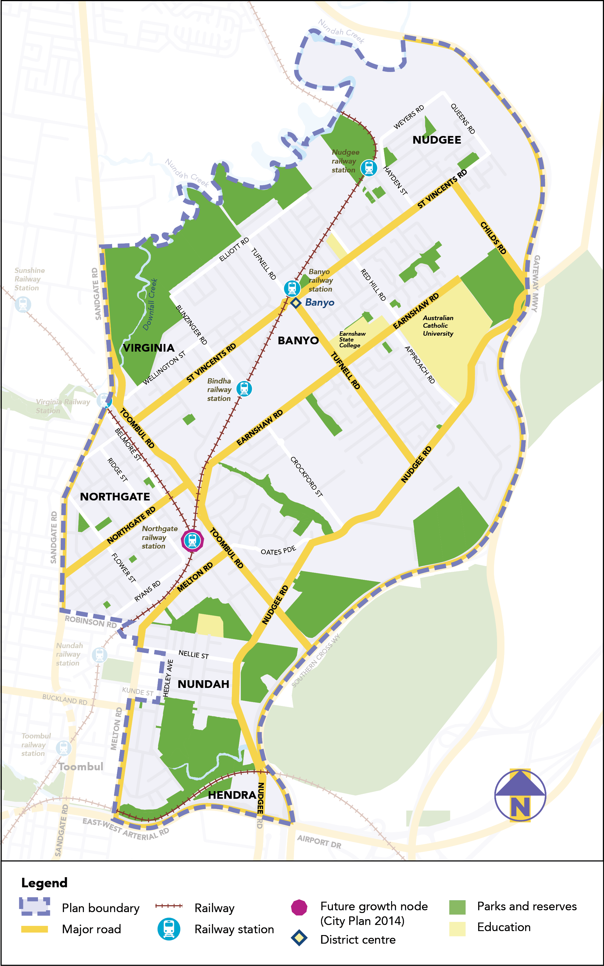

Figure 1—Banyo—Northgate neighbourhood plan boundary

There are six precincts in the neighbourhood plan area:
- Northgate Station precinct (NPP-001)
- Bindha Station precinct (NPP-002)
  - Bindha Station north sub-precinct (NPP-002a)
  - Bindha Station south sub-precinct (NPP-002b)
- Banyo Station precinct (NPP-003)
- Nudgee Station precinct (NPP-004)
- Nudgee north precinct (NPP-005)
- Blinzinger Road precinct (NPP-006).

The intent for development in the neighbourhood plan area is to:
- support the development of Northgate as a growth node for employment and residential uses on the north-west rail transport corridor
- facilitate the transition from traditional industrial areas to mixed industry and business precincts at Northgate and Bindha with a focus on advanced manufacturing
- provide built form and public realm design guidance to create a permeable, high quality, fine-grain urban environment in each station precinct, particularly at Northgate and Bindha
- ensure that development for sensitive uses is appropriately located and does not result in reverse amenity or operational impacts on established industry
- strengthen protections for character and heritage buildings, particularly in areas currently zoned Low-medium density residential within the Traditional building character overlay
- enhance local road and open space networks.

Key planning outcomes

The amendment package will ensure that new development responds to key State-wide, regional and local planning outcomes.

Response to the State Planning Policy July 2017

As an integrated part of City Plan, the amendment package supports the State interests outlined in the State Planning Policy July 2017, in particular:
- Housing supply and diversity – by focusing increased densities around existing centres, services and facilities including around the Banyo railway station
- Liveable communities – by creating liveable and well-designed communities that support resident wellbeing and enhance quality of life
- Development and construction – by supporting economic growth through the facilitation of a range of residential, commercial, retail, industrial and mixed use development opportunities
- Cultural heritage – by conserving places of cultural significance including the Nudgee Waterhole, Australian Catholic University and areas of traditional building character
- Emissions and hazardous activities – by ensuring new development is located to protect sensitive uses from emissions and hazardous activities and protect existing or approved industrial development in industrial zones from encroachment by uses that compromise their ability to function safely and effectively
- Natural hazards, risk and resilience – by avoiding flood and coastal hazard risks to people and property
- Infrastructure integration – by aligning infrastructure and land use planning
- Transport infrastructure – by improving active transport connections.

Response to the South East Queensland Regional Plan 2017 – ShapingSEQ

The amendment package supports the following policies of the South East Queensland Regional Plan 2017 – ShapingSEQ:
- Goal 1 Grow and Goal 4 Sustain – by accommodating growth in an existing urban area within the Urban Footprint
- Goal 2 Prosper – by supporting the intensification of economic activity in the Australia TradeCoast economic cluster, and in the Nudgee/Banyo and Virginia/Northgate Major enterprise and industrial areas
- Goal 3 Connect – by prioritising the use of active transport networks in an existing urban area
- Goal 3 Connect and Goal 5 Live – by facilitating high amenity industry, business and residential development close to railway stations
- Goal 5 Live – by preserving the character and heritage of the Banyo—Northgate area.

Response to City Plan’s Strategic framework

The amendment package is aligned with the Strategic framework of City Plan.

Response to local planning outcomes

The Banyo—Northgate area has access to frequent public transport to the Brisbane CBD via the suburban railway network (particularly at Northgate). It includes a district centre at Banyo and is also close to the Toombul—Nundah Major centre, which has experienced recent strong urban consolidation and growth. Most of the Industry zoned land in Banyo—Northgate is in the Northern industrial area. In addition to providing a local employment hub, this industrial area has citywide economic significance due to its proximity to Australia TradeCoast, its accessibility to regional transport infrastructure, and its capacity to respond to forecast demand for industrial land.

The amendment package seeks to balance these attributes by:
- balancing the future growth of residential, industrial and commercial uses, including confirming residential and commercial opportunities and resolving existing challenges regarding the industrial/residential interface
- maintaining an industry and business focus as part of the proposed Specialised centre zoning at Northgate and Virginia (Bindha railway station)
- preserving Industry zoning elsewhere in the existing Major Industry Area
- supporting the expansion of the Banyo district centre to better serve the increasing residential and worker population in the precinct and minimise need to travel elsewhere
- confirming heritage and character area values and protecting these through the appropriate zones and overlays.

Proposed precincts and zone changes

Northgate Station precinct

The Northgate Station precinct plan (see Figure 2) positions Northgate as a preferred location for advanced manufacturing and creative industry with its access to high-frequency public transport, ready access to the Brisbane airport and port area and Gateway Arterial Road. The code includes guidelines for achieving a commercially oriented built form, high quality pedestrian streets, and improvements in local road connectivity.
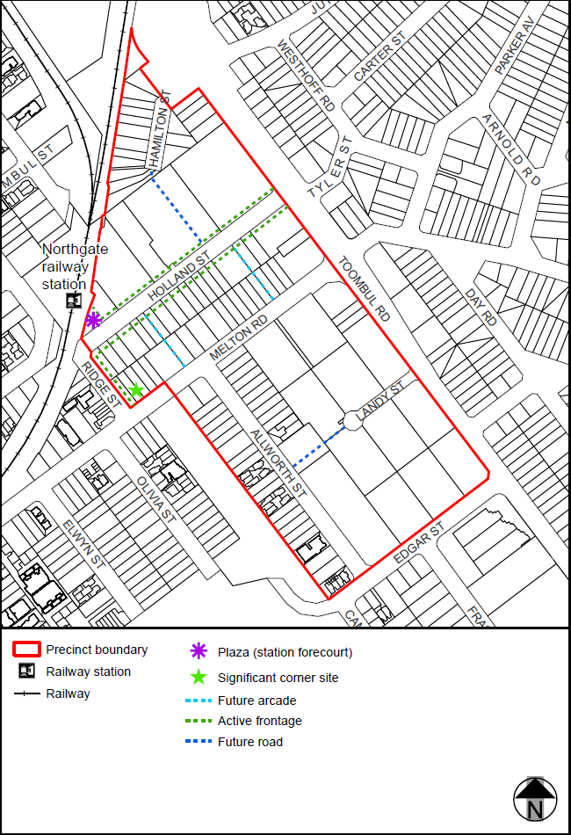

Figure 2––Proposed Northgate Station precinct
Key zoning changes associated with this precinct are highlighted in Figure 3 below.
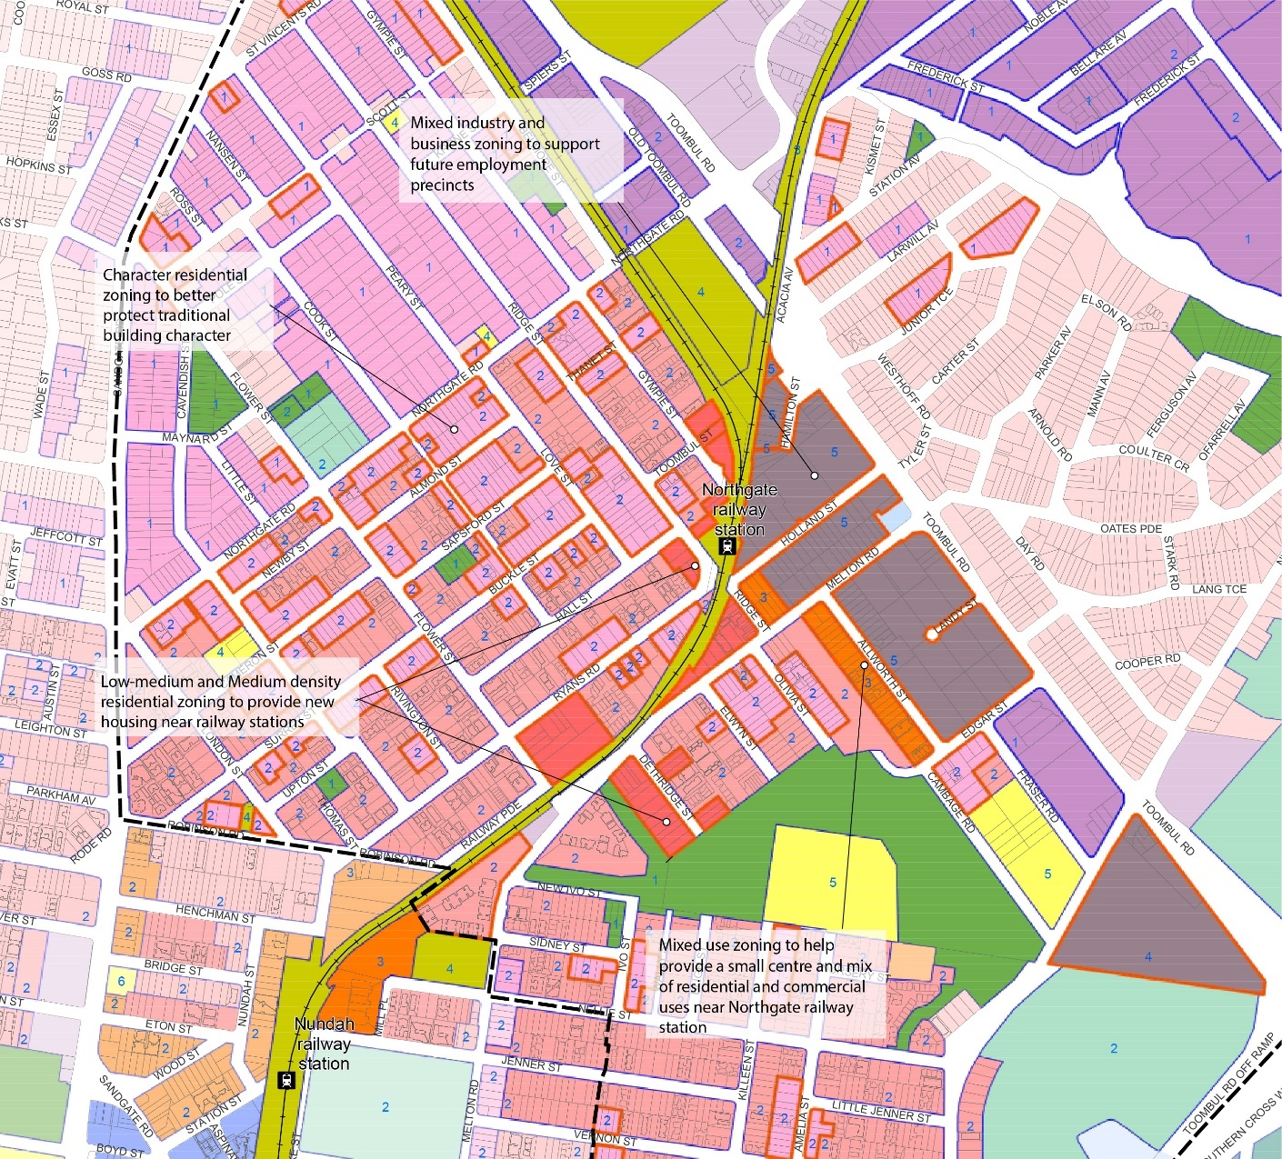

Figure 3––Areas of proposed zoning change – Northgate

Bindha Station precinct

Bindha Station precinct (see Figure 4) includes two sub-precincts: the Bindha Station north sub-precinct and the Bindha Station south sub-precinct. Provisions for the 13-hectare north sub-precinct encourage the redevelopment of low impact industrial land to a major mixed industry and business employment precinct. A key outcome of this redevelopment will be improving the accessibility to, and utilisation of, the Bindha railway station from the north. Provisions for the General industry A zoned land in the south sub-precinct focus on improving accessibility to the railway station from the south and connectivity within the sub-precinct.

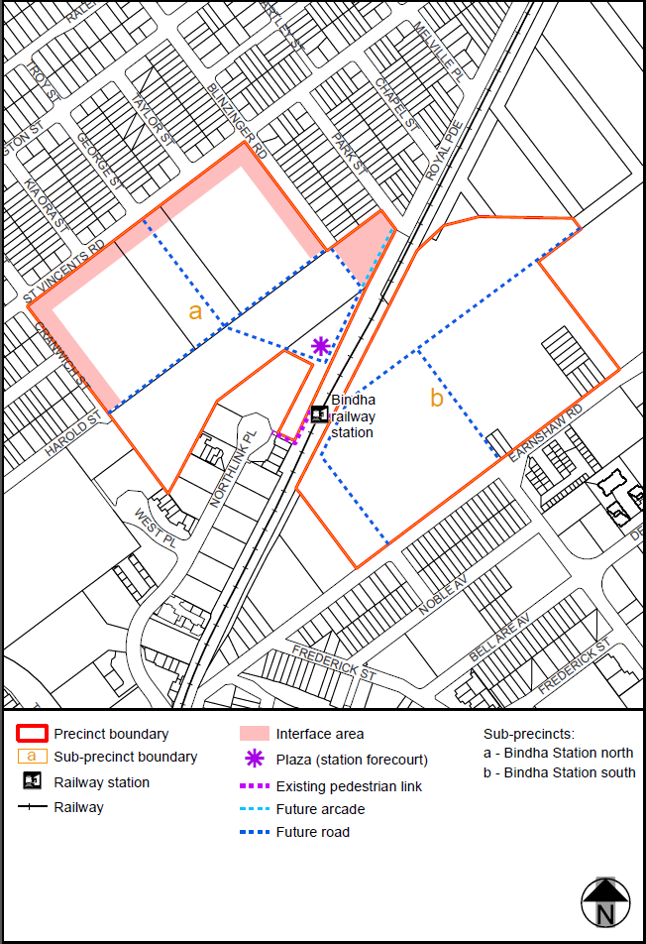

Figure 4––Proposed Bindha Station precinct
Key zoning changes associated with this precinct are highlighted in Figure 5 below.
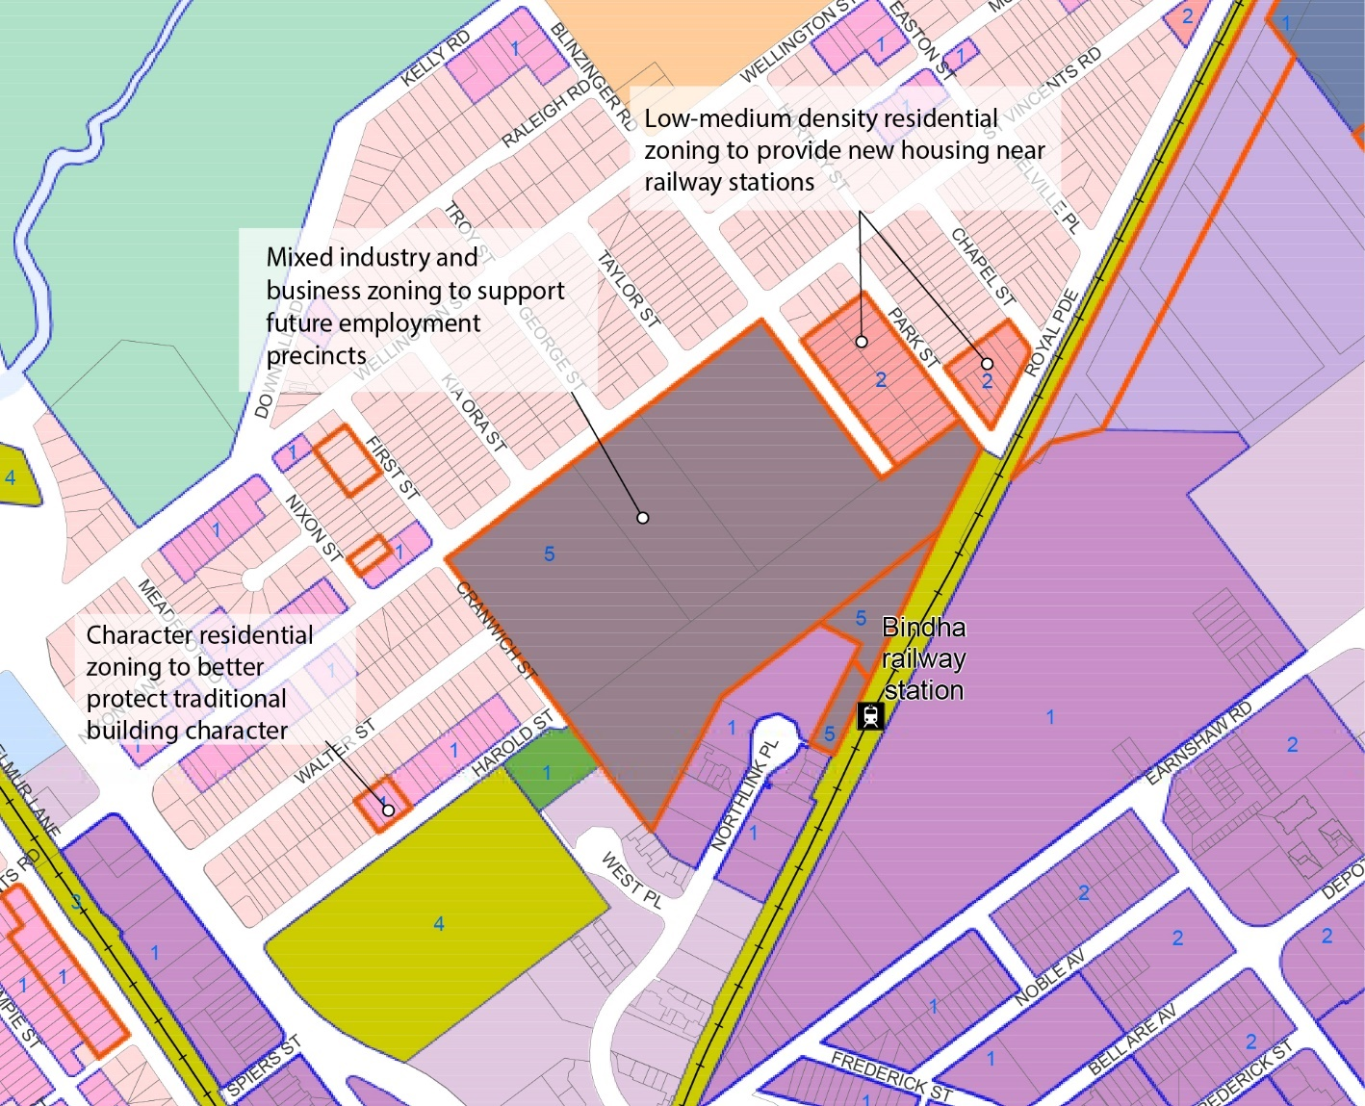
Figure 5—Areas of proposed zoning change – Bindha

Banyo Station precinct

Banyo Station precinct (see Figure 6) responds to the expected growth in local residents and employees by supporting future expansion of the existing district centre near the Banyo railway station. Centre development on Tufnell Road and St Vincents Road will help create active street frontages.

The precinct also includes an industry investigation area and supports low impact industry, and provides specific guidance on integrating development with the established local road network and achieving improved access to the railway station and Bindha Station south sub-precinct.
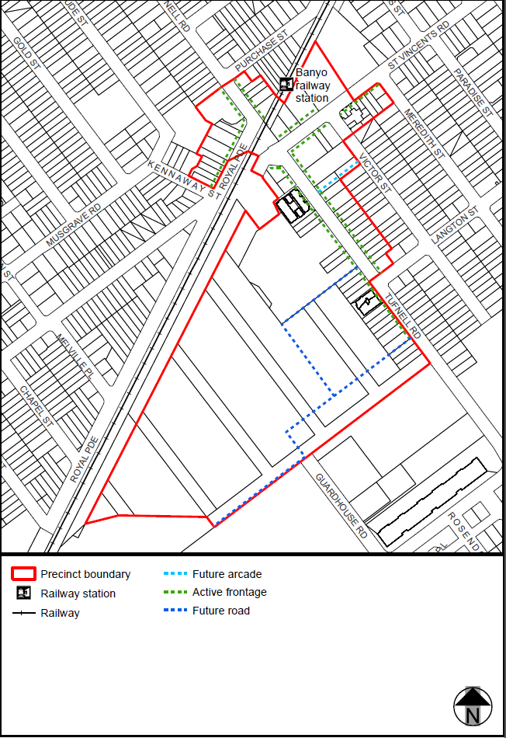

Figure 6––Proposed Banyo Station precinct
Key zoning changes associated with this precinct are highlighted in Figure 7 below.
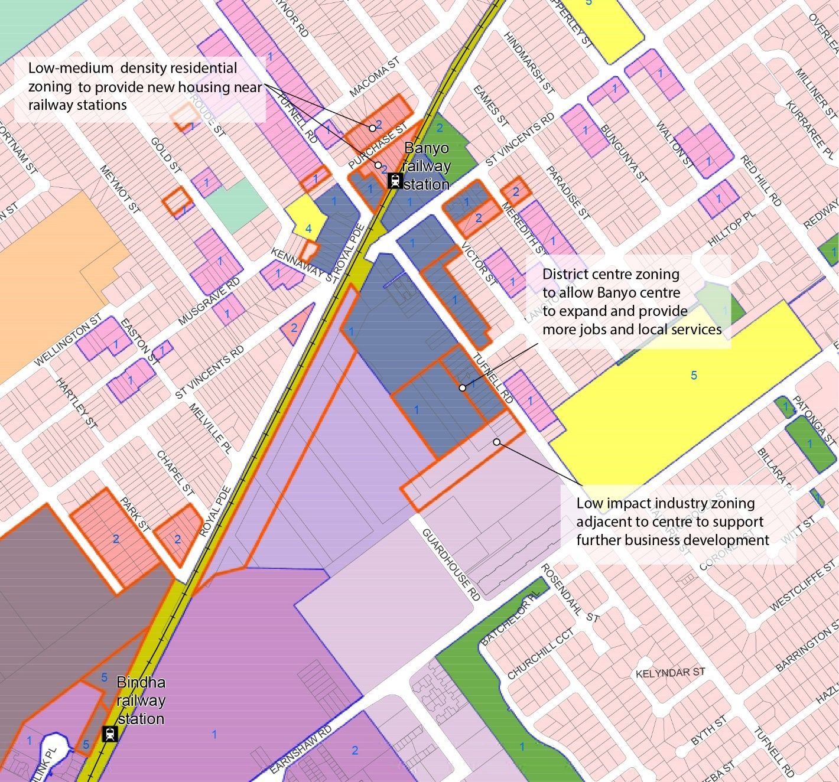

Figure 7––Areas of proposed zoning change – Banyo

Nudgee Station precinct

Nudgee Station precinct (see Figure 8) supports redevelopment of existing Low impact industry zoned land to a mix of low impact industry and business, mixed use and residential uses. Residential and mixed use areas are located close to the railway station and recreation reserve. Land on the south side of Elliott Road is zoned to support small industrial businesses and provide a transition to land for utility infrastructure on the north side of the road.

South of the railway corridor, medium density residential development will integrate the local road network, provide transitions in building bulk and scale to the established low density residential area and consolidate local park on St Achs Street.
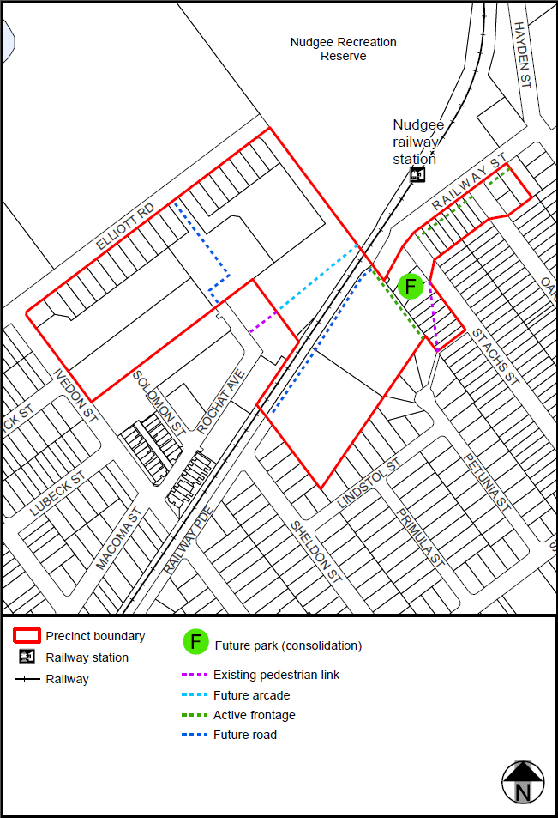

Figure 8––Proposed Nudgee Station precinct
Key zoning changes associated with this precinct are highlighted in Figure 9 below.
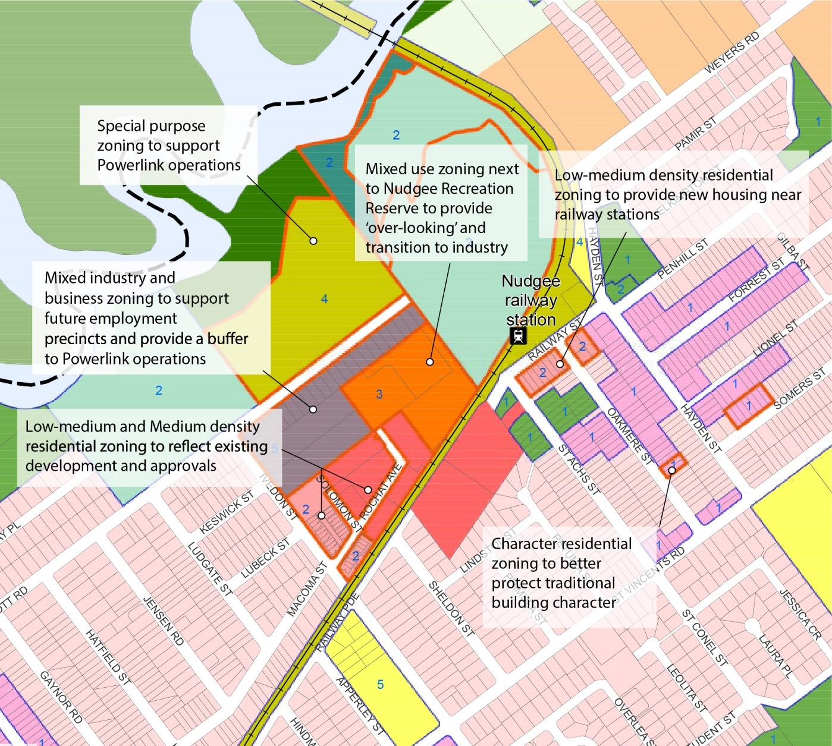

Figure 9—Areas of proposed zoning change – Nudgee

Proposed overlay changes

The amendment package includes changes to the following City Plan overlays:
- Active frontages in residential zones overlay map – to provide small scale, active uses near the Nudgee railway station and St Achs Street Park
- Commercial character building overlay map – to include nine additional commercial character buildings
- Dwelling house character overlay map – to include a number of properties rezoned from non-residential to residential
- Heritage overlay map – to include five additional local heritage places
- Industrial amenity overlay map – has been updated to ensure the industrial amenity investigation area reflect areas that may be subject to emissions from existing industrial uses
- Pre-1911 building overlay map – to include for additional pre-1911 buildings
- Significant landscape tree overlay map – to identify and protect an additional 17 established trees
- Streetscape hierarchy overlay map – to include revised streetscape hierarchy designations throughout the neighbourhood plan area, including for proposed future roads
- Traditional building character overlay map – to add protections for an additional 119 pre-1946 properties and remove protections from 10 properties which no longer include pre-1946 dwellings.

Amendment summary

Table 2––Amendment summary
Part | City Plan reference | Proposed amendment | Part B amendment reference
Part 1  (About the planning scheme) | Section 1.2 Planning scheme components | Changes are proposed to:  omit the Banyo—Nudgee neighbourhood plan, insert the Banyo—Northgate neighbourhood plan, including precincts:  - Northgate Station precinct (NPP-001)  - Bindha Station precinct (NPP-002)  - Bindha Station north sub-precinct (NPP-002a)  - Bindha Station south sub-precinct (NPP-002b)  - Banyo Station precinct (NPP-003)  - Nudgee Station precinct (NPP-004)  - Nudgee north precinct (NPP-005)  - Blinzinger Road precinct (NPP-006)  and amend the Nundah district neighbourhood plan. | Part 1.1 (1 and 2)
Part 5  (Tables of assessment) | Section 5.9 Categories of development and assessment—Neighbourhood plans | Omit the tables of assessment for the Banyo—Nudgee neighbourhood plan.  Insert the tables of assessment for the Banyo—Northgate neighbourhood plan. Amend the tables of assessment for the Nundah district neighbourhood plan. | Part 2.1 (3 to 10)
Part 7  (Neighbourhood plans) | Section 7.2 Neighbourhood plan codes | Omit the Banyo—Nudgee neighbourhood plan code.  Insert the Banyo—Northgate neighbourhood plan code, including supporting figures.  Amend the Nundah district neighbourhood plan code NPM-014.4. | Part 3.1 (11)  Part 3.2 (12, 13 and 14)
Part 8  (Overlays) | Section 8.2 Overlay Codes | Add significant landscape trees identified in the neighbourhood plan area. | Part 4.1 (15 and 16)
Schedule 2  (Mapping) | SC2.1 Strategic framework maps, SFM-003 | Amend the strategic framework map to identify Northgate as a planned growth node. | Part 5.1 (17)  Part 5.2 (18)
Schedule 2  (Mapping) | SC2.2 Zone maps, ZM-001  (Map tiles 13 and 21) | Amend the zone maps for the  Banyo—Northgate neighbourhood plan area. | Part 5.3 (19)  Part 5.4 (20)
Schedule 2  (Mapping) | SC2.3 Neighbourhood plan maps | Omit the map NPM-002.1  Banyo—Nudgee neighbourhood plan map.  Insert the map NPM-002.1  Banyo—Northgate neighbourhood plan map. | Part 5.5 (21)  Part 5.6 (23)
Schedule 2  (Mapping) | SC2.3 Neighbourhood plan maps | Amend the map NPM-014.4 Nundah district neighbourhood plan map. | Part 5.5 (22)
Schedule 2  (Mapping) | SC2.3 Neighbourhood plan maps | Amend the overlay map to identify active frontages in Low-medium density residential zones in the Nudgee Station precinct. | Part 5.7 (24) Part 5.8 (33)
Schedule 2  (Mapping) | SC2.4 Overlay maps,  OM-001.1  Active frontages in residential zones overlay map  (Map tile 13) | Amend the overlay map to identify active frontages in Medium density residential zones in the Nudgee Station precinct. | Part 5.7 (24) Part 5.8 (33)
 | SC2.4 Overlay maps,  OM-003.2  Commercial character building overlay map  (Map tile 13) | Amend the overlay map to identify commercial character buildings. | Part 5.7 (25) Part 5.8 (34)
 | SC2.4 Overlay maps,  OM-004.1  Dwelling house character overlay map  (Map tile 13) | Amend the overlay map to add properties rezoned from non-residential to residential and to remove properties rezoned from residential to non-residential. | Part 5.7 (26) Part 5.8 (35)
 | SC2.4 Overlay maps,  OM-008.1  Heritage overlay map  (Map tiles 13 and 21) | Amend the overlay map to identify additional properties for heritage protections. | Part 5.7 (27) Part 5.8 (36)
 | SC2.4 Overlay maps,  OM-009.1  Industrial amenity overlay map  (Map tile 13) | Amend the overlay map to include additional industrial amenity investigation areas. | Part 5.7 (28) Part 5.8 (37)
 | SC2.4 Overlay maps,  OM-016.2  Pre-1911 building overlay map  (Map tiles 13 and 21) | Amend the overlay map to identify additional pre-1911 buildings. | Part 5.7 (29) Part 5.8 (38)
 | SC2.4 Overlay maps,  OM-019.1  Significant landscape tree overlay map  (Map tiles 13 and 21) | Amend the overlay map to identify significant landscape trees. | Part 5.7 (30) Part 5.8 (39)
 | SC2.4 Overlay maps,  OM-019.2  Streetscape hierarchy overlay map  (Map tile 13) | Amend the overlay to include revised streetscape hierarchy classifications. | Part 5.7 (31) Part 5.8 (40)
 | SC2.4 Overlay maps,  OM-020.1  Traditional building character overlay map  (Map tiles 13 and 21) | Amend the overlay to identify properties rezoned to Character residential and remove properties that no longer contain pre-1946 buildings. | Part 5.7 (32) Part 5.8 (41)
Schedule 6  (Planning scheme policies) | SC6.29 Structure planning PSP, 1 Introduction, 1.1 Relationship to planning scheme | Amend table to include reference to the Banyo—Northgate neighbourhood plan. | Part 6.1 (42)
Appendix 2  (Table of amendments) | Table AP2.1—Table of amendments | Insert date of adoption and effective date, planning scheme version number, amendment type and summary of amendments as a result of the neighbourhood plan. | Part 7.1 (43)

Part B: Major Amendment v18.00/2020

It is hereby certified that this is a true and correct copy of Brisbane City Plan 2014 Major Amendment v18.00/2020 made, in accordance with the Planning Act 2016, by Brisbane City Council.

Dyan Currie
Chief Planner
City Planning and Economic Development
City Planning and Sustainability
Brisbane City Council

Part 1 Amendment of Part 1 (About the planning scheme)

1.1 Amendment of section 1.2 (Planning scheme components)
- Section 1.2 Planning scheme components, Table 1.2.2—Neighbourhood plans precincts and sub-precincts
‘
Banyo—Nudgee neighbourhood plan | NPP-001: Nudgee north  NPP-001a: Nudgee north a  NPP-002: Elliott Road north  NPP-002a: Elliott Road north a  NPP-002b: Elliott Road north b  NPP-002c: Elliott Road north c  NPP-003: Blinzinger Road  NPP-004: Banyo centre  NPP-004a: Banyo centre a  NPP-005: Banyo centre residential  NPP-006: Tufnell Road south  NPP-006a: Tufnell Road south a  NPP-007: St Vincents Road south
’–
omit, insert:
‘
Banyo—Northgate neighbourhood plan | NPP-001: Northgate Station  NPP-002: Bindha Station  NPP-002a: Bindha Station north  NPP-002b: Bindha Station south  NPP-003: Banyo Station  NPP-004: Nudgee Station  NPP-005: Nudgee north  NPP-006: Blinzinger Road
’.
- Section 1.2 Planning scheme components, Table 1.2.2—Neighbourhood plans precincts and sub-precincts
‘
Nundah district neighbourhood plan | NPP-001: St John’s Church  NPP-002: Nellie Street  NPP-003: Tufnell Lodge  NPP-004: Ex Tip Top bakery  NPP-005: Ryans Road industrial
’–omit, insert:
‘
Nundah district neighbourhood plan | NPP-001: Tufnell Lodge  NPP-002: Ex Tip Top bakery
’.

Part 2 Amendment of Part 5 (Tables of assessment)

2.1 Amendment of section 5.9 (Categories of development and assessment—Neighbourhood plans)
- Section 5.9 Categories of development and assessment—Neighbourhood plans, Table 5.9.1—Neighbourhood plan categories of development and assessment changes
‘
Banyo—Nudgee neighbourhood plan | Change | Change | No change | No change
’–
omit, insert:
‘
Banyo—Northgate neighbourhood plan | Change | No change | No change | No change
’.
- Section 5.9 Categories of development and assessment—Neighbourhood plans, Table 5.9.1—Neighbourhood plan categories of development and assessment changes
‘
Nundah district neighbourhood plan | Change | No change | No change | No change
’–
omit, insert:
‘
Nundah district neighbourhood plan | No change | No change | No change | No change
’.
- Section 5.9 Categories of development and assessment—Neighbourhood plans, Table 5.9.7.A—Banyo—Nudgee neighbourhood plan: material change of use–
omit.
- Section 5.9 Categories of development and assessment—Neighbourhood plans, Table 5.9.7.B—Banyo—Nudgee neighbourhood plan: reconfiguring a lot–
omit.
- Section 5.9 Categories of development and assessment—Neighbourhood plans, Table 5.9.7.C—Banyo—Nudgee neighbourhood plan: building work–
omit.
- Section 5.9 Categories of development and assessment—Neighbourhood plans, Table 5.9.7.D—Banyo—Nudgee neighbourhood plan: operational work–
omit.

- Section 5.9 Categories of development and assessment—Neighbourhood plans–
insert before Table 5.9.8.A Bowen Hills neighbourhood plan:
‘

Table 5.9.7.A—Banyo—Northgate neighbourhood plan: material change of use
Use | Categories of development and assessment | Assessment benchmarks
If in the neighbourhood plan area
MCU, if assessable development where not listed in this table | No change | Banyo—Northgate neighbourhood plan code
If in the Mixed industry and business zone precinct of the Specialised centre zone, where in the Northgate Station precinct (Banyo—Northgate neighbourhood plan/NPP-001)
MCU whether or not subsequently listed in this table | Assessable development—Impact assessment
MCU whether or not subsequently listed in this table | If involving a new premises or an existing premises with an increase in gross floor area, where not complying with AO1 or AO12 in the Banyo—Northgate neighbourhood plan code | The planning scheme including:  Banyo—Northgate neighbourhood plan code  Industry code  Prescribed secondary code  Specialised centre code  Specialised centre zone code
Bar | Assessable development—Code assessment
Bar | - | Banyo—Northgate neighbourhood plan code  Industry code  Prescribed secondary code  Specialised centre code  Specialised centre zone code
Veterinary service | Assessable development—Code assessment
Veterinary service | - | Banyo—Northgate neighbourhood plan code  Industry code  Prescribed secondary code  Specialised centre code  Specialised centre zone code
If at 688 Nudgee Road, Northgate (Lot 1 RP48166, Lots 13 to 15 RP48166, Lots 2 to 5 RP48166, Lot 7 SP12459), or at 19 Fraser Road, Northgate (Lot 1 SP121621) where in the Community facilities (Education purpose) zone
Health care | Assessable development—Code assessment
Health care | - | Banyo—Northgate neighbourhood plan code  Community facilities code  Prescribed secondary code
Emergency services | Assessable development—Code assessment
Emergency services | - | Banyo—Northgate neighbourhood plan code  Community facilities code  Prescribed secondary code

Table 5.9.7.B—Banyo—Northgate neighbourhood plan: reconfiguring a lot
Development | Categories of development and assessment | Assessment benchmarks
If in the neighbourhood plan area
ROL, if assessable development where not listed in this table | No change | Banyo—Northgate neighbourhood plan code

Table 5.9.7.C—Banyo—Northgate neighbourhood plan: building work
Development | Categories of development | Assessment benchmarks
Building work, if assessable development | No change | Banyo—Northgate neighbourhood plan code

Table 5.9.7.D—Banyo—Northgate neighbourhood plan: operational work
Development | Categories of development and assessment | Assessment benchmarks
Operational work if, assessable development | No change | Banyo—Northgate neighbourhood plan code
’.

- Section 5.9 Categories of development and assessment—Neighbourhood plans, Table 5.9.53.A—Nundah district neighbourhood plan: material change of use–
omit, insert:
‘

Table 5.9.53.A—Nundah district neighbourhood plan: material change of use
Use | Categories of development and assessment | Assessment benchmarks
If in the neighbourhood plan area
MCU, if assessable development where not listed in this table | No change | Nundah district neighbourhood plan code
’.

Part 3 Amendment of Part 7 (Neighbourhood plans)

3.1 Amendment of section 7.1 (Preliminary)
- Section 7.1 Preliminary, Table 7.1.1—Neighbourhood plan codes
‘
7.2.2.1 | Banyo—Nudgee neighbourhood plan | NPM-002.1
’–
omit, insert:
‘
7.2.2.1 | Banyo—Northgate neighbourhood plan | NPM-002.1
’.

3.2 Amendment of section 7.2 (Neighbourhood plan codes)
- Section 7.2 Neighbourhood plan codes, 7.2.2.1 Banyo—Nudgee neighbourhood plan code–
omit.
- Section 7.2 Neighbourhood plan codes–
insert before 7.2.2.2 Bowen Hills neighbourhood plan code:
‘

7.2.2.1 Banyo—Northgate neighbourhood plan code

7.2.2.1.1 Application
- This code applies to assessing a material change of use, reconfiguring a lot, operational work or building work in Banyo—Northgate neighbourhood plan area if:
- assessable development where this code is an applicable code identified in the assessment benchmarks column of a table of assessment for a neighbourhood plan (section 5.9); or
- impact assessable development.
- Land in Banyo—Northgate neighbourhood plan is identified on NPM-002.1
Banyo—Northgate neighbourhood plan map and includes the following precincts:
- Northgate Station precinct (Banyo—Northgate neighbourhood plan/NPP-001);
- Bindha Station precinct (Banyo—Northgate neighbourhood plan/NPP-002):
- Bindha north sub-precinct (Banyo—Northgate neighbourhood plan NPP-002a);
- Bindha south sub-precinct (Banyo—Northgate neighbourhood plan NPP-002b).
- Banyo Station precinct (Banyo—Northgate neighbourhood plan/NPP-003);
- Nudgee Station precinct (Banyo—Northgate neighbourhood plan/NPP-004);
- Nudgee north precinct (Banyo—Northgate neighbourhood plan/NPP-005);
- Blinzinger Road precinct (Banyo—Northgate neighbourhood plan/NPP-006);
- When using this code, reference should be made to section 1.5, section 5.3.2 and section 5.3.3.
Note—The following purpose, overall outcomes, performance outcomes and acceptable outcomes comprise the assessment benchmarks of this code.
Note—This neighbourhood plan includes a table of assessment with variations to categories of development and assessment. Refer to Table 5.9.7.A, Table 5.9.7.B, Table 5.9.7.C and Table 5.9.7.D.
Note—The terms ‘advanced manufacturing’ and ‘creative industries’ are defined in the Advanced Manufacturing Growth Centre report ‘Advanced manufacturing – a new definition for a new era’ (2017), and Brisbane City Council’s ‘Creative Brisbane. Creative Economy. 2013-22’ report (2013).

7.2.2.1.2 Purpose
- The purpose of the Banyo—Northgate neighbourhood plan code is to provide finer grained planning at a local level for the Banyo—Northgate neighbourhood plan area.
- The purpose of the Banyo—Northgate neighbourhood plan code will be achieved through overall outcomes, including overall outcomes for each precinct of the neighbourhood plan.
- The overall outcomes for the Banyo—Northgate neighbourhood plan are:
- Development in the Low impact industry zone, General industry zone precincts A, B and C, and the Mixed Industry and business zone precinct of the Specialised centre zone supports Brisbane’s economy by facilitating the ongoing operation and evolution of industrial activities in Brisbane’s Northern industrial area and along Toombul Road.
- Residential development is a mix of low density, character residential and low-medium density residential housing with limited provision for medium density residential development in the Medium density residential and Mixed use zones.
- Development in the growth node around Northgate railway station provides a mix of employment and residential uses which is primarily residential to the west of the railway line, and primarily mixed industry and business to the east of the railway line.
- Development in the railway station precincts creates a high quality, fine grain urban environment promoting pedestrian activity, including achieving access through pedestrian arcades, and maximising access to public transport.
- Development creates an integrated local road network which facilitates direct access to railway stations and activity centres, and supports finer grained development.
- Development for a sensitive use within the Industrial amenity investigation area sub-category is compatible with nearby existing uses that have the potential for off-site air or noise emissions and does not adversely impact on the continued operation of those existing uses.
- Development ensures that the environmental values, including habitat, ecological, cultural and waterway values of Nundah Creek, Nudgee Waterhole and the corridor linking the waterhole to the Boondall Wetlands indicated in Figure e are retained and enhanced.
- Development is of a height scale and form which is consistent with the amenity and character, community expectations and infrastructure assumptions intended for the relevant precinct, sub-precinct or site and is only developed at a greater height, scale and form where there is both a community need and economic need for the development.
- Northgate Station precinct (Banyo—Northgate neighbourhood plan/NPP-001) overall outcomes are:
- Development in the Mixed industry and business zone precinct of the Specialised centre zone provides a mix of low impact industrial uses, including advanced manufacturing, creative industries and commercial uses including offices, shops and food and drink outlets.
- Development creates active building frontages and high quality, tree-lined city streetscapes along Holland Street and Ridge Street to support pedestrian movement to Northgate railway station.
- Development near the Northgate railway station creates a publicly accessible plaza that provides an active pedestrian entry to the southern access to Northgate railway station as indicated in Figure a.
- Development in the Mixed use zone on Ridge Street provides cafes, restaurants, and local shops near the Northgate railway station and provides a significant corner site to identify the southern entrance to the Northgate Station precinct (Banyo—Northgate neighbourhood plan/NPP-001).
- Bindha Station precinct (Banyo—Northgate neighbourhood plan/NPP-002) overall outcomes are:
- Development of the large land holdings close to the Bindha railway station, which forms part of the Northern industrial area, supports Brisbane’s industrial economy by providing a mix of advanced manufacturing, low impact industry, and office uses.
- Development achieves legible pedestrian access to the Bindha railway station for residents and employees.
- Development in the Bindha Station north sub-precinct (Banyo—Northgate neighbourhood plan/NPP-002a):
- achieves an integrated mixed industry and business precinct with a focus on advanced manufacturing;
- creates a local road network, including a north-south connection between St Vincents Road and Bindha railway station and east west connections between Harold Street and Blinzinger Road and between Blinzinger Road and Bindha railway station as indicated in Figure b, which minimises direct access to identified freight routes;
- creates a publicly accessible plaza to provide a pedestrian entry to the Bindha railway station as indicated in Figure b.
- Development in the interface area of the Bindha Station north sub-precinct (Banyo—Northgate neighbourhood plan/NPP-002a), shown in Figure b:
- has a built form that provides a transition between the mixed industry and business area outside the interface area, and the surrounding low and low-medium density residential areas;
- provides a human scale front façade that is engaging at street level;
- provides for a range of industry and business uses;
- may include a limited amount of residential development where a residential use is adjacent to or opposite land in a residential zone; provides an acceptable level of residential amenity where occupants should expect ambient noise levels to be relatively high, both inside and outside buildings, due to their proximity to industrial activities; and does not prejudice the operation of existing or future industry uses.
- Development in the Bindha Station south sub-precinct (Banyo—Northgate neighbourhood plan/NPP-002b):
- creates a local road network including north-south connections between Earnshaw Road and Bindha railway station, and an east-west connection from the Bindha Station south sub-precinct (Banyo—Northgate neighbourhood plan/NPP-002b) to the Banyo Station precinct (Banyo—Northgate neighbourhood plan/NPP-003) as indicated in Figure b.
- Banyo Station precinct (Banyo—Northgate neighbourhood plan/NPP-003) overall outcomes are:
- Development establishes Tufnell Road and St Vincents Road as active main streets providing for a mix of small scale commercial and residential tenancies.
- Development provides a diverse range of centre activities for the residents, workers and visitors of the Banyo district catchment including a maximum of two full line supermarkets.
- Development creates new road connections to Tufnell Road (Banyo Station precinct, Banyo—Northgate neighbourhood plan/NPP-003), Earnshaw Road and the Bindha Station south sub-precinct (Banyo—Northgate neighbourhood plan/NPP-002b) as indicated in Figure c.
- Nudgee Station precinct (Banyo—Northgate neighbourhood plan/NPP-004) overall outcomes are:
- Development creates a mix of low impact industry and office activities on Elliott Road and Ivedon Street that provides a buffer between utility services on the north side of Elliott Road and residential development on Ivedon Street, Rochat Avenue and Solomon Street.
- Development is oriented to and provides an active frontage to the Nudgee Recreation Reserve, as indicated in Figure d.
- Development extends Rochat Avenue to Elliott Road to improve local road network accessibility as indicated in Figure d.
- Development creates an arcade to improve pedestrian access to the Nudgee railway station from Rochat Avenue in accordance with Figure d.
- Development extends Railway Parade to Railway Street to improve local road network accessibility to Nudgee railway station as indicated in Figure d.
- Development supports the consolidation of St Achs Street Park and Railway Park as indicated in Figure d.
- Development in Railway Street provides a mix of low-medium density residential, small scale retail and food and drink outlets.
- Nudgee north precinct (Banyo—Northgate neighbourhood plan/NPP-005) overall outcomes are:
- Development provides a retirement facility and complementary facilities on the Mercy Centre site (131 Queens Road, Nudgee).
- Development protects the habitat and ecological values of Nundah Creek and the Nudgee Waterhole to Boondall Wetlands corridor.
- Blinzinger Road precinct (Banyo—Northgate neighbourhood plan/NPP-006) overall outcomes are:
- Development comprises a mix of dwelling houses and multiple dwellings at a yield of 16 to 25 dwellings per hectare which is sensitive to the physical and visual character and amenity of the adjoining Low density residential neighbourhood.

7.2.2.1.3 Performance outcomes and acceptable outcomes

Table 7.2.2.1.3.A—Performance outcomes and acceptable outcomes
Performance outcomes | Acceptable outcomes
General
PO1  Development is of a height, scale and form that achieves the intended outcome for the precinct, improves the amenity of the neighbourhood plan area, contributes to a cohesive streetscape and built form character and is:  - consistent with the anticipated density and assumed infrastructure demand;  - aligned to community expectations about the number of storeys to be built;  - proportionate to and commensurate with the utility of the site area and frontage width;  - designed to avoid a significant and undue adverse amenity impact on adjoining development;  - sited to enable existing and future buildings to be well separated from each other and avoid affecting the potential development of an adjoining site.  Note—Development that exceeds the intended number of storeys or building height can place disproportionate pressure on the transport network, public space or community facilities in particular.  Note—Development that is over-scaled for its site can result in an undesirable dominance of vehicle access, parking and manoeuvring areas that significantly reduce streetscape character and amenity. | AO1  Development complies with the number of storeys and building height in Table 7.2.2.1.3.B.  Note—Neighbourhood plans will mostly specify a maximum number of storeys where zone outcomes have been varied in relation to building height. Some neighbourhood plans may also specify height in metres. Development must comply with both parameters where maximum number of storeys and height in metres are specified.
PO2  Development for a publicly accessible plaza or arcade provided as part of development is easily accessed, attractive and supports personal safety. | AO2.1  Development provides for pedestrian and cyclist movement adjoining and through a site at street level or at-grade.  Note—Grade separated pedestrian movement systems, such as an overhead bridge or underpass, are avoided because they are less attractive and safe for users.
AO2.2
Development for a plaza, arcade, and other external area in the site which is intended for public access at night complies with:
- AS/NZS 1158.3.1:2005 Lighting for roads and public spaces Category P3;
- AS 4282-1997 Control of the obtrusive effects of outdoor lighting.
PO3  Development facilitates new pedestrian linkages to local streets (arcades) that improve pedestrian walkability to Northgate railway station and Nudgee railway station. | AO3  Development for the arcades identified in Figure a, between Holland Street and Melton Road, and Figure d, between Rochat Avenue and Nudgee railway station:  - provides pedestrian access during hours of operation of the use;  - integrates with adjoining buildings;  - links established pedestrian networks, parking and public transport facilities;  - has a minimum corridor width of 6m, including a minimum unobstructed pavement width of 3m;  - has an active use edge;  - is finished with high quality materials considering public safety;  - is provided at-grade with an adjoining public area and connects safely without any lip or step;  - incorporates crime prevention through environmental design principles to maximise safety;  - has signage at each end identifying the connection provided;  - is straight and allows for visual connection to the other end.  Note—Crime prevention principles can be found in the Crime prevention through environmental design planning scheme policy.
PO4  Development improves connectivity for road users, pedestrians and cyclists by providing the following local roads:  - a local road between Hamilton Street and Holland Street, and between Landy Street and Allworth Street as indicated in Figure a;  - local roads between St Vincents Road and Bindha railway station, between Harold Street and Blinzinger Road and between Blinzinger Road and Bindha railway station as indicated in Figure b;  - local roads to Tufnell Road and Earnshaw Road and to the Bindha Station south sub-precinct as indicated in Figure c;  - local roads between Rochat Avenue and Elliott Road, and between Railway Parade and Railway Street as indicated in Figure d;  - a local road from Blinzinger Road, opposite Raleigh Street, to Wellington Street as indicated in Figure f. | AO4  No acceptable outcome is prescribed.
If in the Northgate Station precinct (Banyo—Northgate neighbourhood plan/NPP-001)
PO5  Development ensures that the building bulk and scale is consistent with the intended form and character of the Northgate Station precinct. | AO5.1  Development is contained within the building envelope for the site by applying:  - the maximum building height;  - front, rear and side setback requirements;  - building separation requirements;  - car parking setback requirements;  - active frontage requirements.  Note—The building envelope must include all requirements from any applicable overlay codes.  Note—This can be demonstrated by a building envelope plan, elevations and sections.
AO5.2
Development has front, side and rear boundary setbacks that comply with Table 7.2.2.1.3.C.
PO6  Development creates an attractive building interface with the streetscape along Holland Street and Ridge Street that is transit supportive to:  - facilitate safe, logical and direct pedestrian access to the railway station entry point;  - activate public space entry to the railway station;  - create vibrant and attractive street environment;  - enable casual surveillance of Holland Street and Ridge Street public spaces and the immediate railway station entry environment;  - provide a high level of personal and community safety and physical and visual integration with the railway station;  - provide a human scale, front façade that is engaging at street level. | AO6  Development along Holland Street and Ridge Street is treated as an active frontage–primary as indicated in Figure a, and provides:  - a continuous built form to the street at the nominated setback;  - a ground storey fully occupied by highly active non-residential uses including food and drink outlet or shop;  - a first and second storey featuring windows or balconies promoting interaction with and surveillance of the street;  - awnings for the primary pedestrian entry on the active building frontage;  - lighting of publicly accessible areas including the underside of awnings;  - at least 1 pedestrian entry and exit for every 10m of building frontage;  - a minimum of 50% transparent external wall materials up to a height of 2.5m above pavement level;  - a minimum ground-storey height of 4.2m.
PO7  Development of vehicle access and parking does not impact on active frontages. | AO7.1  Development along Holland Street and Ridge Street, ensures that vehicle and service access is:  - not located on this active frontage–primary;  - from a secondary frontage or from an adjoining premises if a shared driveway and access arrangement is established.
AO7.2
Development along Holland Street and Ridge Street ensures that parking is not located adjacent to the frontage or is not visible from the street.
PO8  Development provides car parking which:  - minimises the impact on the quality of adjoining streetscapes or public spaces in terms of location, bulk, form and amenity impacts including noise, light or odours;  - takes account of the following:  - the location of active frontages and public spaces;  - setback distances to mitigate impacts;  - the scale and detail of any parking structure walls when viewed from the street and adjoining properties;  - the visual impact of open car parking and vehicle movement areas on the street and adjoining properties;  - convenient, safe and legible vehicle access and car parking for users. | AO8.1  Development provides car parking which is:  - not visible from the street, other public spaces or adjoining properties; or  - located below ground or behind active uses for the full street frontage;  - set back from front, rear and side boundaries in compliance with the requirements in Table 7.2.2.1.3.D.  Note—Car parking which extends 1m above ground level will be counted in the maximum height and will be subject to the relevant boundary setback requirements.
AO8.2
Development does not provide a basement parking structure which:
- extends above ground level forward of the main building line;
- impacts on connections between the public footpath or space and the development.
AO8.3
Development only provides car parking located above ground if:
- it is fully integrated within the building design and is sleeved by development to required active frontages; or
- it offers short term car parking for customer, visitors or service providers, that is a portion of the total required car parking, and does not impact on active frontage requirements; or
- it is located to the side or rear of the site away from the primary street or active frontage.
AO8.4
Development for a multistorey or podium car park:
- is not located on the street frontage and is behind smaller uses to create an active frontage and avoid long blank walls particularly adjacent to a primary entrance from a key pedestrian connection; or
- includes building façade details that extend to disguise the car parking floors; or
- is screened to become a visually interesting structure.
AO8.5
Development ensures that visitor or customer car parking is:
- clearly signposted;
- lit at night;
- not located behind a security barrier.
Note—The detailed design is in accordance with the Transport, access, parking and servicing code and planning scheme policy.
PO9  Development creates an active railway station plaza to improve visual and pedestrian connectivity to the southern Holland Street entry of the Northgate railway station. | AO9.1  Development provides a railway station forecourt (plaza) of at least 400m2 on Holland Street adjacent to the Northgate railway station in accordance with Figure a which:  - is a regular shape and has a minimum frontage to Holland Street of 10m and a minimum dimension of 20m;  - is integrated with surrounding development and with the pedestrian access to the Northgate railway station;  - is located at the level of the ground storey of adjoining buildings;  - is suitable for pedestrian and cyclist access;  - includes a minimum of 50% hard paved area;  - includes a minimum of 20% deep-planting area to accommodate subtropical shade trees;  - is a minimum 75% open to the sky;  - does not provide for a vehicle entry, driveway, car parking, bin storage or servicing area;  - does not provide for a mechanical ventilation outlet or vent on a frontage adjoining the plaza.
AO9.2
Development provides active frontages to Holland Street and the railway station plaza as indicated in Figure a.
AO9.3
Development for a plaza:
- is publicly accessible;
- provides equitable access to and movement in the plaza in accordance with AS 1428.1-2009 Design for access and mobility;
- has a dominant ground level that is less than 1m above or below the dominant adjacent street level;
- is designed such that the majority of the plaza space, that is an area which is more than 50%, is visible from the dominant adjacent public street.
PO10  Development of a significant corner site creates a locally distinct streetscape on the Ridge Street, Holland Street and Melton Road frontages to maximise street level activity and pedestrian movement to Northgate railway station. | AO10  Development is designed to emphasise the corner setting of the significant corner site as indicated in Figure a.
If in the Northgate Station precinct (Banyo—Northgate neighbourhood plan/NPP-001), where in the Specialised centre (Mixed industry and business) zone
PO11  Development has a site cover which:  - balances built form with open space, parking and landscaping at ground level;  - limits areas of external surface car parking;  - provides for landscaping and deep planting areas. | AO11  Development has a maximum site cover of 75%.  Note—The site cover includes at-grade car parking areas that are covered with shelter. Enclosed car parking areas are included if they protrude more than 1m above ground level.
PO12  Development provides for a wide range of industry and business uses, with a focus on low impact industry, research and technology industry and service industry uses. | AO12  Development on a site 2,500m2 or greater ensures that at least 60% of the gross floor area is used for low impact industry, or research and technology industry or service industry.
If in the Bindha Station north sub-precinct (Banyo—Northgate neighbourhood plan/NPP-002a)
PO13  Development provides a comprehensive response to integrating large sites, that:  - provides a mix of low impact industry, research and technology industry, and service industry uses;  - provides small scale uses that serve workers in the mixed industry and business area such as food and drink outlets, shops and community facilities;  - may include some residential uses in the interface area shown on Figure b, where a residential use:  - is adjacent to and addresses St Vincents Road, Cranwich Street or Blinzinger Road;  - is located, designed and constructed to achieve the air quality (planning) criteria in Table 8.2.13.3.B, odour criteria in Table 8.2.13.3.C and health risk criteria in Table 8.2.13.3.D;  - is located, designed and constructed to achieve the noise (planning) criteria in Table 8.2.13.3.E to protect the development from adverse noise impacts;  - demonstrates that the scale and design of new buildings will respect and respond to the neighbouring Suburban Living Area;  - ensures building heights step down to neighbouring low density and low-medium density residential areas;  - provides a high quality public realm and internal access circulation with a strong pedestrian focus through subtropical landscaping, streetscape improvements and passive surveillance;  - provides a railway station forecourt public plaza as a public space to support a central public space and improved visual and pedestrian connectivity between the precinct and Bindha railway station;  - provides high quality pedestrian and cyclist access that connects with the Bindha railway station and promotes reduction in private transport demands;  - provides vehicular access and circulation to the site that integrates with the local road network.  Note—An air quality impact report prepared in accordance with the Air quality planning scheme policy can assist in demonstrating achievement of this performance outcome.  Note—A noise impact assessment report prepared in accordance with the Noise impact assessment planning scheme policy can assist in demonstrating achievement of this performance outcome. | AO13  Development is consistent with a structure plan, prepared in accordance with the Structure planning planning scheme policy, that demonstrates the following:  - at least 60% of the gross floor area for the sub-precinct as a whole is used for low impact industry, or research and technology industry or service industry ;  - a railway station forecourt public plaza is located near Bindha station as shown in Figure b;  - an integrated, publicly accessible, road network connecting St Vincents Road, Harold Street and Blinzinger Road to Bindha railway station as indicated in Figure b;  - an arcade connecting Park Street to Bindha Station as shown in Figure b;  - building heights in the interface area in Figure b do not exceed three storeys;  - vehicular access to primary freight access roads is provided via the internal road network;  - residential development is provided only if:  - located in the interface area indicated in Figure b;  - located adjacent to, and addressing, St Vincents Road, Cranwich Street or Blinzinger Road;  - the use does not extend more than 26m perpendicular to the road frontage;  - no more than 50% of the length of the road frontage comprises residential uses;  - the use is not located within the minimum separation distance specified to a use in Table 8.2.13.3.G.  Note—Refer SC6.29 Structure planning planning scheme policy for further guidance.
If in the Bindha Station south sub-precinct (Banyo—Northgate neighbourhood plan/NPP-002b)
PO14  Development achieves new local public road access, extending the surrounding street network through the site to support finer grained redevelopment, an integrated precinct outcome and access to Bindha railway station. | AO14  Development achieves an integrated local road connection to Bindha railway station and to the Banyo Station precinct, as indicated in Figure b.
If in the Banyo Station precinct (Banyo—Northgate neighbourhood plan/NPP-003)
PO15  Development in the District centre zone provides small scale shops and offices fronting Tufnell Road and St Vincents Road, and one additional full line supermarket near the future roads connecting to Tufnell Road identified in Figure c. | AO15  No acceptable outcome is prescribed.
If in the Nudgee Station precinct (Banyo—Northgate neighbourhood plan/NPP-004)
PO16  Development in Mixed use zone provides a building design that incorporates passive surveillance of Nudgee Recreation Reserve. | AO16  Development where facing the Nudgee Recreation Reserve is oriented to overlook the reserve with windows and balconies located on upper levels designed to provide casual surveillance opportunities.
PO17  Development provides land for public park on St Achs Street. | AO17  Development allows for the conversion of the access strip at 70 St Achs Street to public open space in Figure d once alternative access from Railway Parade has been established.
PO18  Development where fronting Ivedon Street has a building size and bulk which is consistent with adjoining and facing residential areas. | AO18  Development building height where within 30m of the Ivedon Street frontage does not exceed 2 storeys.
If in the Nudgee north precinct (Banyo—Northgate neighbourhood plan/NPP-005)
PO19  Development is sited to protect the ecology and landscape values of the Nudgee Waterhole to Boondall Wetlands environment corridor. | AO19  No acceptable outcome is prescribed.
If in the Blinzinger Road precinct (Banyo—Northgate neighbourhood plan/NPP-006)
PO20  Development provides a new local park on the corner of Blinzinger Road and Wellington Street, as indicated in Figure f. | AO20  Development provides local recreation space as shown in Figure f.

Table 7.2.2.1.3.B—Maximum building height
Development | Maximum building height (storeys)
If in the Northgate Station precinct (Banyo—Northgate neighbourhood plan/NPP-001), where in the Specialised centre (Mixed industry and business) zone
Development of a site less than 2,500m2, or where less than 60% of the gross floor area is for low impact industry or research and technology industry or service industry. | 4 storeys
Development of a site 2,500m2 or greater and where at least 60% of the gross floor area is for low impact industry, or research and technology industry or service industry. | 6 storeys
If in the Bindha Station north sub-precinct (Banyo—Northgate neighbourhood plan/NPP-002a)
Development within the interface area indicated in Figure b. | 3 storeys
Development outside the interface area where less than 60% of the gross floor area for the sub-precinct as a whole is for low impact industry or research and technology industry or service industry. | 4 storeys
Development outside the interface area where at least 60% of the gross floor area for the sub-precinct as a whole is for low impact industry, or research and technology industry or service industry. | 6 storeys
If in the Nudgee north precinct (Banyo—Northgate Neighbourhood plan/NPP-005)
Any development | 2 storeys

Table 7.2.2.1.3.C—Boundary setback requirements for Northgate Station precinct
Height | Minimum boundary setback
Height | Front/street (m) |  | Side (m) | Rear (m)
Height | Where fronting Holland Street (Active frontage) | Where fronting Toombul Road | Side (m) | Rear (m)
Ground storey | 0 | 3 | 0 if blank  2 otherwise | 6
Podium or up to 3 storeys | 0 | 3 | 0 if blank  3 otherwise | 6
Tower – above 3 storeys to 6 storeys | 6 | 6 | 6 | 10
Notes—
- For development located on a site with 2 or more street frontages, a primary street frontage will be nominated.
- For a site with 2 or more street frontages, all common boundaries with adjoining lots are considered side boundaries.
- Building height transition and building separation requirements to a residential development may vary boundary setback requirements.
- Front boundary setbacks are generally not influenced by building separation requirements.

Table 7.2.2.1.3.D—Siting requirements for car parking
Height of wall or parking  Car parking configuration | Minimum boundary setback to parking or parking structure (m)
Height of wall or parking  Car parking configuration | Front/street | Side/rear
Below ground level or above ground level by less than 1m and enclosed | 0 if below ground level  4 if above ground level by less than 1m | 0
Above ground level by less than 4.5m and enclosed | 6 | 0
Above ground level between 4.5m and 2 storeys or 7.5m and enclosed | 6 | 0  3 if partially open
Above ground level between 7.5m and 3 storeys or 10.5m and enclosed | 6 | 0  6 if partially open
Above ground level by greater than 3 storeys and 10.5m | No acceptable outcome is prescribed
Notes—
- Height is to the highest point of the car parking structure including any roofing or shelter to the car parking area, measured above ground level to any point on the site.
- The height also includes fences, balustrades or podium planters located above the enclosed parking structure.
- Where a terrace area is created on a car parking structure, any roofing is to comply with the boundary setback requirements for a balcony in Table 7.2.2.1.3.C.
- A number of car parking design configurations and wall heights relative to ground level may occur on a site. The impact of refuse collection is to be considered in the design of car parking if refuse storage is located in a parking area or structure.

Figure a—Northgate Station precinct

Figure b—Bindha Station precinct

Figure c—Banyo Station precinct

Figure d—Nudgee Station precinct

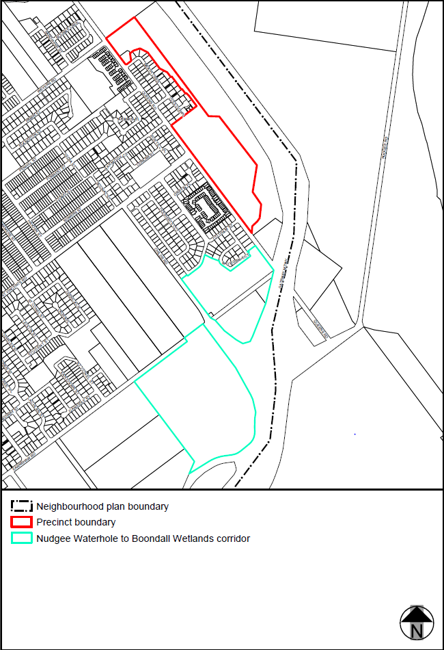 Figure e—Nudgee north precinct
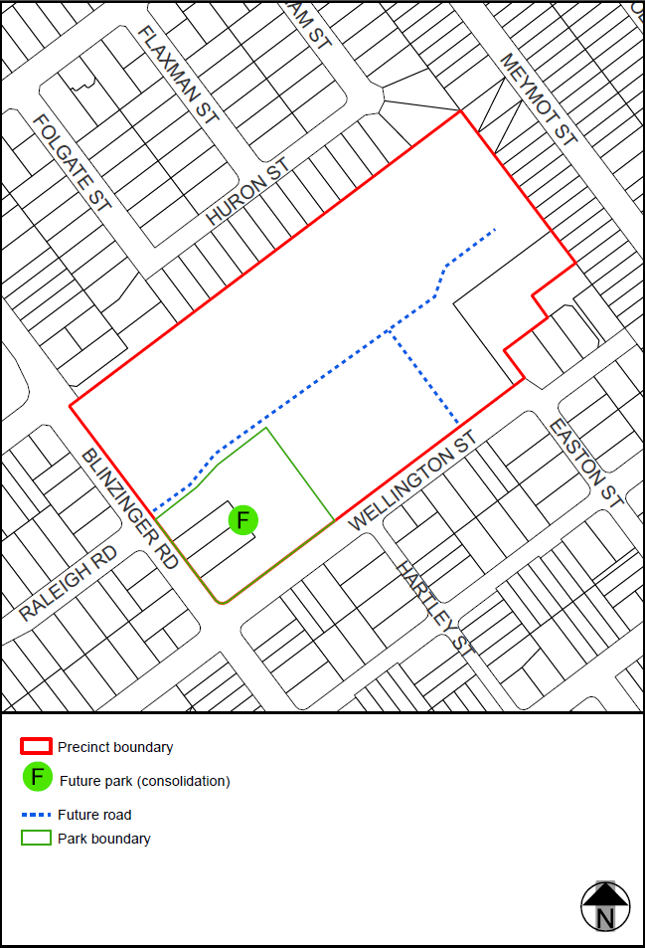

Figure f—Blinzinger Road precinct
’.

- Section 7.2 Neighbourhood plan codes, 7.2.14.4 Nundah district neighbourhood plan code–
omit, insert:
‘

7.2.14.4 Nundah district neighbourhood plan code

7.2.14.4.1 Application
- This code applies to assessing a material change of use, reconfiguring a lot, operational work or building work in Nundah district neighbourhood plan area if:
- assessable development where this code is an applicable code identified in the assessment benchmarks column of a table of assessment for a neighbourhood plan (section 5.9); or
- impact assessable development.
- Land in Nundah district neighbourhood plan is identified on NPM-014.4 Nundah district neighbourhood plan map and includes the following precincts:
- Tufnell Lodge precinct (Nundah district neighbourhood plan/NPP-001);
- Ex Tip Top bakery precinct (Nundah District neighbourhood plan/NPP-002);
- When using this code, reference should be made to section 1.5, section 5.3.2 and section 5.3.3.
Note—The following purpose, overall outcomes, performance outcomes and acceptable outcomes comprise the assessment benchmarks of this code.
Note—This neighbourhood plan includes a table of assessment with variations to categories of development and assessment. Refer to Table 5.9.53.A, Table 5.9.53.B, Table 5.9.53.C and Table 5.9.53.D.

7.2.14.4.2 Purpose
- The purpose of the Nundah district neighbourhood plan code is to provide finer grained planning at a local level for Nundah district neighbourhood plan area.
- The purpose of the Nundah district neighbourhood plan code will be achieved through overall outcomes, including overall outcomes for each precinct of the neighbourhood plan.
- The overall outcomes for the Nundah district neighbourhood plan are:
- The district has a mix of low density and low-medium density housing as its dominant land use. Medium density housing is concentrated close to the Toombul Nundah Major centre. The design of infill residential development is sympathetic to the established streetscapes, character and amenity of the district.
- A balanced mix of housing densities and types is provided to meet the community’s needs including the elderly population and emerging trend of smaller sized households. Public housing integrates with existing residential areas and promotes a socially diverse community reducing potential isolation of some residents.
- Important local heritage places and landmarks such as the First Free Settlers Monument and the Corpus Christi Church are protected and enhanced.
- Environmental assets, such as Kedron Brook and Downfall Creek are protected, enhanced and rehabilitated so that they continue to contribute towards the biodiversity of the district.
- Kalinga, Shaw, and Oxenham Parks are recreational areas for the community. These are complemented by local parklands such as Boyd, Nundah Memorial, ARC Hill and Ross Parks, which are accessible, safe and attractive places to meet and play.
- Development is of a height, scale and form which is consistent with the amenity and character, community expectations and infrastructure assumptions intended for the relevant precinct or site and is only developed at a greater height, scale and form where there is both a community need and an economic need for the development.
- Tufnell Lodge precinct (Nundah district neighbourhood plan/NPP-001) overall outcomes are:
- This precinct is used for community purposes.
- Development on the site incorporates the significant mature vegetation on site and is of suitable grade throughout with medium density development towards the Buckland Road frontage and low density development adjacent to the neighbouring low density areas.
- Ex Tip Top bakery precinct (Nundah district neighbourhood plan/NPP-002) overall outcomes are:
- This precinct accommodates uses such as offices, indoor sport and recreation or educational establishments that support the Toombul—Nundah Major Centre.
- Appropriate buffering is incorporated on the site providing an interface with adjoining residential properties.

7.2.14.4.3 Performance outcomes and acceptable outcomes

Table 7.2.14.4.3.A—Performance outcomes and acceptable outcomes
Performance outcomes | Acceptable outcomes

General
PO1  Development is of a height, scale and form that achieves the intended outcome for the precinct, improves the amenity of the neighbourhood plan area, contributes to a cohesive streetscape and built form character and is:  - consistent with the anticipated density and assumed infrastructure demand;  - aligned to community expectations about the number of storeys to be built;  - proportionate to and commensurate with the utility of the site area and frontage width;  - designed to avoid a significant and undue adverse amenity impact on adjoining development;  - sited to enable existing and future buildings to be well separated from each other and avoid affecting the potential development of an adjoining site.  Note—Development that exceeds the intended number of storeys or building height can place disproportionate pressure on the transport network, public space or community facilities in particular.  Note—Development that is over-scaled for a site can result in an undesirable dominance of vehicle access, parking and manoeuvring areas that significantly reduce streetscape character and amenity. | AO1  Development complies with the number of storeys and building height in Table 7.2.14.4.3.B.  Note—Neighbourhood plans will mostly specify a maximum number of storeys where zone outcomes have been varied in relation to building height. Some neighbourhood plans may also specify height in metres. Development must comply with both parameters where maximum number of storeys and height in metres are specified.
If in the Ex Tip Top bakery precinct (Nundah district neighbourhood plan/NPP-002)
PO2  Development is of a scale and design generally compatible with those of nearby buildings and contributes positively to the amenity and character of the local area. | AO2.1  Development provides vehicular access to the site via the Eton Street and/or Oliver Street frontages.  Note—The building envelope must include all requirements from any applicable overlay codes.  Note—This can be demonstrated by a building envelope plan, elevations and sections.
AO2.2
Development provides a landscaped buffer of at least 10m in width adjacent to the entire length of the western boundary of the precinct.

Table 7.2.14.4.3.B—Maximum building height
Development | Building height (m)
If in the Ex Tip Top bakery precinct (Nundah district neighbourhood plan/NPP-002)
Any development in this precinct | 10
’.

Part 4 Amendment of Part 8 (Overlays)

4.1 Amendment to section 8.2.19 (Significant landscape tree overlay code)
- Section 8.2.19 Significant landscape tree overlay code, Table 8.2.19.3.C—Significant landscape trees in specific locations–
insert before Bardon:
‘

Banyo
Delonix regia poinciana | 1 Coronet Street (front garden) | L20 RP103134
Delonix regia poinciana | 419 Earnshaw Road (rear eastern corner) | L9 RP84918
Corymbia maculata spotted gum | 425 Earnshaw Rd (Kagoola Street frontage) | L1 RP34635  L8 RP98070
Eucalyptus tereticornis forest red gum | 228 St Vincents Road (back garden) | L345 and L363 RP34623
’.
- Section 8.2.19 Significant landscape tree overlay code, Table 8.2.19.3.C—Significant landscape trees in specific locations–
insert before Paddington:
‘

Northgate
Araucaria cunninghamii hoop pine | 43 Cook Street (mid north side boundary) | L24 RP34520
Araucaria cunninghamii hoop pine | 51 Cook Street (rear boundary) | L4 RP64678
Ficus benjamina  weeping fig | 30 Junior Terrace (back garden) | L550 to L551 RP34599
Araucaria cunninghamii hoop pine | 136 Gympie Street (front corner) | L1 RP62283
Eucalyptus microcorys stringybark | 321 Melton Road (behind 43 Allworth Street) | L1 RP164296
Araucaria cunninghamii hoop pine | 5 Station Avenue (rear eastern boundary) | L10 RP34595
Mangifera indica mango | 14 Station Avenue (front garden) | L69 RP34595
Nudgee
Eucalyptus tereticornis forest red gum | 35 Aramis Place (rear northern corner) | L41 RP866748
Mangifera indica mango | 431 St Vincents Road (front north corner) | L1 RP50949
Araucaria cunninghamii hoop pine | 91 Red Hill Road (back garden) | L9 RP84177
Nundah
Delonix regia poinciana | 62 Cameron Street (front of lot) | L1 RP84897
Eucalyptus grandis flooded gum | 64 Cameron Street (front yard) | L2 RP84897
Ficus macrocarpa var. hillii Hill’s fig | 49 Melton Road (Hows Road frontage) | L2 RP33946
’.

Part 5 Amendment of Schedule 2 (Mapping)

5.1 Amendment to Schedule 2.1 (Strategic framework maps)
- Schedule 2 Mapping, SC2.1 Strategic framework maps, SFM-003 Brisbane selected transport corridors and growth nodes strategic framework map–
omit, insert: SC2.1 Strategic framework map, SFM-003–refer to Supplement 1a.

5.2 Amendment to Table SC2.1.1 (Strategic framework maps)
- Schedule 2 Mapping, SC2.1 Strategic framework maps, Table SC2.1.1—Strategic framework maps, SMF-003–
omit, insert:
‘
SFM-003 | Brisbane selected transport corridors and growth nodes strategic framework map | 28 February 2020
’.

5.3 Amendment to Schedule 2.2 (Zone maps)
- Schedule 2 Mapping, SC2.2 Zone maps, ZM-001 (Tile 13 and 21)–
omit, insert: SC2.2 Zone Maps, ZM-001 (Tiles 13 and 21)–refer to Supplement 1b and 1c.

5.4 Amendment to Table SC2.2.1 (Zone maps)
- Schedule 2 Mapping, SC2.2 Zone Maps, Table SC2.2.1—Zone Maps–
insert after Gazettal date, <<date>>:
‘
Not applicable | ZM-001 | Zoning map  Map tiles 13 and 21 | 28 February 2020
’.

5.5 Amendment to Schedule 2.3 (Neighbourhood plan maps)
- Schedule 2 Mapping, SC2.3 Neighbourhood plan maps, NPM-002.1 Banyo—Nudgee neighbourhood plan map–
omit, insert: NPM-002.1 Banyo—Northgate neighbourhood plan map–refer to Supplement 1d.
- Schedule 2 Mapping, SC2.3 Neighbourhood plan maps, NPM-014.4 Nundah district neighbourhood plan map–
omit, insert: NPM-014.4 Nundah district neighbourhood plan map –refer to Supplement 1e.

5.6 Amendment to Table SC2.3.1 (Neighbourhood plan maps)
- Schedule 2 Mapping, SC2.3 Neighbourhood plan maps, Table SC2.3.1—Neighbourhood plan maps
‘
NPM-002.1 | Banyo—Nudgee neighbourhood plan map | 30 June 2014
’–
omit, insert:
‘
NPM-002.1 | Banyo—Northgate neighbourhood plan map | 28 February 2020
’.

5.7 Amendment of Schedule 2.4 (Overlay maps)
- Schedule 2 Mapping, SC2.4 Overlay maps, OM-001.1 Active frontage in residential zones overlay map (Tile 13)–
omit, insert: OM-001.1 Active frontage in residential zones overlay map (Tile 13)–refer to Supplement 1f.
- Schedule 2 Mapping, SC2.4 Overlay maps, OM-003.2 Commercial character buildings overlay map (Tile 13)–
omit, insert: OM-003.2 Commercial character buildings overlay map (Tile 13)–refer to Supplement 1g.
- Schedule 2 Mapping, SC2.4 Overlay maps, OM-004.1 Dwelling house character overlay map (Tile 13)–
omit, insert: OM-004.1 Dwelling house character overlay map (Tile 13)–refer to Supplement 1h.
- Schedule 2 Mapping, SC2.4 Overlay maps, OM-008.1 Heritage overlay map (Tiles 13 and 21)–
omit, insert: OM-008.1 Heritage overlay map (Tiles 13 and 21)–refer to Supplement 1i and 1j.
- Schedule 2 Mapping, SC2.4 Overlay maps, OM-009.1 Industrial amenity overlay map (Tile 13)–
omit, insert: OM-009.1 Industrial amenity overlay map (Tile 13)–refer to Supplement 1k.
- Schedule 2 Mapping, SC2.4 Overlay maps, OM-016.2 Pre-1911 building overlay map (Tile 13 and 21)–
omit, insert: OM-016.2 Pre-1911 building overlay map (Tiles 13 and 21)–refer to Supplement 1l and 1m.
- Schedule 2 Mapping, SC2.4 Overlay maps, OM-019.1 Significant landscape tree overlay map (Tile 13 and 21)–
omit, insert: OM-019.1 Significant landscape tree overlay map (Tiles 13 and 21)–refer to Supplement 1n and 1o.
- Schedule 2 Mapping, SC2.4 Overlay maps, OM-019.2 Streetscape hierarchy overlay map (Tile 13)–
omit, insert: OM-019.2 Streetscape hierarchy overlay map (Tile 13)–refer to Supplement 1p.
- Schedule 2 Mapping, SC2.4 Overlay maps, OM-020.1 Traditional building character overlay map (Tile 13 and 21)–
omit, insert: OM-020.1 Traditional building character overlay map (Tiles 13 and 21)–refer to Supplement 1q and 1r.

5.8 Amendment of Table SC2.4.1 (Overlay maps)
- Schedule 2 Mapping, SC2.4 Overlay maps, Table SC2.4.1—Overlay maps–
insert before OM-001.2, Airport environs overlay map—Obstacle Limitation Surfaces, 30 June 2014:
‘
OM-001.1 | Active frontages in residential areas overlay map  Map tile 13 | 28 February 2020
’.
- Schedule 2 Mapping, SC2.4 Overlay maps, Table SC2.4.1—Overlay maps–
insert before OM-003.3, Critical infrastructure and movement network overlay map, 30 June 2014:
‘
OM-003.2 | Commercial character building overlay map  Map tile 13 | 28 February 2020
’.
- Schedule 2 Mapping, SC2.4 Overlay maps, Table SC2.4.1—Overlay maps–
insert before OM-005.1, Extractive resources overlay map (all tiles, other than where specified below), 30 June 2014:
‘
OM-004.1 | Dwelling house character overlay map  Map tile 13 | 28 February 2020
’.
- Schedule 2 Mapping, SC2.4 Overlay maps, Table SC2.4.1—Overlay maps–
insert before OM-009.1, Industrial amenity overlay map (all tiles, other than where specified below), 30 June 2014:
‘
OM-008.1 | Heritage overlay map  Map tiles 13 and 21 | 28 February 2020
’.
- Schedule 2 Mapping, SC2.4 Overlay maps, Table SC2.4.1—Overlay maps–
insert before J, Intentionally left blank:
‘
OM-009.1 | Industrial amenity overlay map  Map tile 13 | 28 February 2020
’.
- Schedule 2 Mapping, SC2.4 Overlay maps, Table SC2.4.1—Overlay maps–
insert before Q, Intentionally left blank:
‘
OM-016.2 | Pre-1911 building overlay map  Map tiles 13 and 21 | 28 February 2020
’.
- Schedule 2 Mapping, SC2.4 Overlay maps, Table SC2.4.1—Overlay maps–
insert before OM-019.2 Streetscape hierarchy overlay map (all tiles, other than where specified below), 30 June 2014:
‘
OM-019.1 | Significant landscape trees overlay map  Map tiles 13 and 21 | 28 February 2020
’.
- Schedule 2 Mapping, SC2.4 Overlay maps, Table SC2.4.1—Overlay maps–
insert before OM-020.1, Traditional building character overlay map (all tiles, other than where specified below), 30 June 2014:
‘
OM-019.2 | Streetscape hierarchy overlay map  Map tile 13 | 28 February 2020
’.
- Schedule 2 Mapping, SC2.4 Overlay maps, Table SC2.4.1—Overlay maps–
insert before OM-020.2, Transport air quality corridor overlay map (all tiles, other than where specified below), 30 June 2014:
‘
OM-020.1 | Traditional building character overlay map  Map tiles 13 and 21 | 28 February 2020
’.

Part 6 Amendment of Schedule 6 (Planning scheme policies)

6.1 Amendment to Schedule 6.29 (Structure planning planning scheme policy)
- Schedule 6 Planning scheme policies (PSP), SC6.29 Structure planning planning scheme policy, 1 Introduction, 1.1 Relationship to planning scheme–
insert before Ferny Grove—Upper Kedron neighbourhood plan code:
‘
Banyo—Northgate neighbourhood plan code
Table 7.2.2.1.3.A | AO13 | All
’.

Part 7 Amendment of Appendix 2 (Table of amendments)

7.1 Amendment to Appendix 2 (Table of Amendments)
- Appendix 2 Table of Amendments, Table AP2.1—Table of amendments–
insert after v17.00/2019:
‘
26 November 2019  (adoption) and 28 February 2020 (effective) | V18.00/2020 | M | <<type of amendment>> amendment to planning scheme (xx of the Minister’s Guidelines and Rules under the Planning Act 2016 – July 2017);  Refer to Amendment v18.00/2020 for further detail.
’.

Supplement 1—A3 Map Tiles



